Recommendations for Working with the Presentation
for the Thematic Lesson on the Topic:
«The Dark Side of AI»

Objective of the lesson -- to motivate students to develop a personal strategy for competent behavior in situations of growing financial risks and financial fraud.

Tasks of the lesson:
- to establish in students the foundations of competent financial behavior;
- to form in students an understanding of the signs of financial fraud situations, as well as signs of phishing and other fraudulent schemes;
- to teach students:
- to recognize the threat of fraud and not to perform actions involving payments and transfers in favor of fraudsters;
- to use algorithms of action in typical situations related to possible or already committed financial fraud;
- to take precautionary measures when using different types of money and conducting transactions with them;
- to be critical of offers with signs of pressure, manipulation, or fraudulent actions;
- to understand and realize that the owner of the funds bears responsibility for all financial decisions, even if the decisions were made under the influence of advertising and pressure from fraudsters.

The methodological material is advisory in nature; the teacher, taking into account the characteristics of the students, can vary the tasks, their number, and change the stages of the lesson.

Slide (Slide contents) | Commentary for the teacher
Slide 1  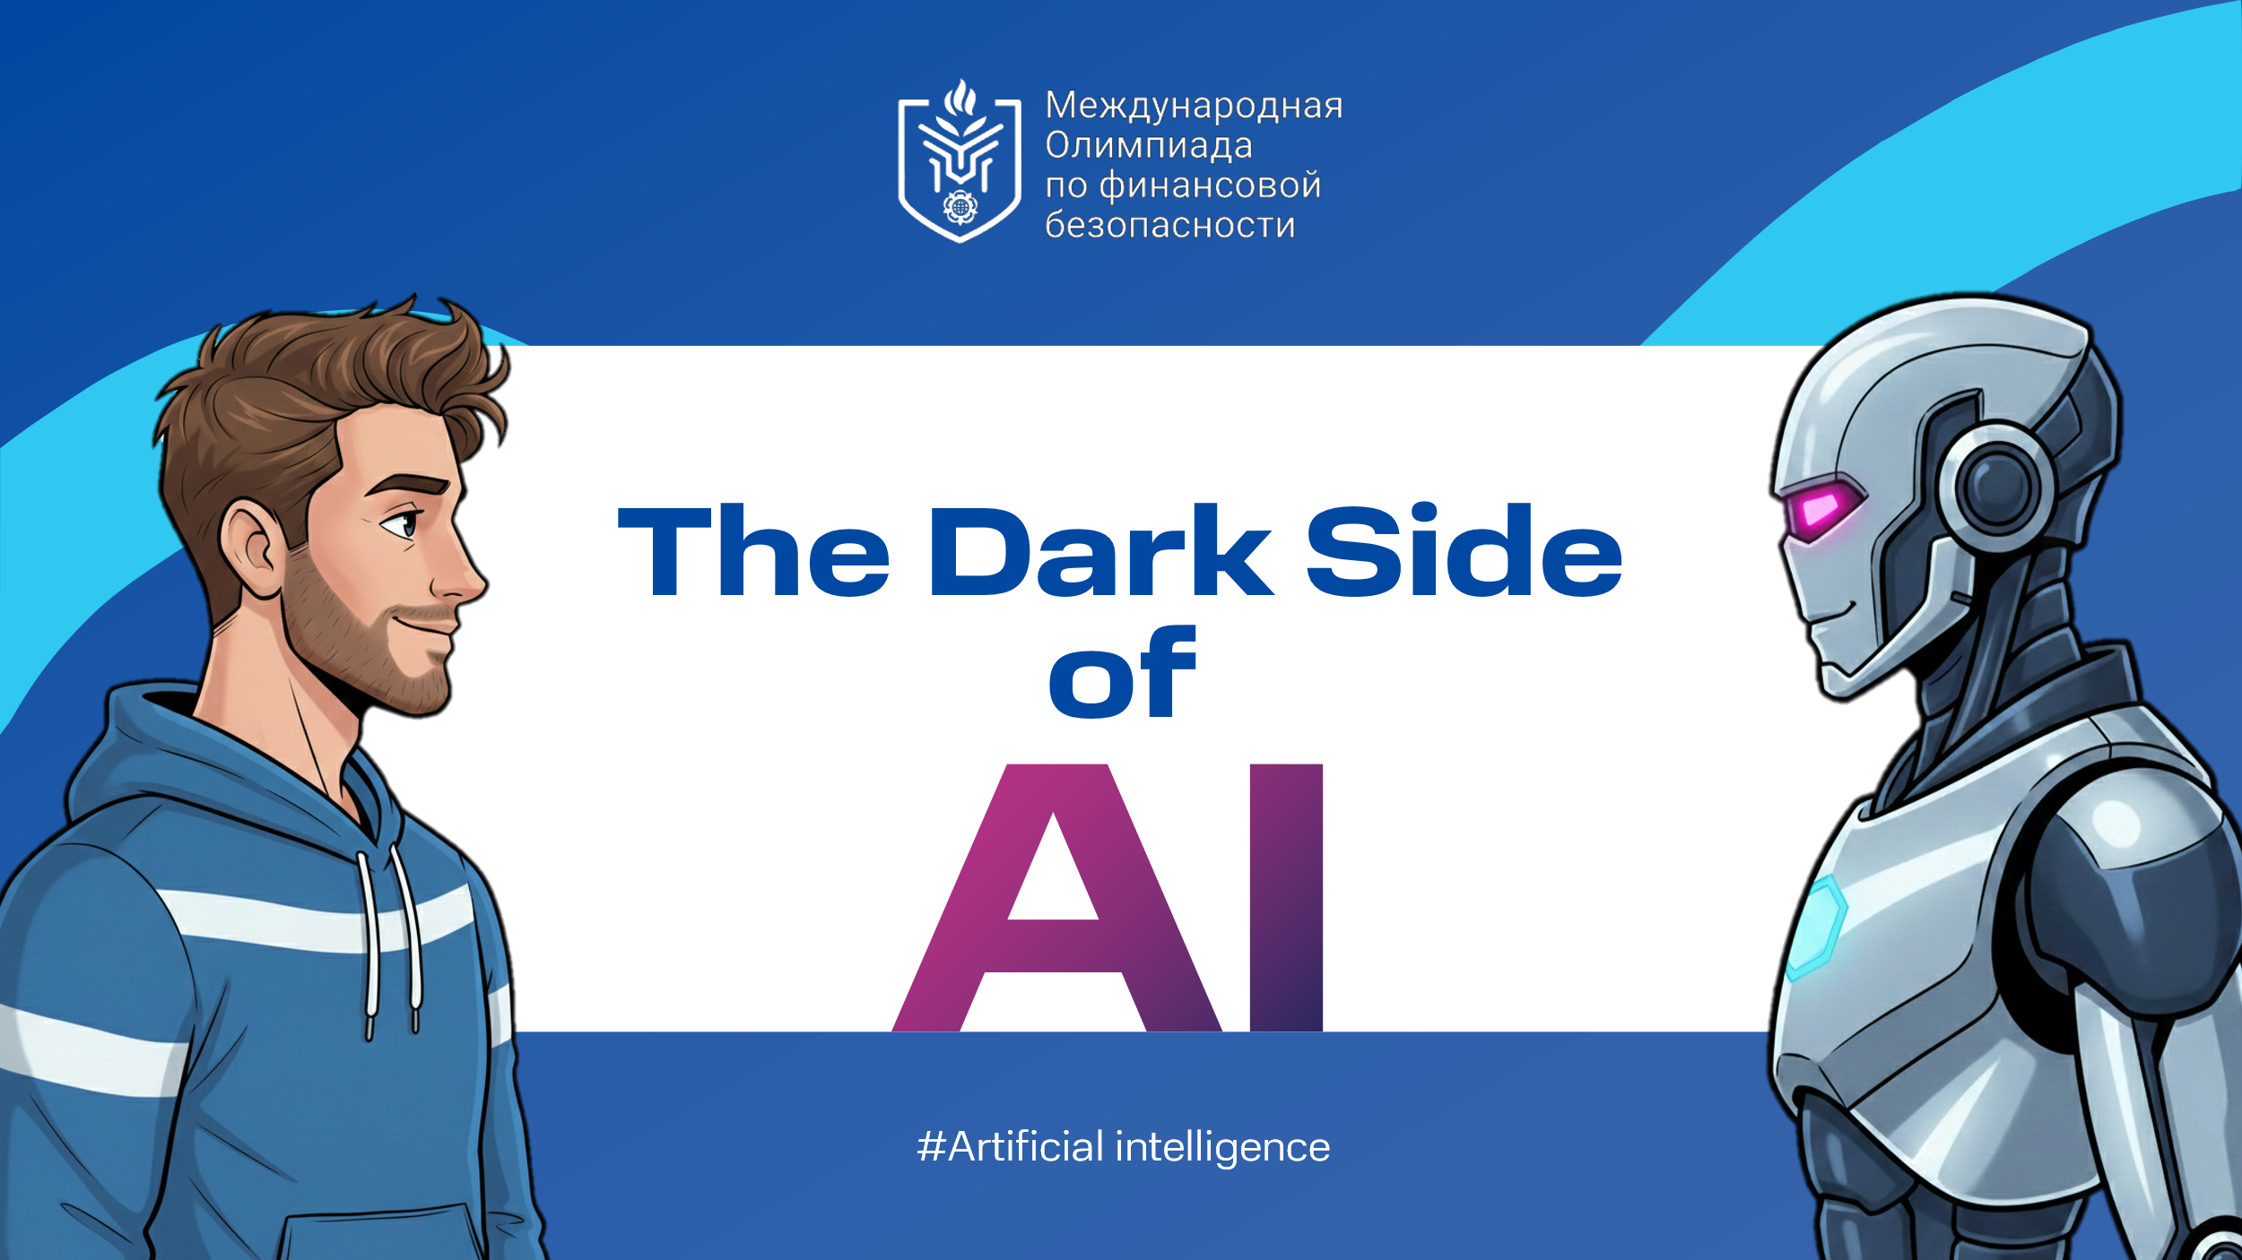 | Financial literacy in the era of artificial intelligence is acquiring new, critically important significance. It ceases to be just the ability to manage a budget and becomes a skill of digital self-defense, expressed in digital hygiene, critical thinking, and the ability to counteract algorithmic threats emanating from the Internet. The importance of financial literacy at the present moment can hardly be overestimated.  Probably, it will be no secret or surprise to anyone that artificial intelligence has imperceptibly penetrated all spheres of our lives and plays a huge role in modern society. Due to the rapid growth of computing power of computers and machine learning algorithms, neural networks, besides writing texts and solving mathematical problems, have learned to recognize objects. This has particularly impacted the increase in the number of unmanned transport (cars, trucks, trams, etc.) and the improvement of logistics (for example, in terms of creating optimal delivery routes).

Slide 2  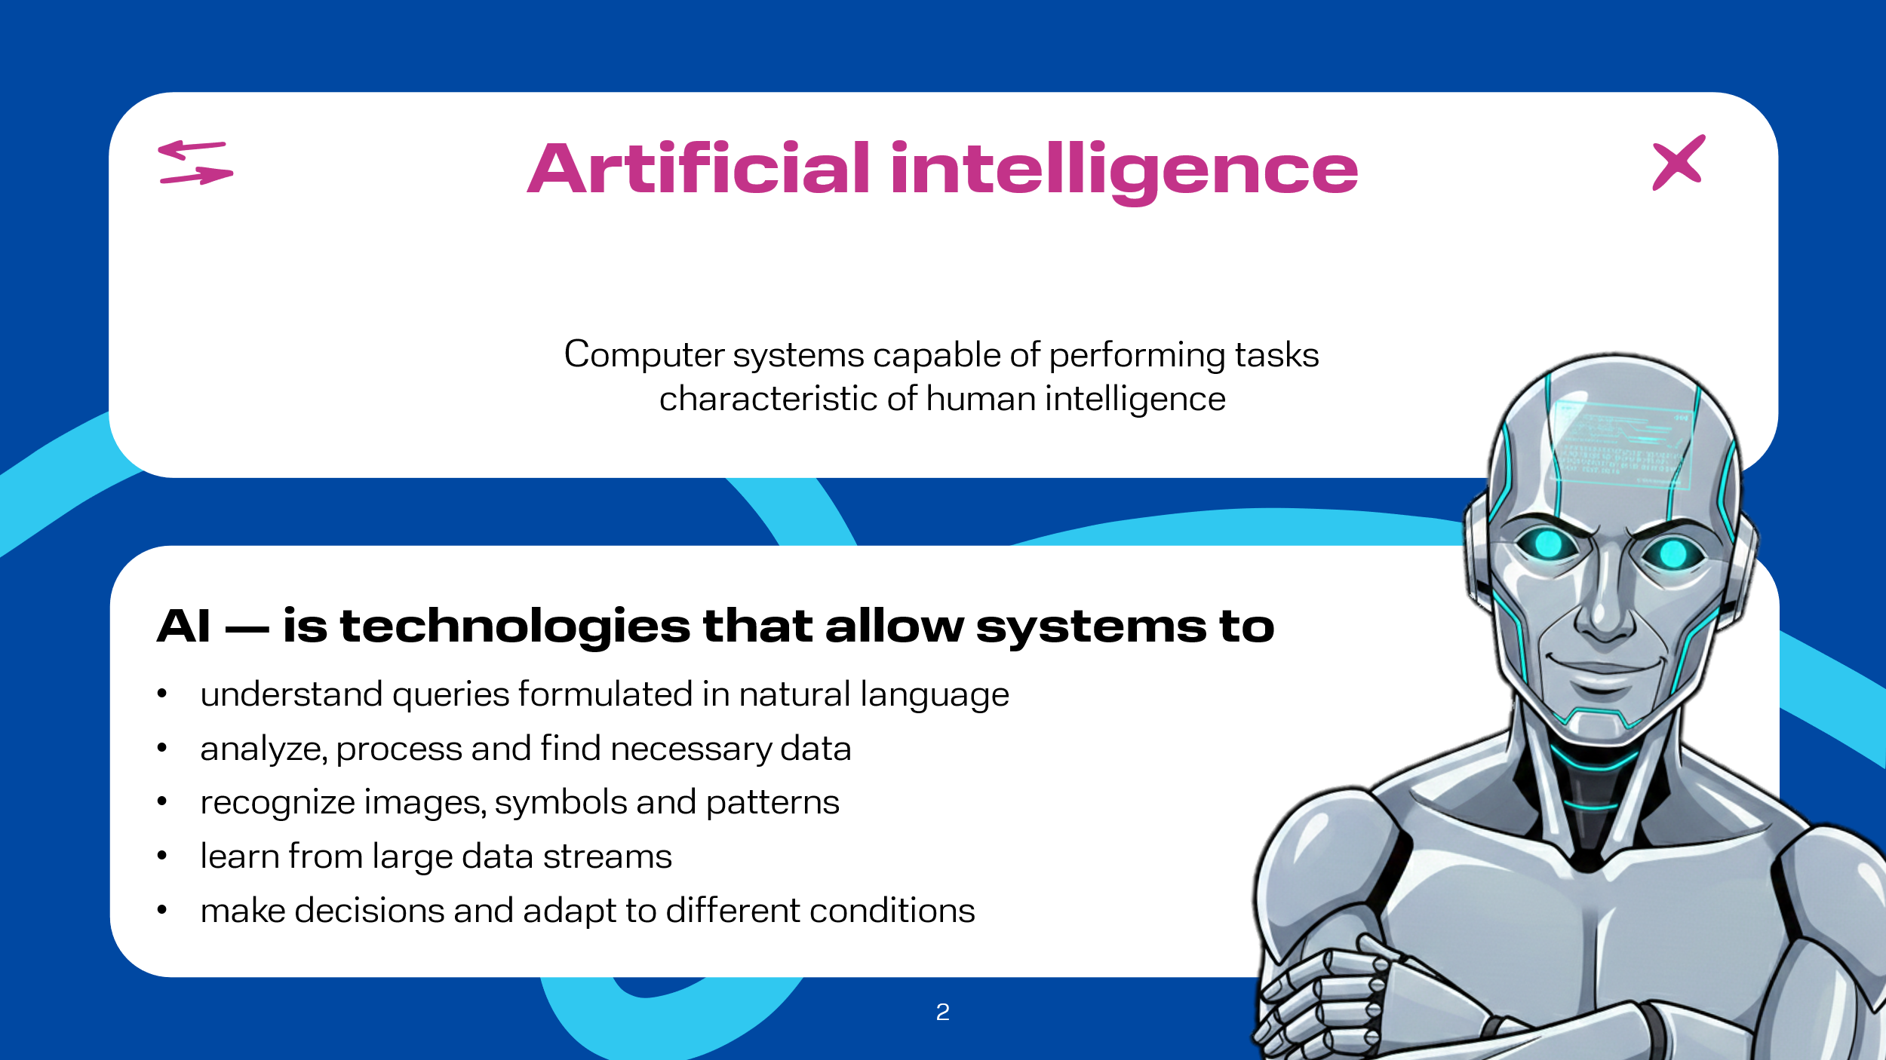 | Artificial Intelligence (AI) – a field of science that deals with the development of computer systems capable of performing tasks characteristic of human intelligence. This includes data analysis, pattern recognition, processing texts and queries formulated in natural language, learning from data streams, and decision-making. AI is based on algorithms, models, and technologies that allow machines to perceive the surrounding world, interpret data, draw conclusions, make decisions, and adapt to changing conditions.

Slide 3  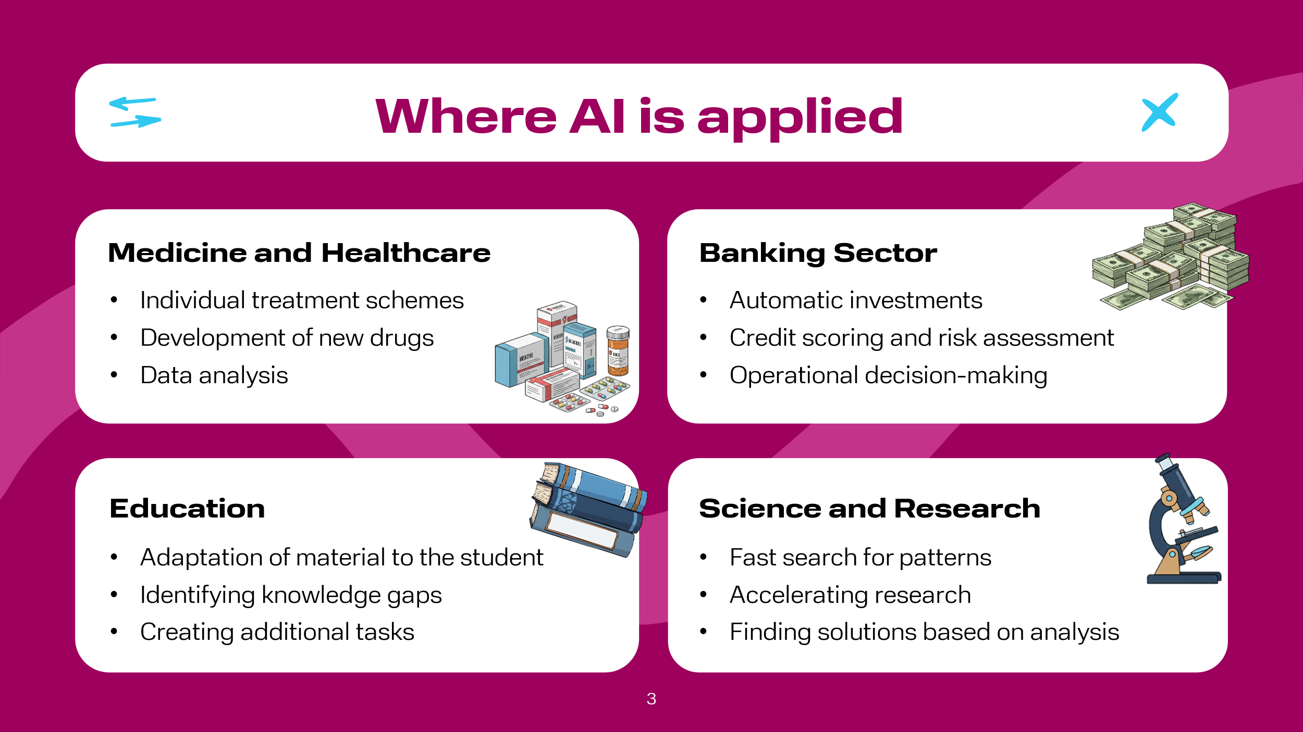 | Let's consider some aspects of AI's influence on our lives.  Medicine and Healthcare. Computer vision algorithms analyze X-rays, MRIs, and CT scans, detecting tumors, fractures, and other pathologies faster and more accurately than humans. AI is actively used in drug development, in communication via chatbots that allow patients to make appointments with the right doctors. AI participates in the development of so-called personalized medicine, whose task is to predict potential patient diseases and apply individual treatment schemes based on big data analysis.  Banking Sector. AI is actively used in making decisions on granting credit products within the framework of so-called scoring, where not only the client's credit history is assessed, but also a large amount of other information, which allows for making informed decisions. Given the rapid increase in the financial literacy of the population, more and more citizens are investing their savings in the stock market (stocks, bonds, mutual funds) to obtain potentially higher returns than savings products like deposits and savings accounts. Banks, in turn, use AI for instant, automatic purchase of certain securities on the exchange for the client, reacting to the slightest market changes.  Education Sector. Today, there are many educational platforms/aggregators and other organizations actively using AI technologies. They tailor educational material to the pace and knowledge level of each student, including identifying knowledge gaps in a particular topic, selecting appropriate additional tasks, which certainly has a positive effect on the learning process.  Science. This is an area where AI models are actively used, as they are indispensable tools in scientific research. AI can find patterns in a short period of time where it would take a person days/weeks/years. An example is the development of software by Russian scientists using AI for rapid automatic detection of changes in forest conditions -- fires, logging, etc. This innovation is capable of quickly eliminating or minimizing negative consequences.

Slide 4  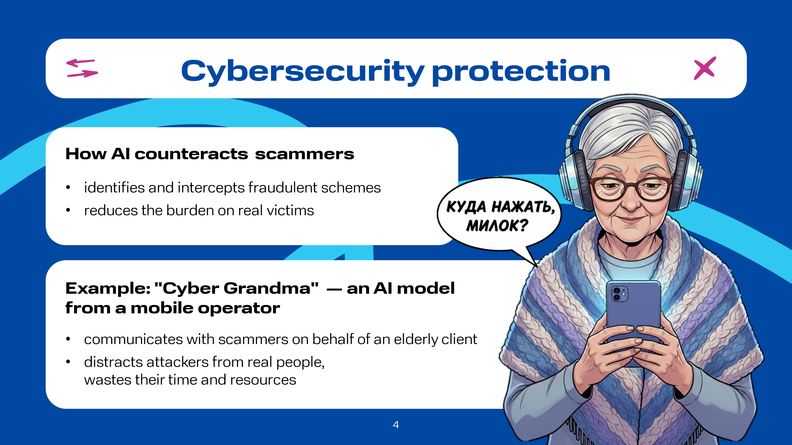 | In addition to the above, AI is used to protect our cybersecurity. For example, one of the largest mobile operators in the Russian Federation created "Cyber Grandma" -- an AI model that communicates with fraudsters disguised as an elderly female client. As a result, the cybercriminal spends time and resources communicating with AI instead of a real person who could have been harmed by their activity. AI is also actively used in the business sector. For instance, one of the largest marketplaces in the Russian Federation has implemented AI in many processes to simplify employees' lives. For example, 95% of product cards are now moderated without human involvement.  Big changes have occurred in the HR sector. For example, a popular online recruitment and job search service in the Russian Federation launched an AI assistant for recruiters in November 2025, which took over routine tasks and freed up time for specialists to do live work with people.

Slide 5  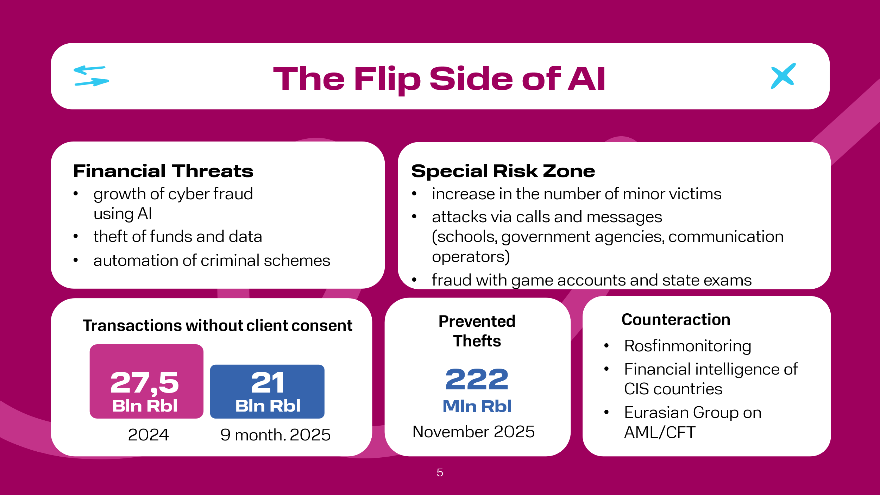 | The list of how AI positively affects the lives of all people on our planet could go on for a very long time. However, there is a flip side, and one of them is financial crimes using AI.  The Federal Service for Financial Monitoring (Rosfinmonitoring), with the active participation of financial intelligence units of the CIS countries, interacting within the framework of the Eurasian Group on Combating Money Laundering and Financing of Terrorism, is actively working, among other things, to counteract illegal actions with stolen funds.  First, let's look at the overall picture in this area recently: according to the Central Bank of Russia, the volume of transactions without the voluntary consent of clients for 9 months of 2025 amounted to 21 billion rubles, for the entire 2024 this volume was 27.5 billion rubles. Comparison of these indicators suggests that despite the efforts of the Central Bank of the Russian Federation, commercial banks, the Ministry of Internal Affairs of the Russian Federation, Roskomnadzor, and other institutions, the issue of financial security is very acute and does not lose its relevance. According to the Ministry of Internal Affairs of the Russian Federation, in November 2025 alone, the department managed to prevent theft amounting to over 222 million rubles. It is important to pay special attention to the increase in the number of minors affected by cyber fraudsters. According to the Ministry of Internal Affairs of the Russian Federation, the target of fraudsters is the money of teenagers' parents. Using the personal data of minors, attackers call or send messages to teenagers on behalf of an educational organization, government authorities, or mobile operators to obtain authorization codes. Cases of fraud in the sale or purchase of game accounts and answers for state exams have also been recorded.

Slide 6  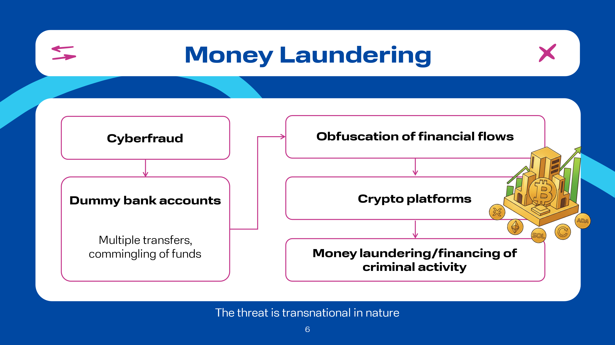 | To launder funds obtained from illegal activities, cybercriminals still actively use classic banking mechanisms. Financial flows pass through many dummy accounts, where illegal money is mixed with legal transactions, after which it is often sent to crypto platforms for final legitimization or financing of further criminal activities, for example, terrorist activities. It is worth noting that the scale of this problem is often underestimated, and the threat itself is transnational in nature, affecting not only Russia and the Commonwealth of Independent States, but the entire world.

Slide 7  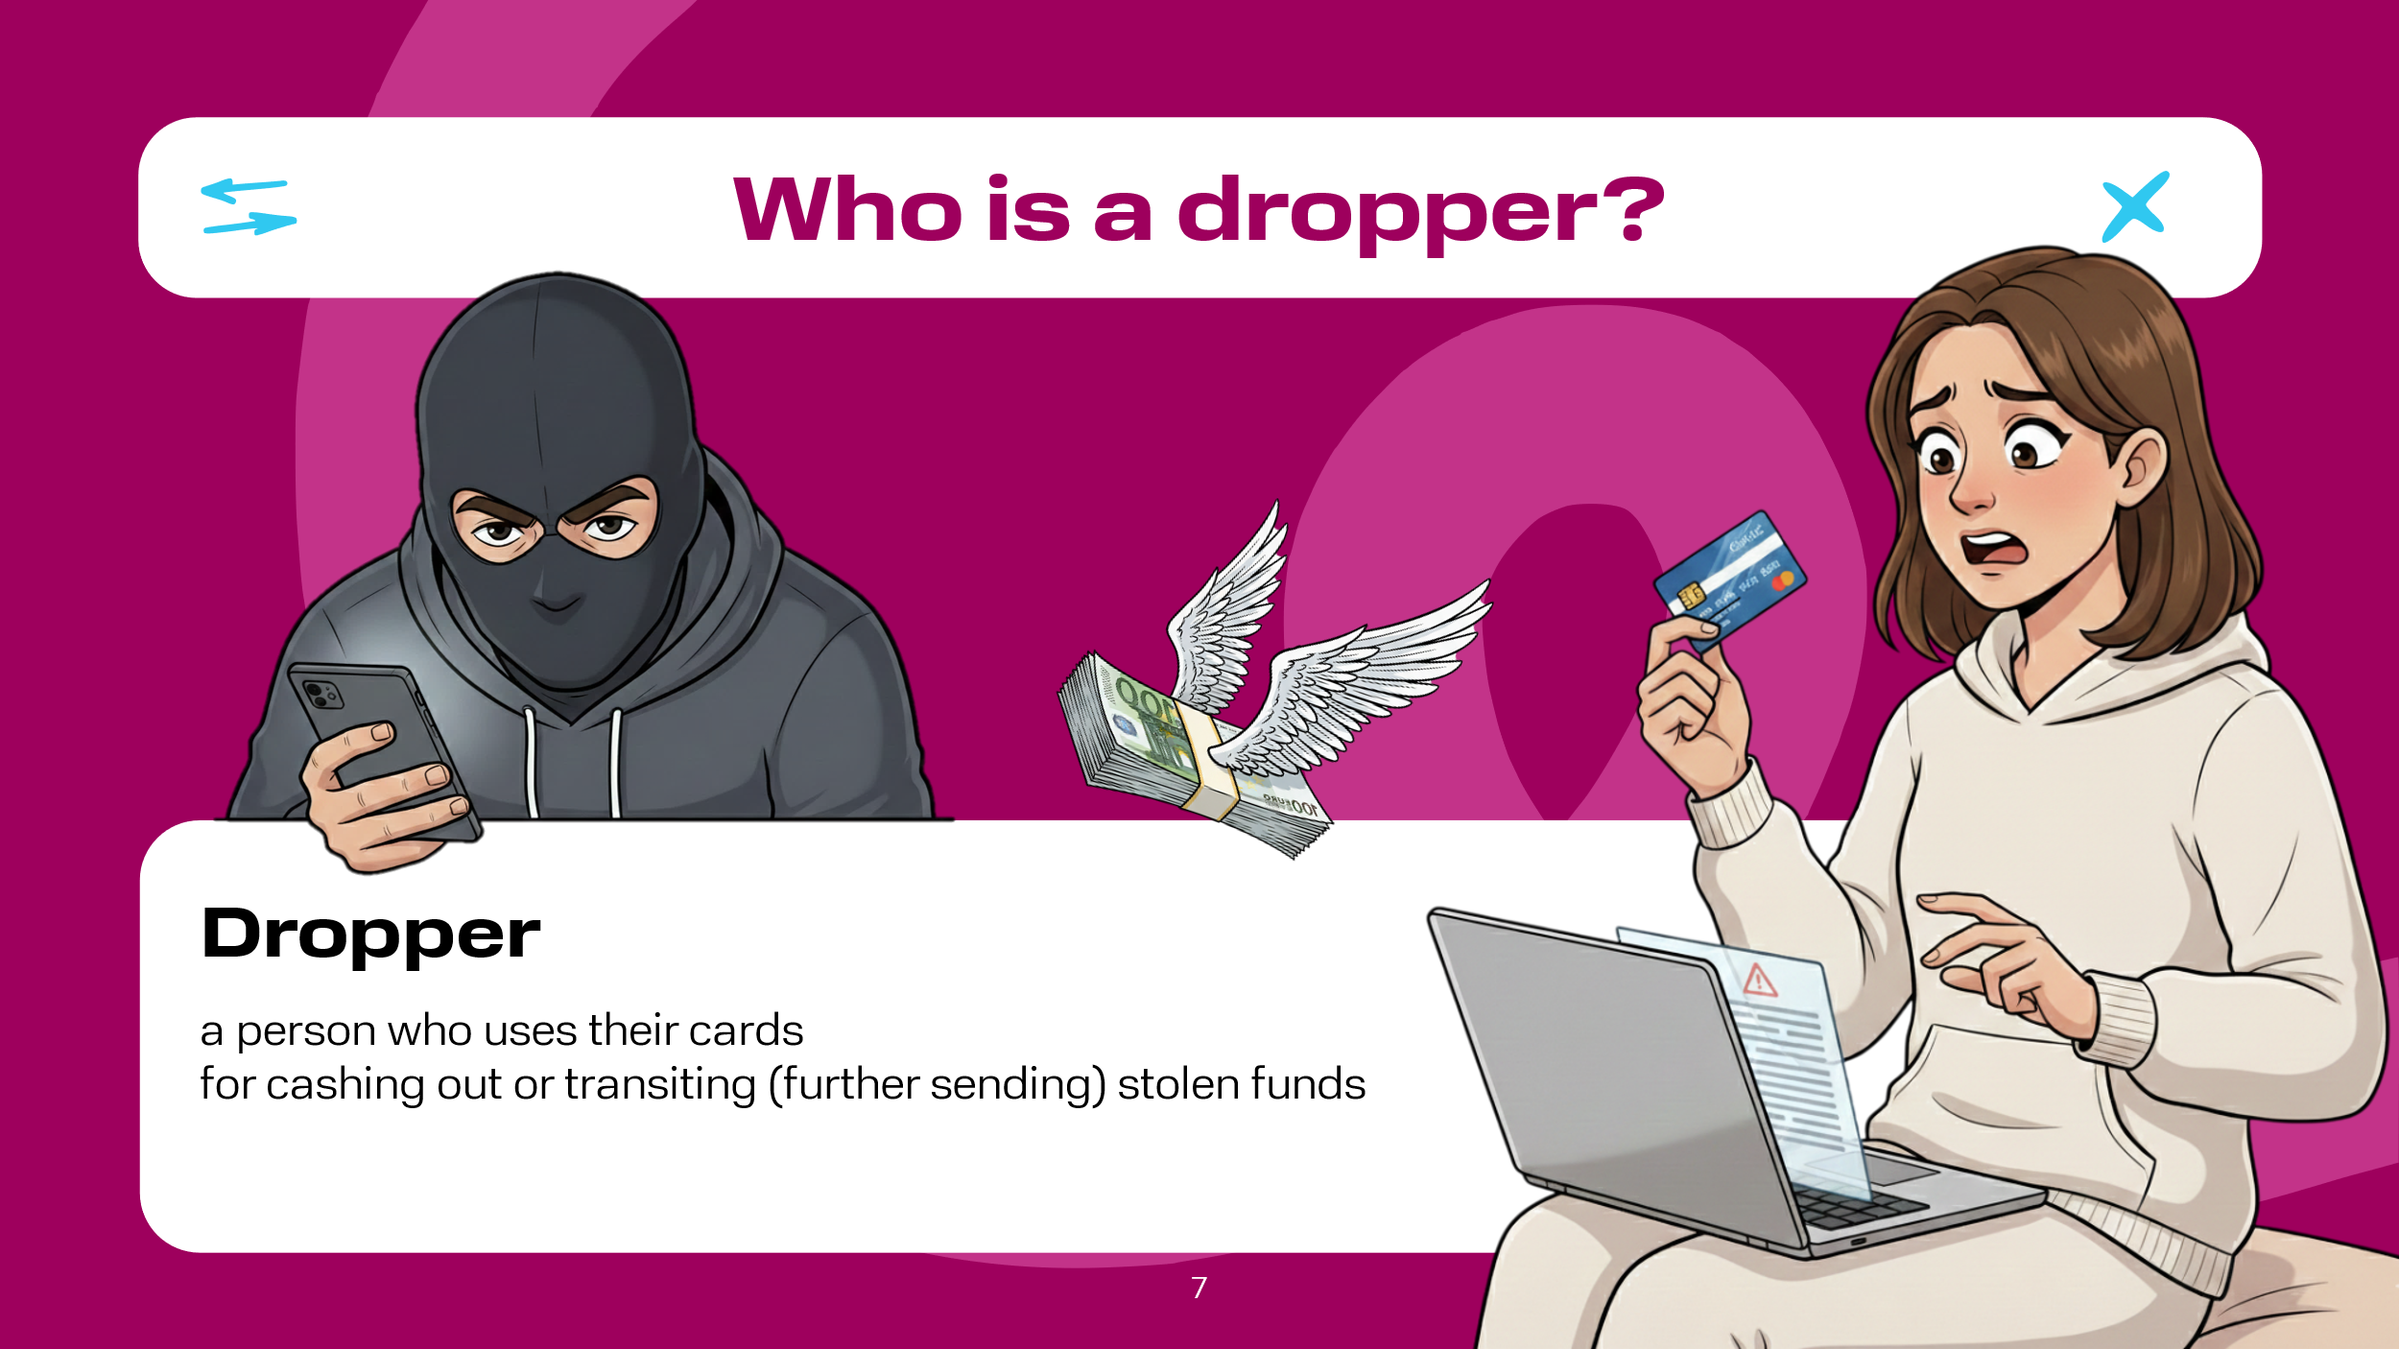 | A dropper is a person who uses their cards for cashing out or transiting (further sending) stolen funds.

Slide 8  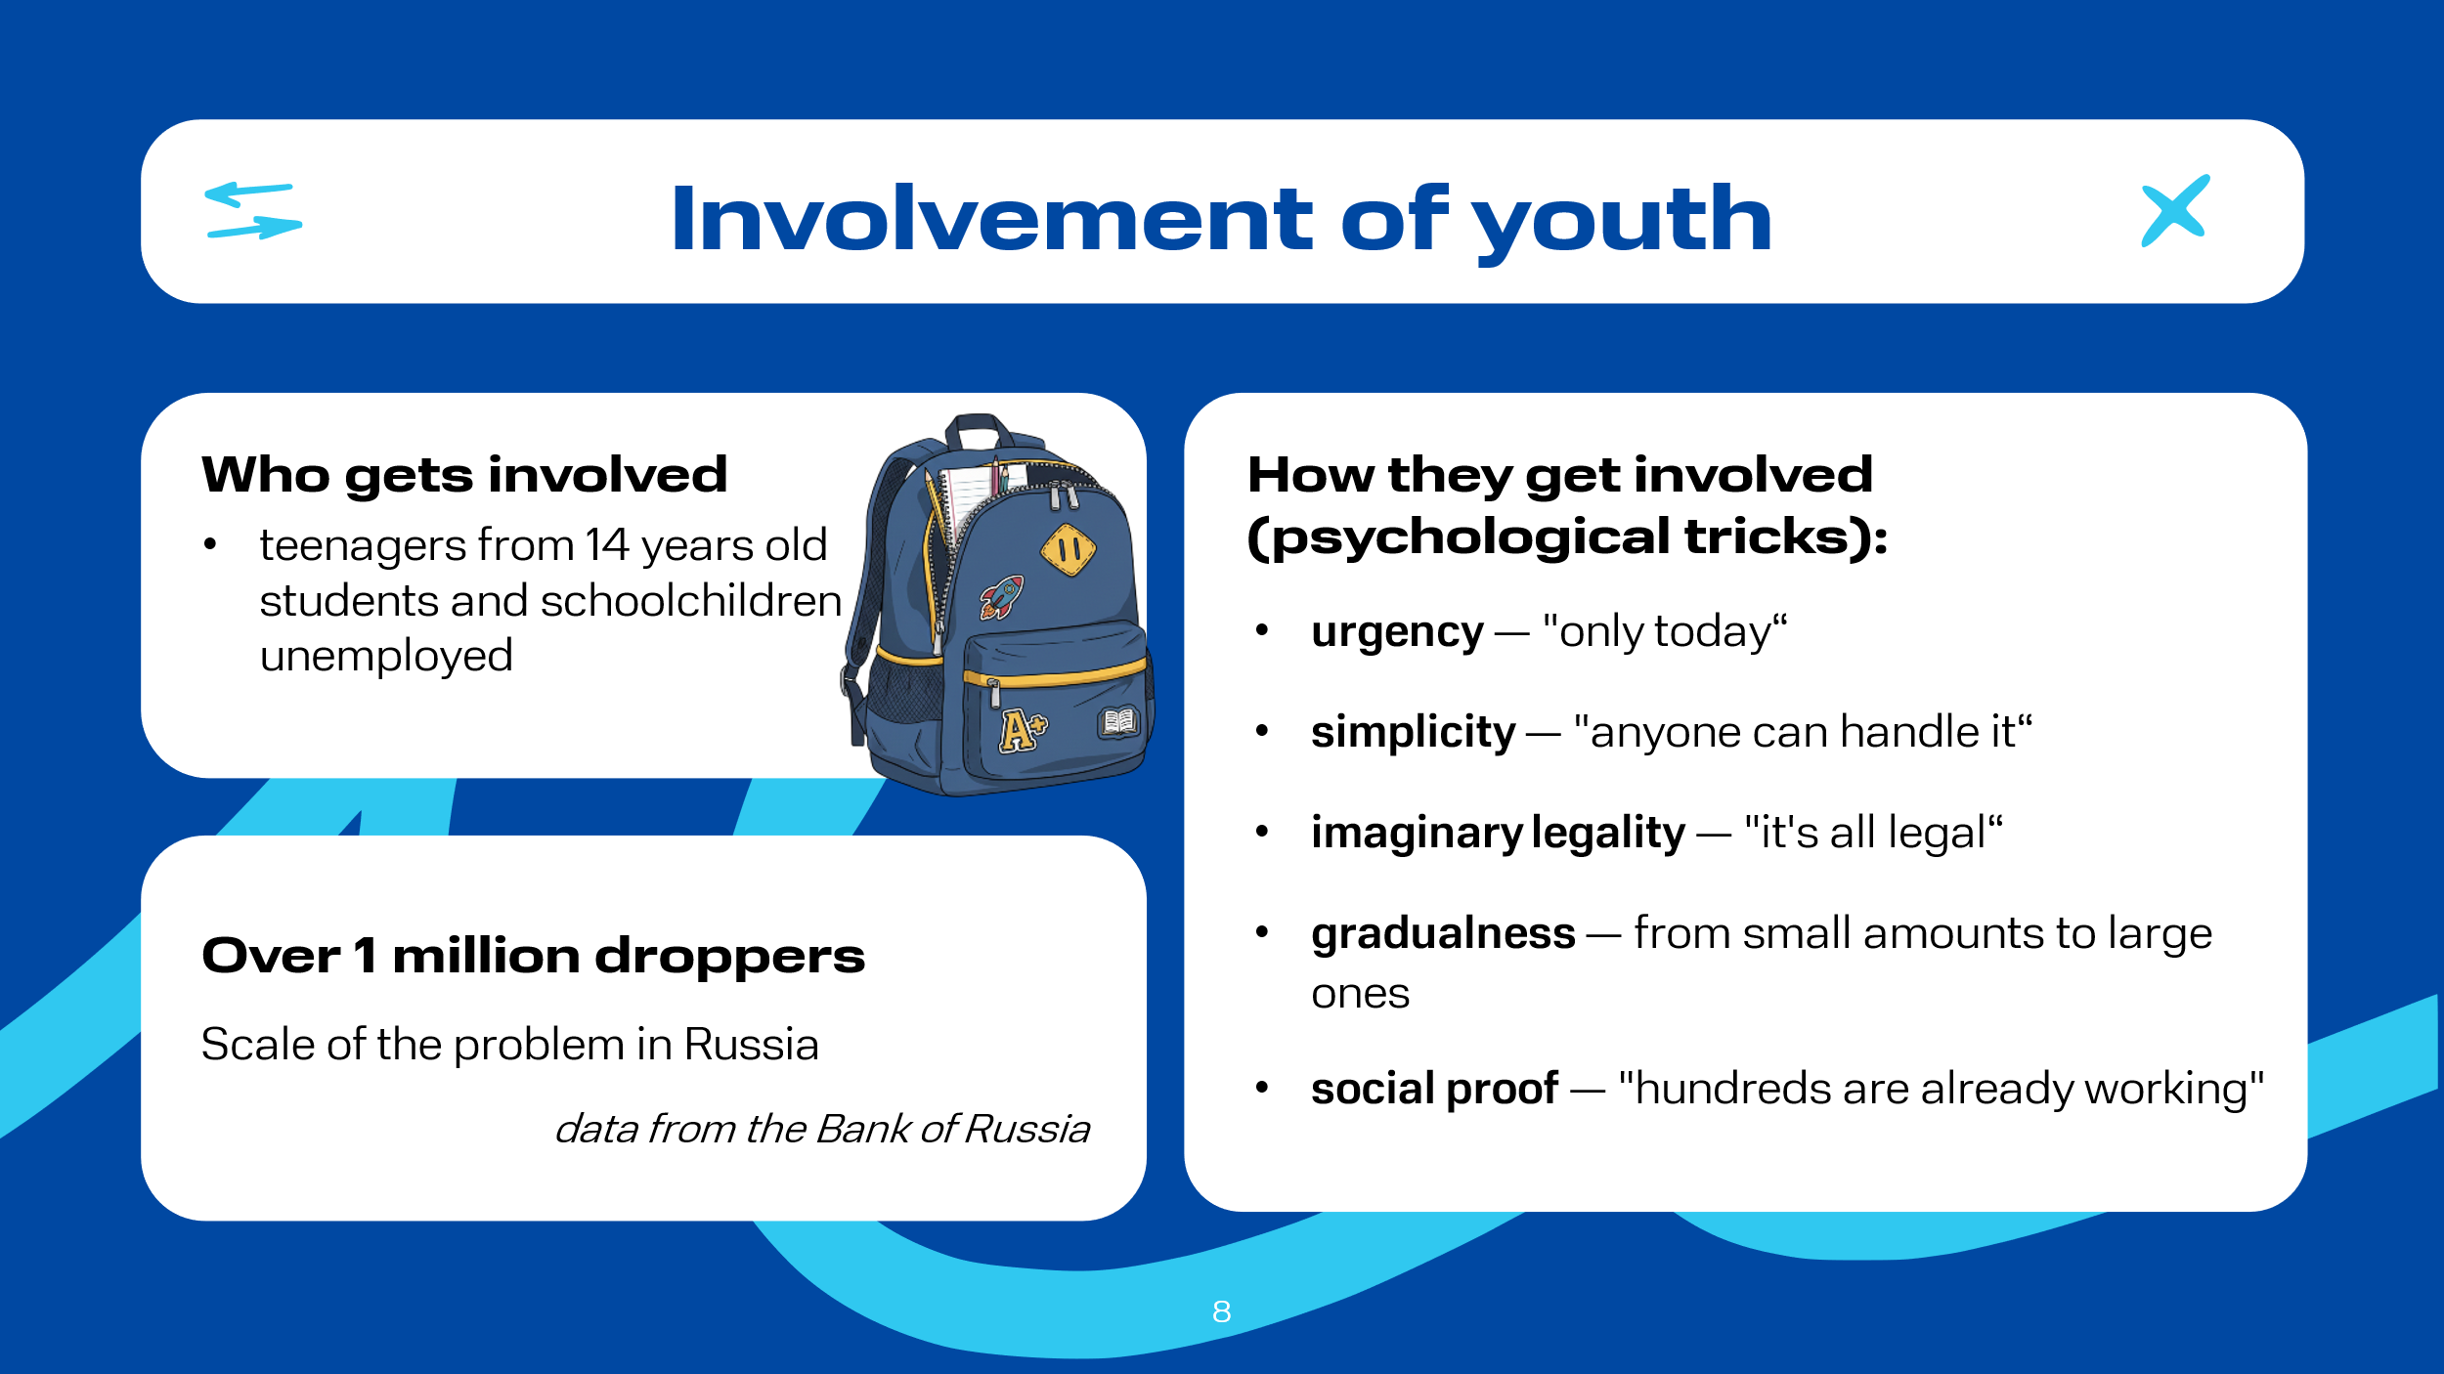 | Cybercriminals are forced to more actively involve not only young people, but often teenagers aged 14 and older, in the money laundering process. According to the Central Bank of Russia, over 1 million droppers were identified in the Russian Federation, so this issue cannot be ignored. According to the Ministry of Internal Affairs of the Russian Federation, droppers are most often unemployed residents of small towns with low salaries; students and schoolchildren looking for easy money. To attract young people to dubious schemes, fraudsters use the following psychological tricks:  urgency – «offer is open only until evening», « spots are filling up»;  simplicity – «nothing complicated, even a schoolchild can handle it »;  safety – «it's completely legal», « everyone does it »;  gradualness – they start with small amounts, gradually increasing the turnover ;  social proof – «we already have 500 people workingовек», « look at the reviews ».  The danger for schoolchildren and students lies, among other things, in their lack of understanding of the responsibility for participating in such schemes.

Slide 9  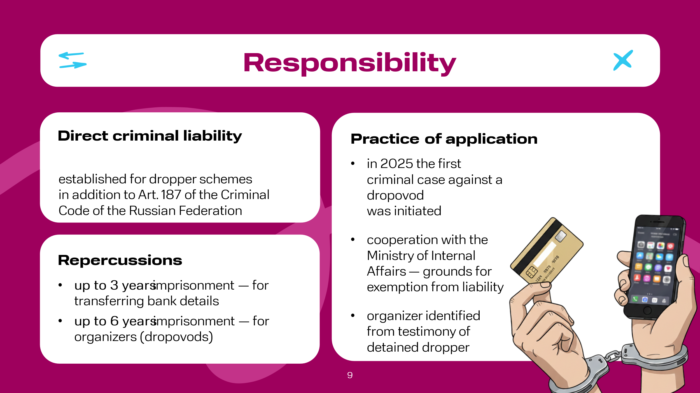 | In June 2025, Russian President V.V. Putin signed a law supplementing Article 187 of the Criminal Code of the Russian Federation with specific liability for participation in dropper schemes. Thus, the document establishes criminal penalties of up to 3 years in prison for persons providing their bank details for a fee, and up to 6 years for organizers of such activities. In 2025, Russia opened the first criminal case in the country against a so-called "dropovod", i.e., the organizer of a scheme for illegally cashing out funds. According to the Ministry of Internal Affairs of the Russian Federation, information on him was provided by one of the detained droppers in exchange for exemption from criminal liability.  Thus, the topics addressed in this lesson are particularly relevant in modern life for every person.

Slide 10  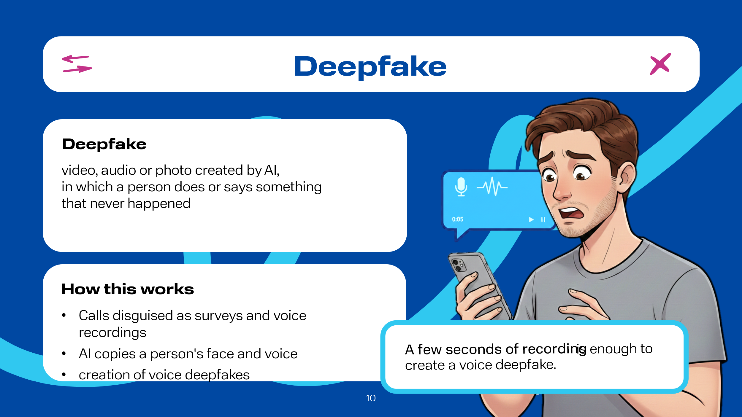 | Artificial intelligence technologies are developing rapidly, and one of the most impressive and at the same time alarming manifestations is the deepfake.  Deepfake – is a video, audio, or photo created by artificial intelligence, in which a person does or says something that never happened. One can imagine that a computer has learned to copy an actor's voice and face so well that it can "insert" them into a new film without their participation. This technology originated many years ago. For example, back in 2015, during the creation of the famous film "Furious 7," the image of the main character was recreated using available computer technology. This was done due to the death of one of the main actors and the need to complete an important storyline.  It is worth noting that this was the first large-scale case in the world. But today, deepfakes have reached a new level. Modern technologies allow you to create a full-fledged voice deepfake using just a few seconds of a real person's recorded voice. For this purpose, attackers in the Russian Federation have begun massively calling citizens under the guise of sociological surveys to record their voices for subsequent creation of deepfakes.

Slide 11  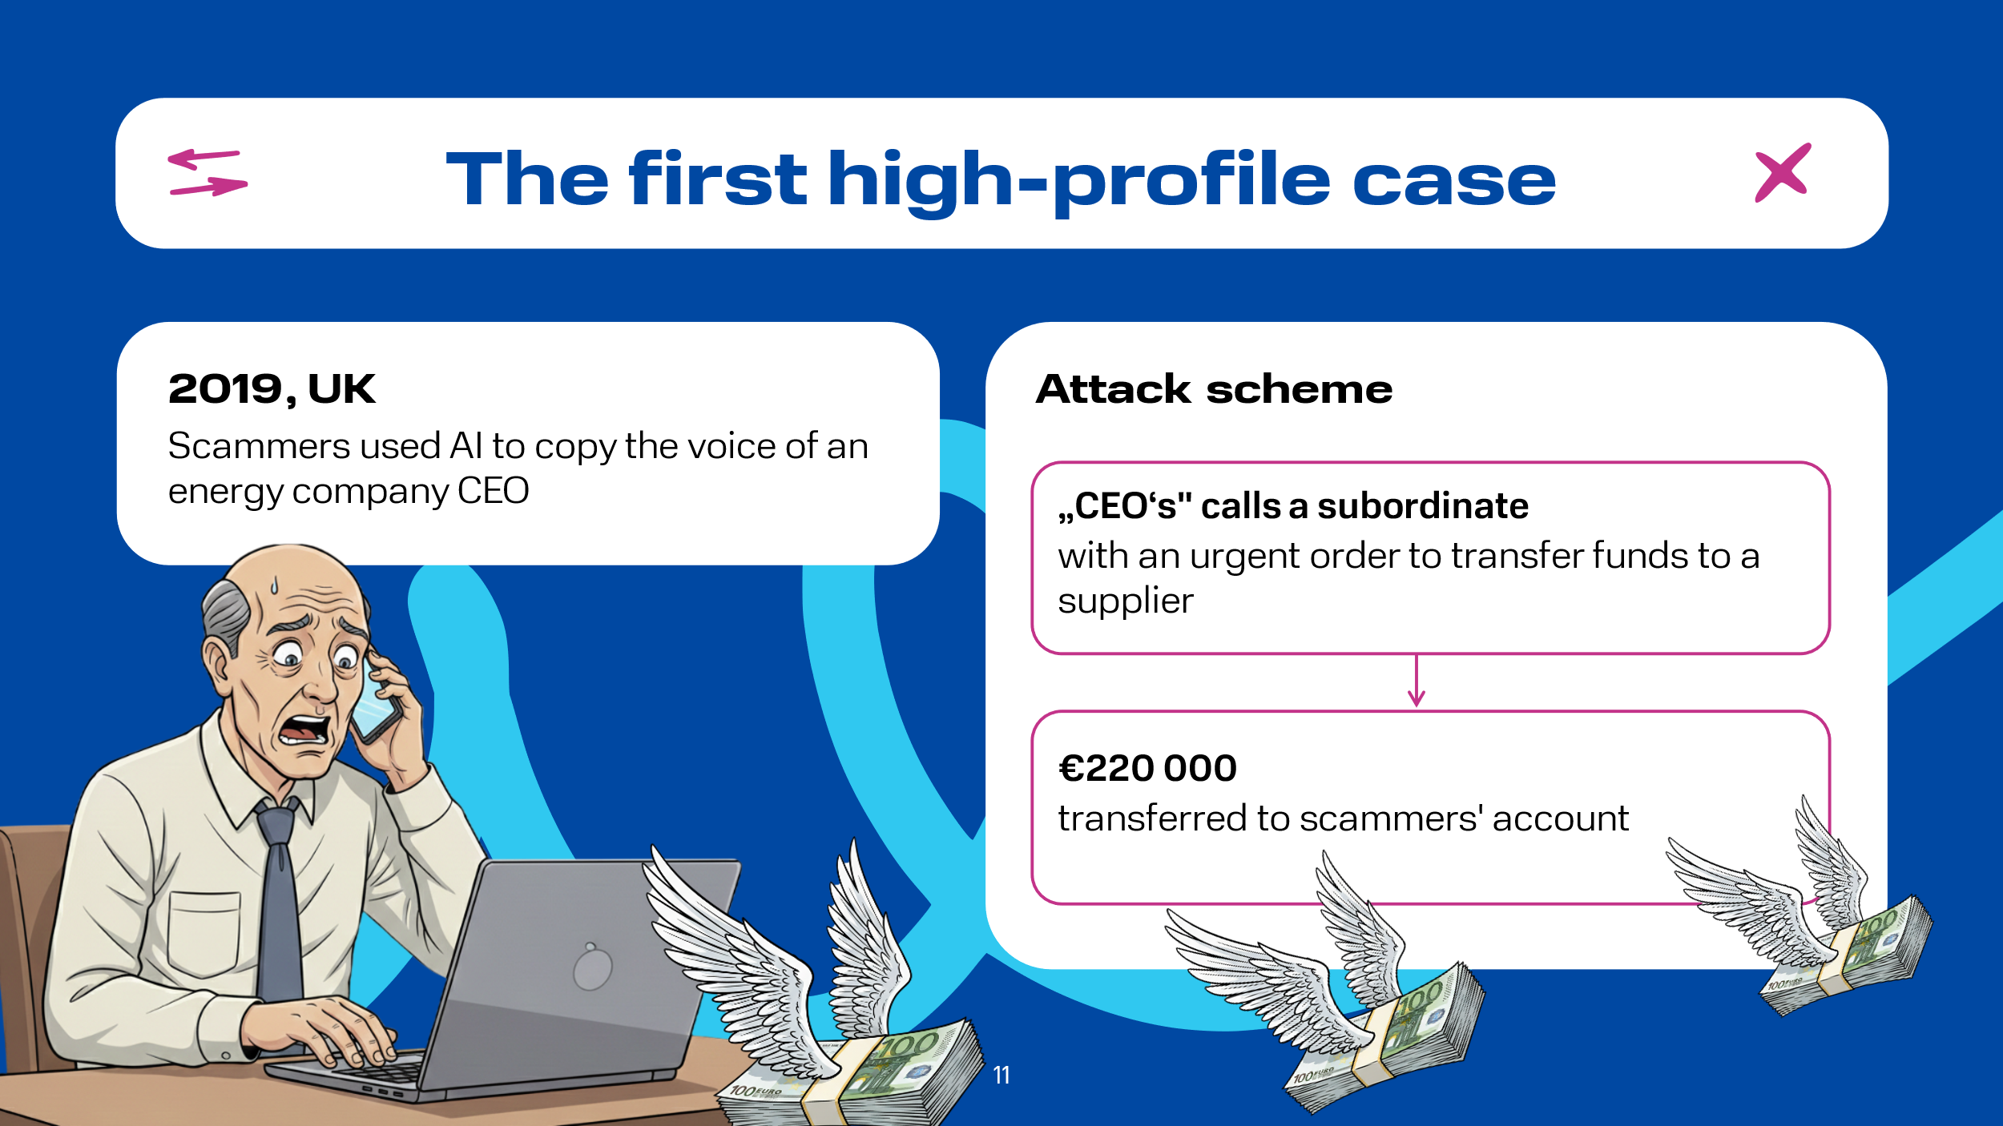 | Widely known is the case that occurred in 2019 in the UK: fraudsters used AI to copy the voice of the CEO of a German energy company. They called his subordinate, ordering an urgent transfer of €220,000 to a Hungarian supplier's account. The money was transferred instantly. This is one of the first documented cases.

Slide 12  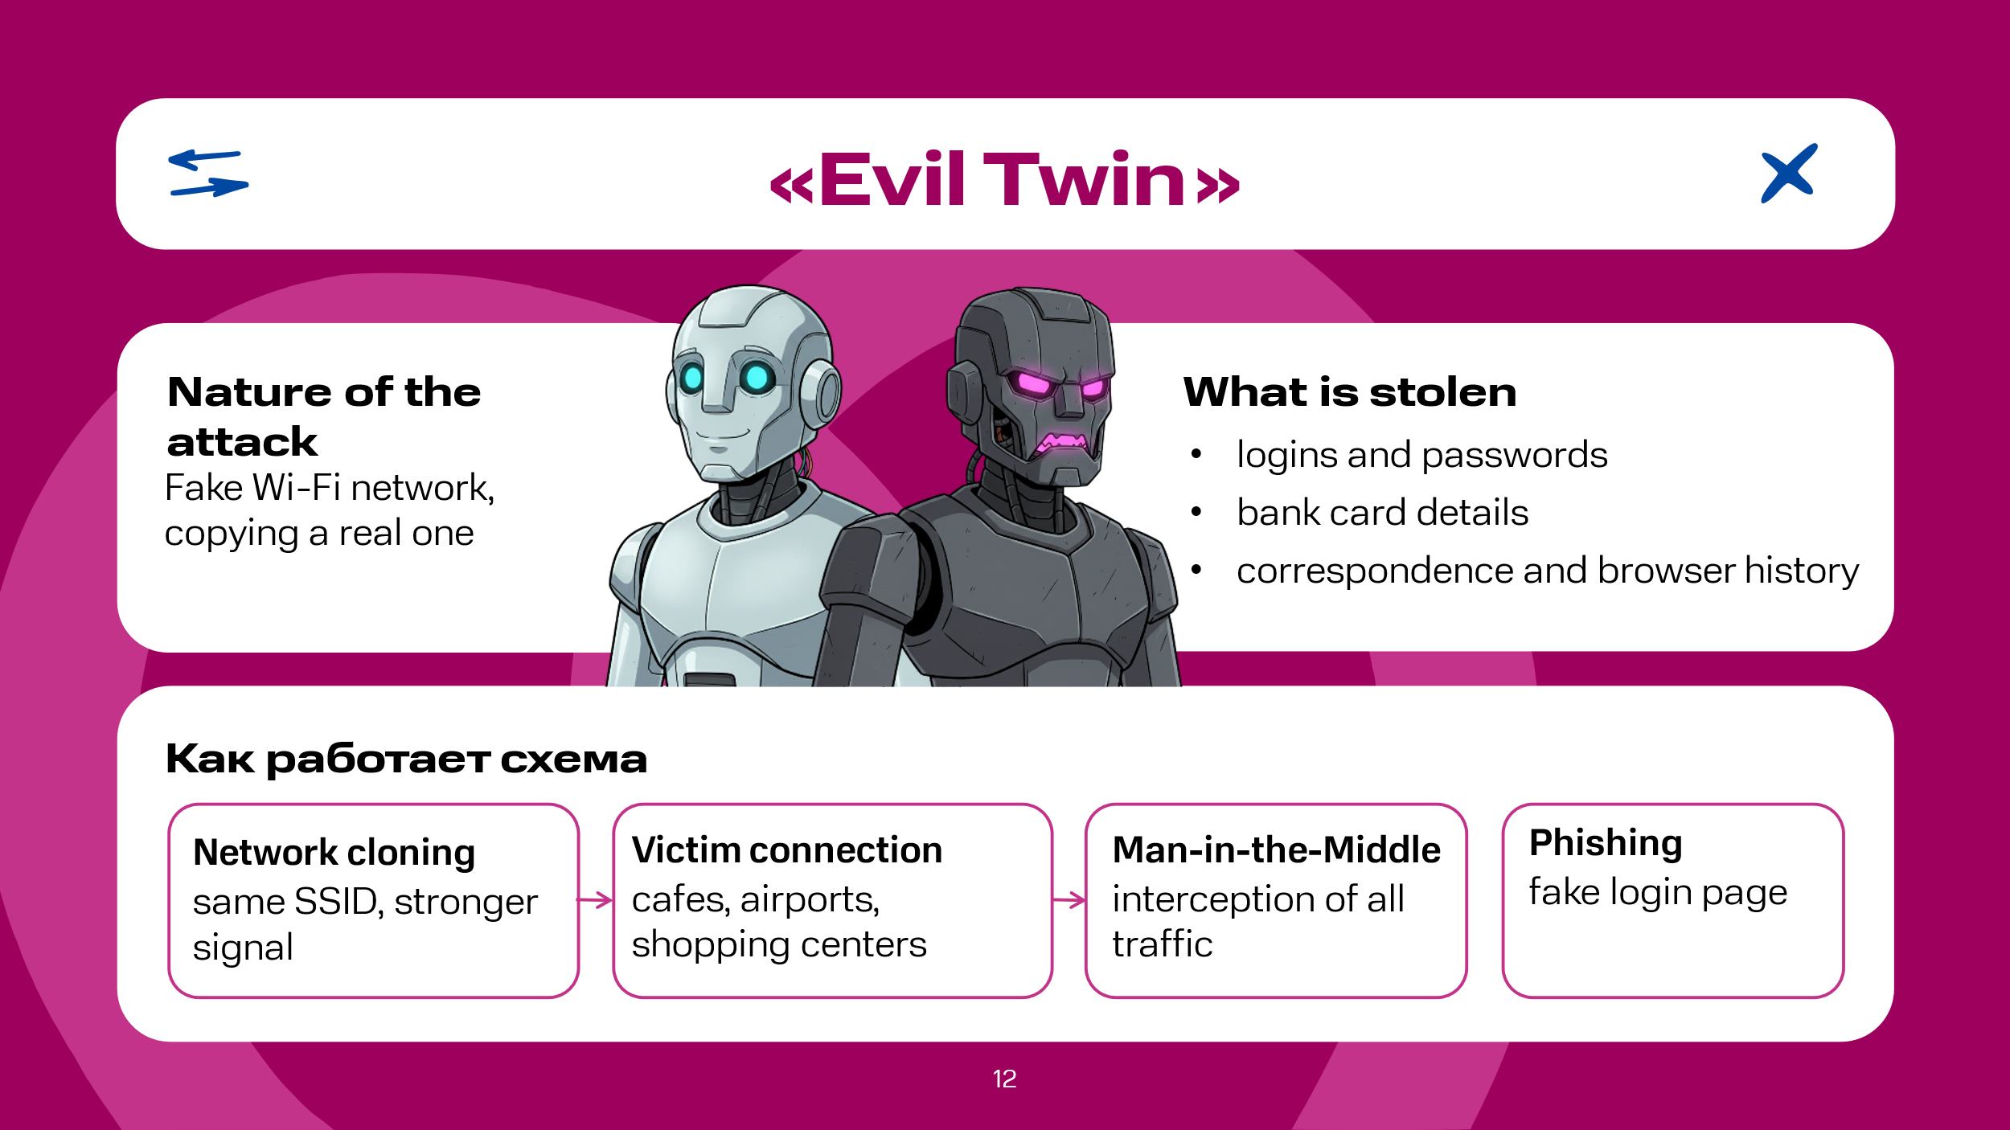 | Consider an example of an analogue of deepfakes called "Evil Twin Attack". This is a fairly classic and at the same time very dangerous attack. The danger lies in the fact that an unsuspecting Internet user unknowingly transmits their data to attackers, and it works according to the following scheme:  - cloning ("deepfake for the network"): the attacker creates a Wi-Fi network with an identical SSID name. Using modern devices, they make the signal of their access point much stronger than the original;  - luring the victim: a user in a cafe, airport, or shopping center sees a list of networks. The "twin" network often appears at the top of the list (due to the strong signal) and looks familiar. The person connects to it, thinking it is legitimate free Wi-Fi;  - traffic interception (Man-in-the-Middle): all of the victim's internet activity (passwords, correspondence, browsing history, bank card details) now passes through the attacker's device. They become the "man in the middle," seeing and recording everything;  - phishing and coercion: often the "evil twin" shows a fake login page requiring phone number confirmation or social media authorization. This is done to steal even more data.  Consequently, while surfing the Internet, a user may transmit to attackers logins and passwords for email, social networks, banks; payment details of their bank cards; site visit history, and much more.

Slide 13  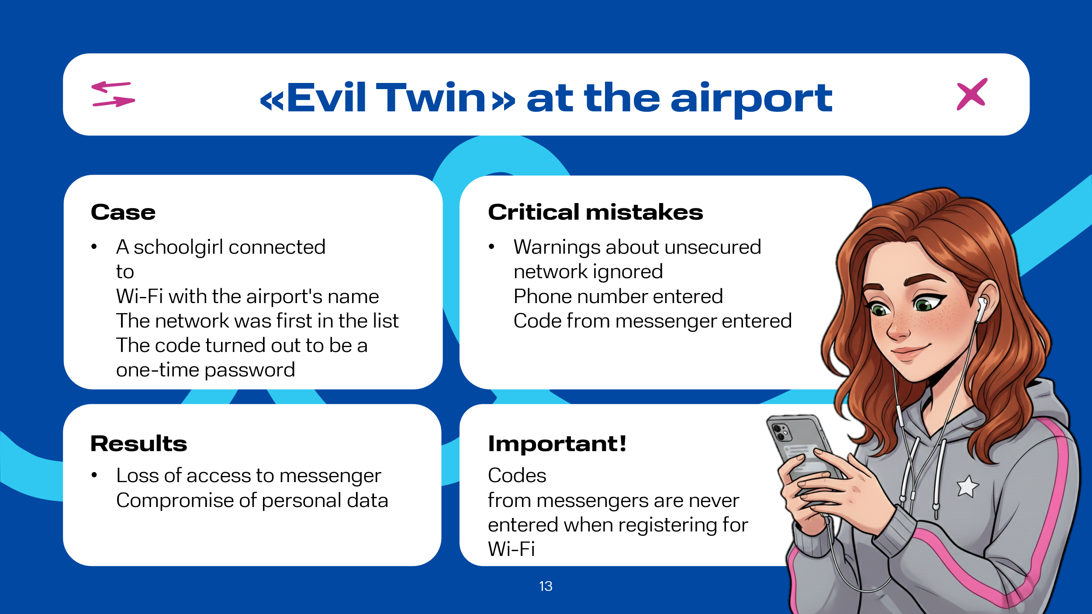 | A clear example is a real situation that happened with a student from one of the schools who was heading to another city for an Olympiad. At the airport, the student connected to a Wi-Fi network with the name of that airport, especially since it was the first network in the list of available ones on the mobile device. Despite the mobile phone's warning about the network being unsecured, the schoolgirl completed the registration. By entering her phone number and the access code that arrived on her phone in one of the popular messengers, the girl lost access to it, as this code was a one-time password for logging into the messenger. Inattention proved fatal -- for such registration forms, no codes from messengers are required.

Slide 14  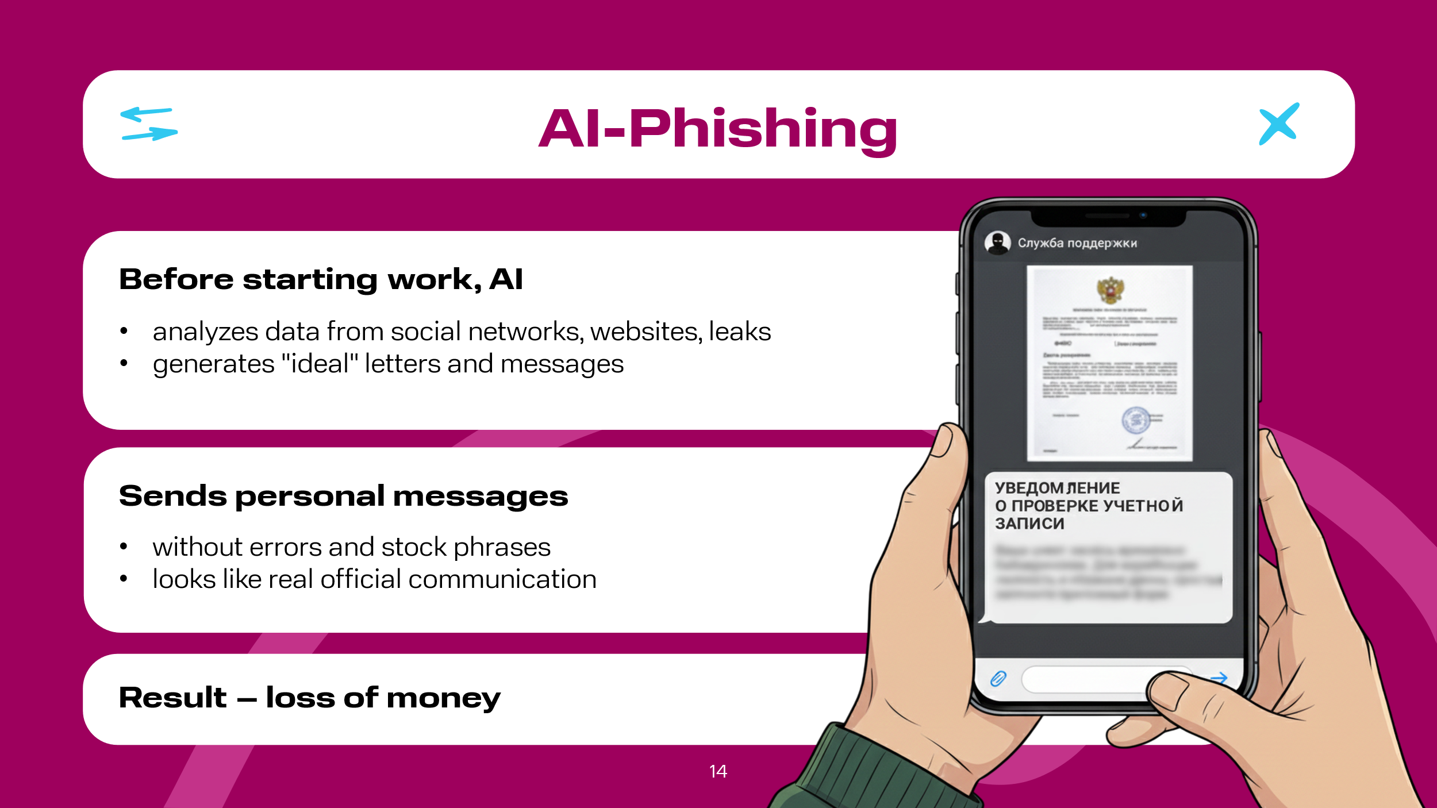 | AI-Phishing. Phishing is taking on new forms, using more subtle and sophisticated methods to lull potential victims' vigilance. Previously, phishing emails were template-based, with errors and generic salutations, e.g., "Dear Customer!". Now, AI, including that based on ChatGPT, analyzes the victim's data from various social networks, corporate websites, school websites, or leaks that occur regularly, and generates the perfect email. Leaks refer to hacker attacks on servers of various companies where their clients' data is stored, for example, information about discount card holders.  An example is a case that occurred in a government institution. An employee of the organization allegedly received a message in a messenger chat from their high-ranking boss's account, stating that during an inspection by representatives of the FSB of Russia (Federal Security Service of the Russian Federation), the dissemination of personal data within the organization was detected. In addition, the victim was sent a scanned copy of a letter allegedly written on behalf of the FSB of Russia addressed to the head of the government institution, and the letter was composed competently, observing all norms of incoming correspondence, indicating all correct information (full name of the victim, position and full name of the manager, name of the organization). All this lulled the victim's vigilance. The situation then developed according to the following scenario: the letter stated, among other things, that an "FSB representative" with his full name specified should contact the victim. Then, after his call, the victim received a call from a "representative of Rosfinmonitoring," as a result of which the victim was persuaded to withdraw their personal funds and hand them over to a so-called "cash courier."

Slide 15  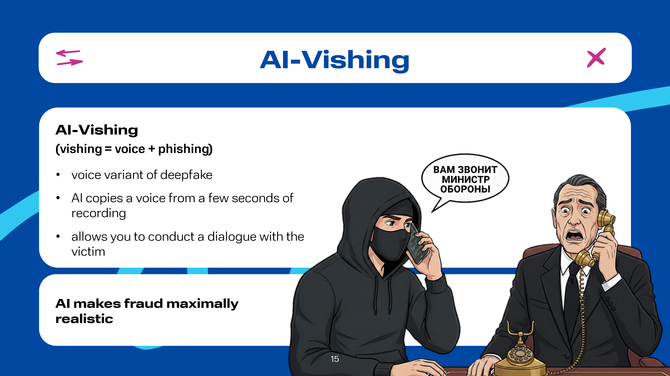 | AI-Vishing (vishing = voice + phishing). This is a type of deepfake where AI acts as a voice "copier." Today, AI only needs a few seconds of an original recording of a person's conversation to create a full-fledged audio message or make a call with the ability to conduct a dialogue.  An example here is the case that occurred in 2025 in Italy: fraudsters, using this technology and posing as Italian Defense Minister Guido Crosetto and other officials, called Italian entrepreneurs to convince them of the need to transfer money. It is worth noting that the victims in this case were people well-known to the world community, such as Prada President Patrizio Bertelli, fashion designer Giorgio Armani, Executive Vice Chairman of Pirelli & C. SpA Marco Tronchetti Provera, billionaire Massimo Moratti, former owner of the Milan football club "Inter," and others.

Slide 16  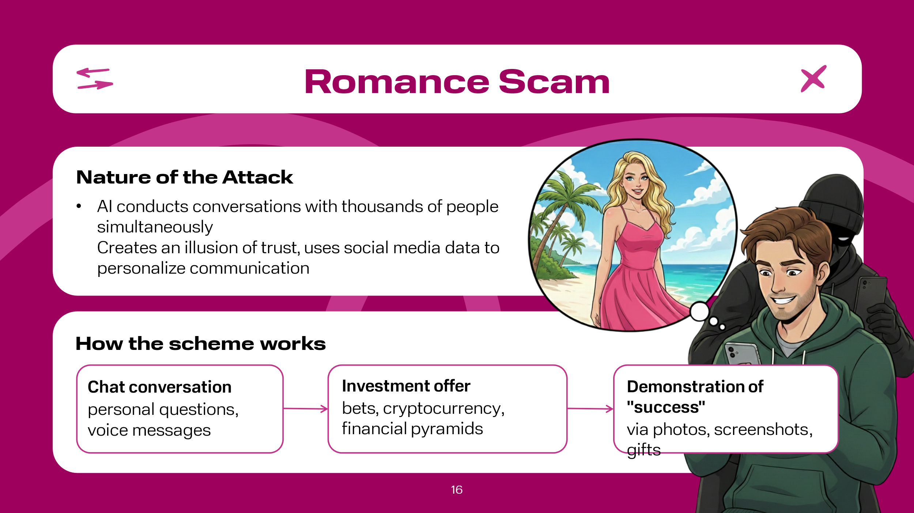 | Social Engineering via Social Networks and Dating Apps (Romance Scam). Emotional closeness with relatives, friends, and loved ones is important to everyone. The hormones produced by the body during this cause feelings of attachment and a desire to continue communication, and this, as a result, leads to a decrease in the level of critical thinking due to involvement in the communication process. For this purpose, cybercriminals readily use neural networks capable of chatting with thousands of people simultaneously. It is worth noting that the communication itself, before involving the victim in a scheme that will leave them without money, can take days, weeks, or months for plausibility. Moreover, to increase the victim's trust in the interlocutor (named "neural network"), attackers pre-enrich the neural network with data about the potential victim, for example, based on data from their social network page. The main danger of this approach is that AI does not get tired, does not make mistakes, adapts to the interlocutor emotionally, and reads the user's psychological profile well. At the same time, the victim is not sent some template phrases, but a genuine individual approach is applied, which allows achieving a high level of illusory connection and intimacy. All this lulls a person's vigilance, after which they are asked, for example, to invest in a financial pyramid, buy cryptocurrency, and so on. Consider an example. A man received a message in a personal chat on a social network from an unknown woman. She asked a question about the effectiveness of the working methods of one of the coach trainers the man was subscribed to. Having received an answer, the woman actively continued the conversation in the chat, asking questions about hobbies, travel, and starting a business of his own. After a while, a voice message was sent to the man, obviously to create more trusting communication. Gradually, the topic of conversation shifted to the area of betting on football matches. The woman said she had insider information that made it easy to earn money. Then she sent several more voice messages saying she had decided to place bets, as well as screenshots confirming her winnings, many times exceeding the stakes. The man realized this was dangerous communication and stopped it. Despite this, the interlocutor continued to send messages, in particular, she sent a photo of new purchases, including a latest-model smartphone bought with the previously mentioned winnings. After that, the man added the interlocutor to the blacklist, and the communication ceased.

Slide 17  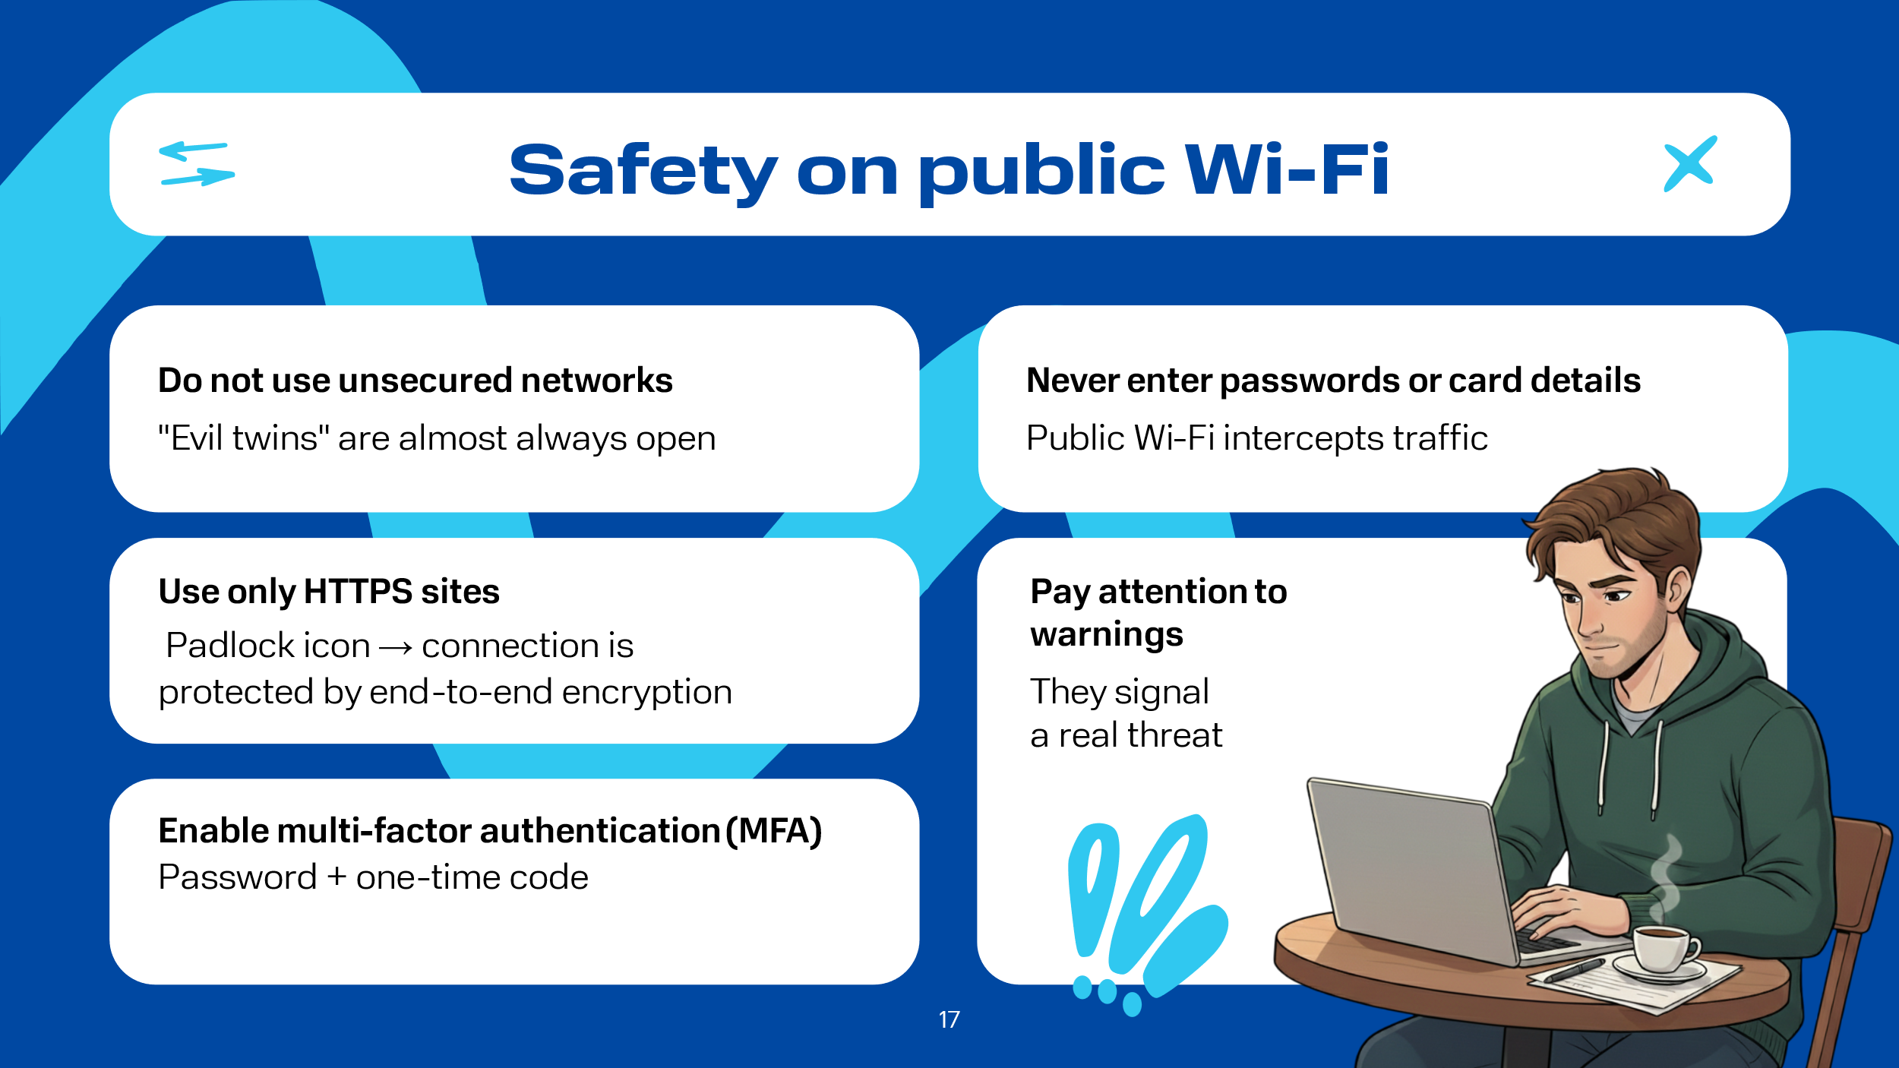 | «Evil twins» are almost always unsecured connections. Attackers rely on the user not knowing about the associated risks and connecting to a fake access point.  Do not ignore the system's security warning about the network. A real threat may lurk behind it. Instead of mindlessly closing the notification, take a second to understand what it is protecting you from. This simple action can prevent data leaks or loss of money.  Forbid yourself from entering logins, passwords, and bank card details on public Wi-Fi networks. This is the golden rule of digital security. Criminals easily intercept such traffic. The only guarantee is a complete refusal to authorize in such conditions.  Be sure to enable multi-factor authentication (MFA) wherever possible. This method protects your account in two or more steps: for example, after a password, you need to enter a one-time code from an SMS or app. This is a simple but extremely effective barrier for attackers. Do not neglect this setting.  Pay attention to the address bar. When using public Wi-Fi, only visit sites with the HTTPS protocol (a padlock icon at the beginning of the address). The letter S means "secure" -- such a connection is protected by end-to-end encryption, which will hide your actions from interception. This is not a guarantee but significantly reduces the risks of compromising your data.

Slide 18  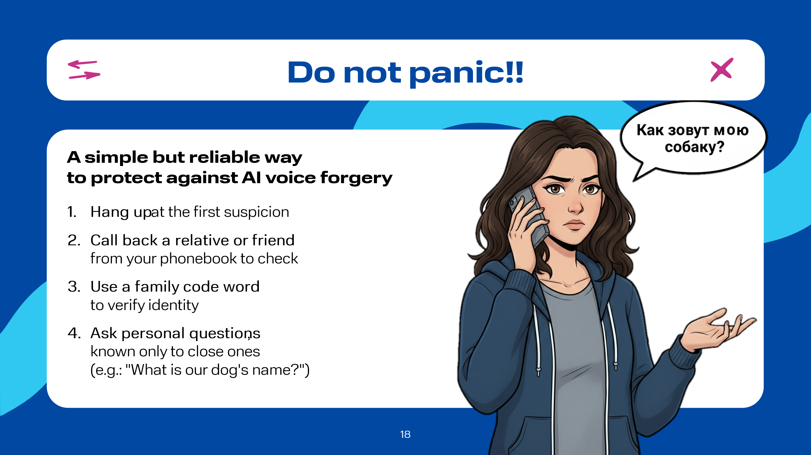 | The most important rule that can be applied to all types of fraud, especially in the context of voice forgery with a request for money or any urgent actions, even if the voice sounds like a "relative," is not to panic. First, you must hang up at the first suspicion; second, you must independently call back your relative or friend at the phone number listed in your phonebook to verify the information and authenticity. Third, given AI's ability to convincingly fake voices, it is recommended within your family to come up with a code word known only to a narrow circle of people, which will immediately help you understand who is on the "other end of the line." This is the simplest and most guaranteed method. Fourth, ask a personal question, the answer to which only you and your loved ones know, for example, "Did we go to Grandpa Dima's village this summer?" or "What's our dog's name?". AI will not provide a direct answer to these questions, as it does not possess our memories.

Slide 19  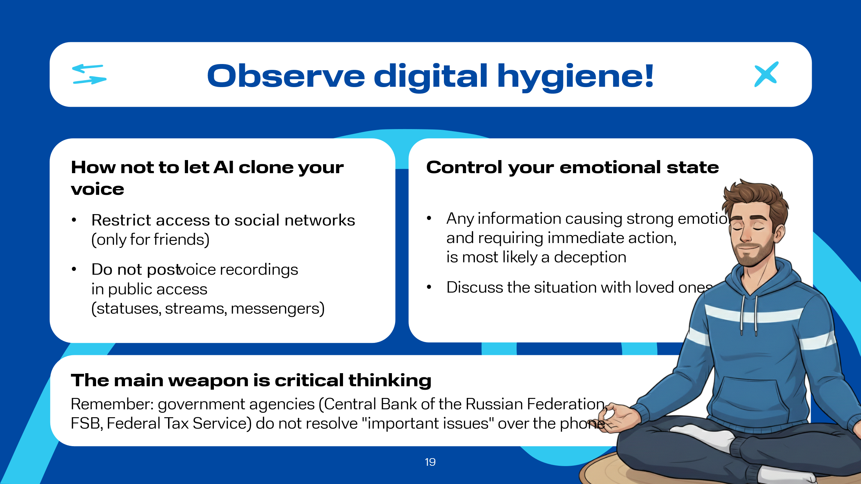 | At the same time, we must not give AI the opportunity to clone our voice, for which we must follow these rules:  restrict access to your social networks (set privacy to friends only);  do not post voice samples publicly (statuses in messengers, social networks, streams).  Control your emotional state!  The basic safety rule is that when you receive information that carries positive or negative emotions, requiring some immediate action from us, we must understand that it is most likely a deception. In this case, you need to stop, invite a colleague, friend, or loved ones to discuss the situation; most likely they will immediately tell you that this is the influence of fraudsters. You must always remember that employees of the Central Bank of the Russian Federation, Rosfinmonitoring, the FSB of Russia, and the Federal Tax Service of Russia will never call, let alone resolve issues of "state importance" over the phone. Considering the active use of AI in gathering information about us, the skillfulness in composing letters, and the fact that such calls are made by specially trained people capable of intimidating and throwing a person into a stupor and unstable emotional state, our primary weapon can only be our vigilance and critical thinking.

Slide 20  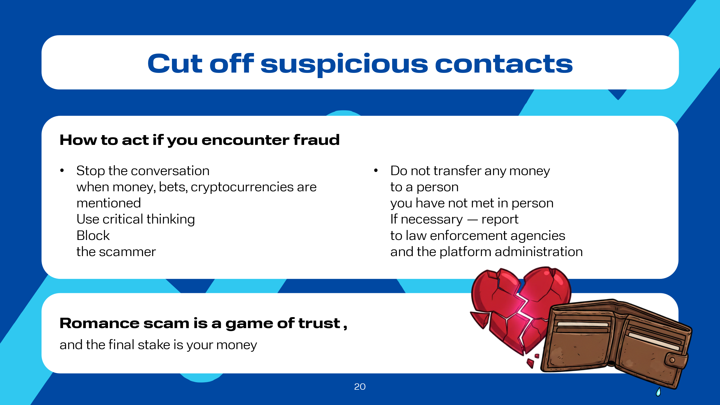 | Online dating is currently a very developed tool for expanding one's social circle, so it would be wrong to completely restrict oneself from such a tool. But if a conversation about money, betting, cryptocurrencies, and similar words suddenly arises in the correspondence, the conversation must be stopped immediately and forever, because with 99% probability it is fraudsters. Romance scam is a long game of trust, where the final stake is your money, and your feelings are the currency. Fraudsters are talented psychologists, and modern technologies like AI give them unprecedented opportunities for mass reach and persuasiveness.  Your main shield is critical thinking about everything you see and hear, as well as the rule: "No money, under any pretext, to a person you have never met in person."  If you or someone you know becomes a victim, it is important to stop communicating; not to blame yourself; block the fraudster; if necessary, report to law enforcement agencies and the platform administration.

Slide 21  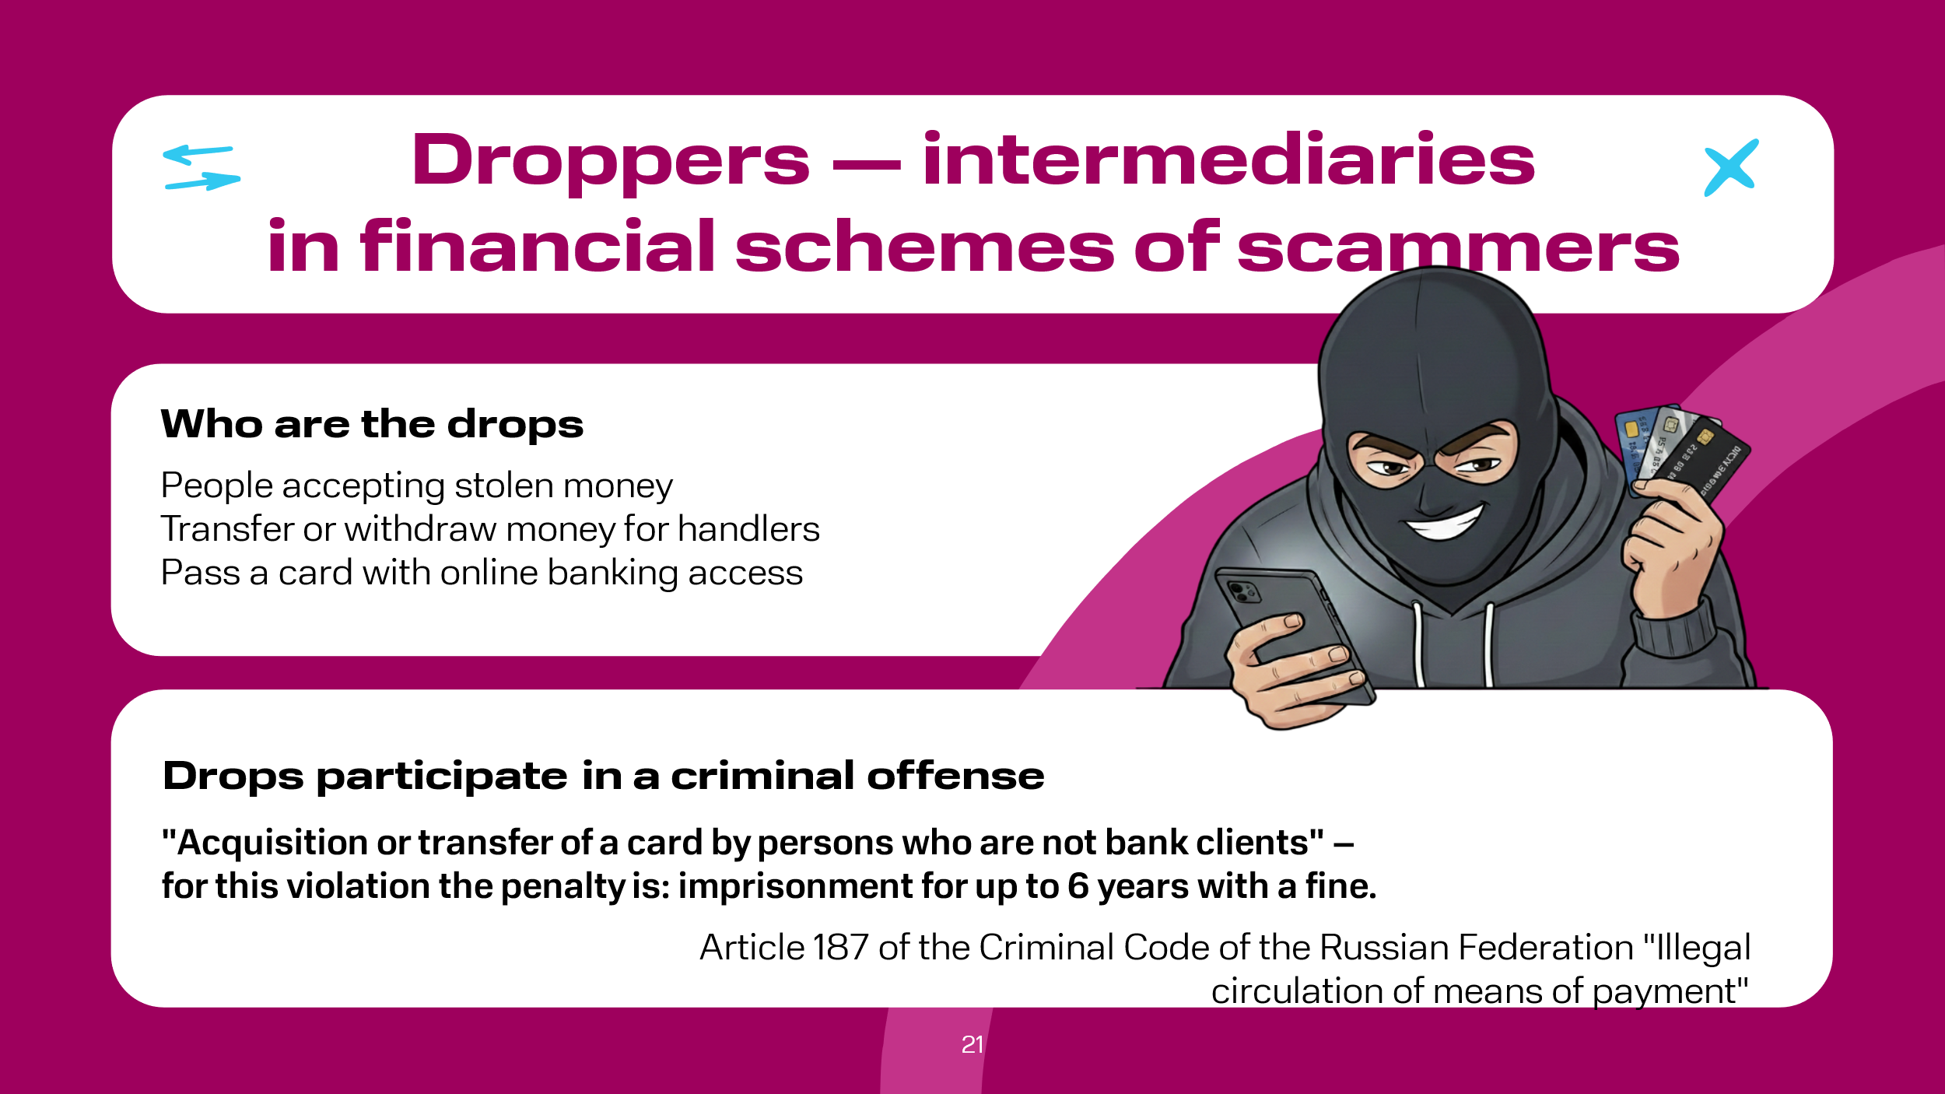 | Technologies do not stand still. At the same time, cybercriminals, as before, face the pressing issue of withdrawing or cashing out stolen funds. For these purposes, fraudsters still typically attract young people, who are commonly called drops.  A drop is an intermediary between the attackers and their victims. A drop performs a fairly simple function: receives stolen money into their account and transfers it to the next participants in the scheme or withdraws cash and hands it over to their supervisors, keeping a small commission. Another option to become a drop is to issue a bank card and hand it over, along with access to online banking, to the attackers.  It is worth noting that one can become a drop accidentally or intentionally. At the same time, young people do not realize that they are, in one way or another, accomplices to a criminal offense. While in 2024 in the Russian Federation there was no separate article for dropper activity, in 2025 the situation changed radically, as Russian President V.V. Putin signed Federal Law No. 176-FZ, which introduces criminal liability for droppers -- front persons used by fraudsters to cash out or transfer stolen funds. This Federal Law amends Article 187 of the Criminal Code of the Russian Federation "Illegal Circulation of Means of Payment," where the punishment depends on the degree of involvement in the scheme. Special attention should be paid to the following clause: "Acquisition or transfer of a card by persons who are not bank clients" -- for this violation, a citizen can be imprisoned for up to six years with a fine. This is important to know, because, as is known, "ignorance of the law does not exempt from responsibility." Moreover, if the violation is committed by a minor, the parents or legal representatives will be responsible.

Slide 22  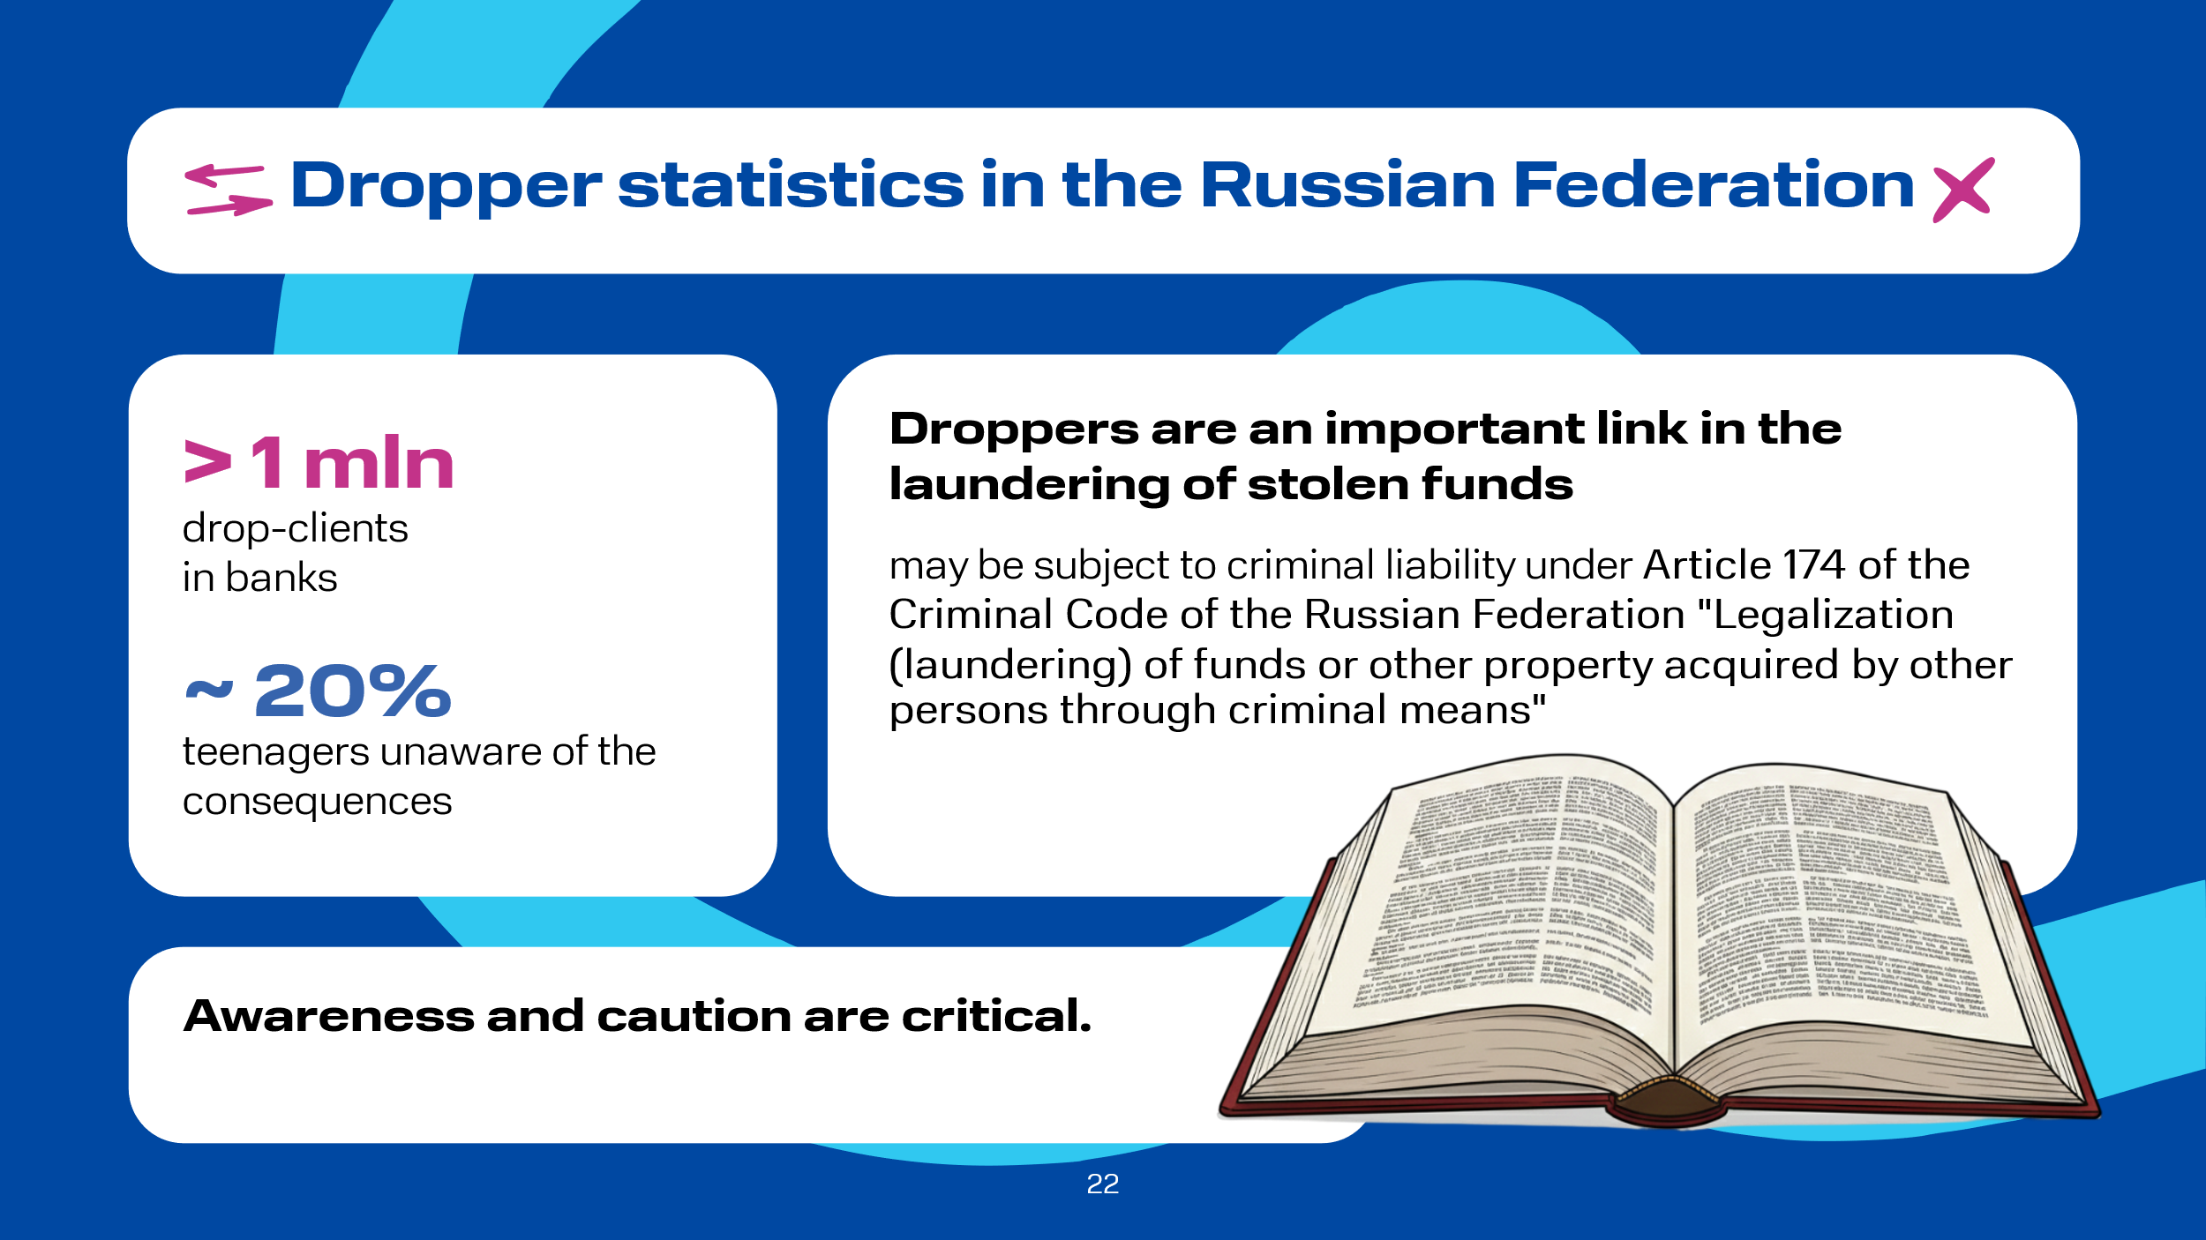 | Unfortunately, the statistics are depressing: according to the Central Bank of the Russian Federation, the number of drop clients in Russian banks exceeded 1 million people . Moreover, the regulator reports that about 20% of citizens involved in dropper schemes are teenagers, obviously not realizing the seriousness of the consequences of their actions .  Droppers are important links in the criminal chain of legalizing illegally obtained funds, and therefore they can also be held criminally liable under Article 174 of the Criminal Code of the Russian Federation "Legalization (laundering) of funds or other property acquired by other persons by criminal means."

Slide 23  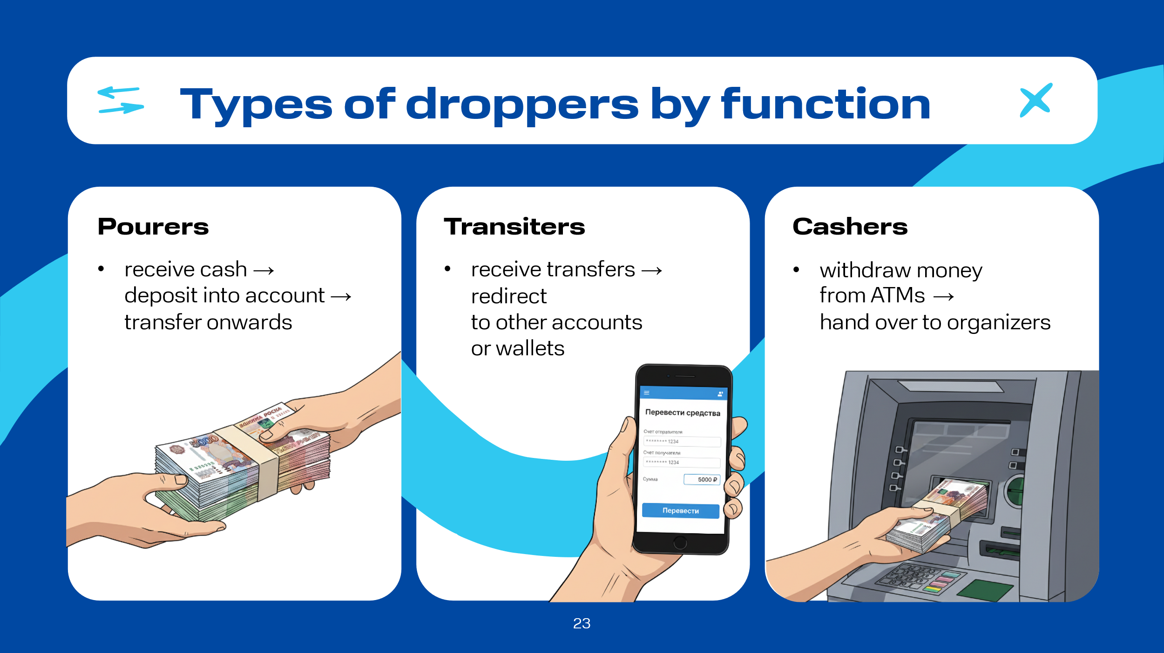 | Droppers are conditionally divided into groups according to the functions they perform:  pourers – receive cash from criminals, deposit it into their personal bank account, and send it on to other scheme participants;  transiters – receive transfers to their bank card and redirect them to third-party accounts or electronic wallets;  cashers – withdraw cash from ATMs and hand it over to the crime organizers.

Slide 24  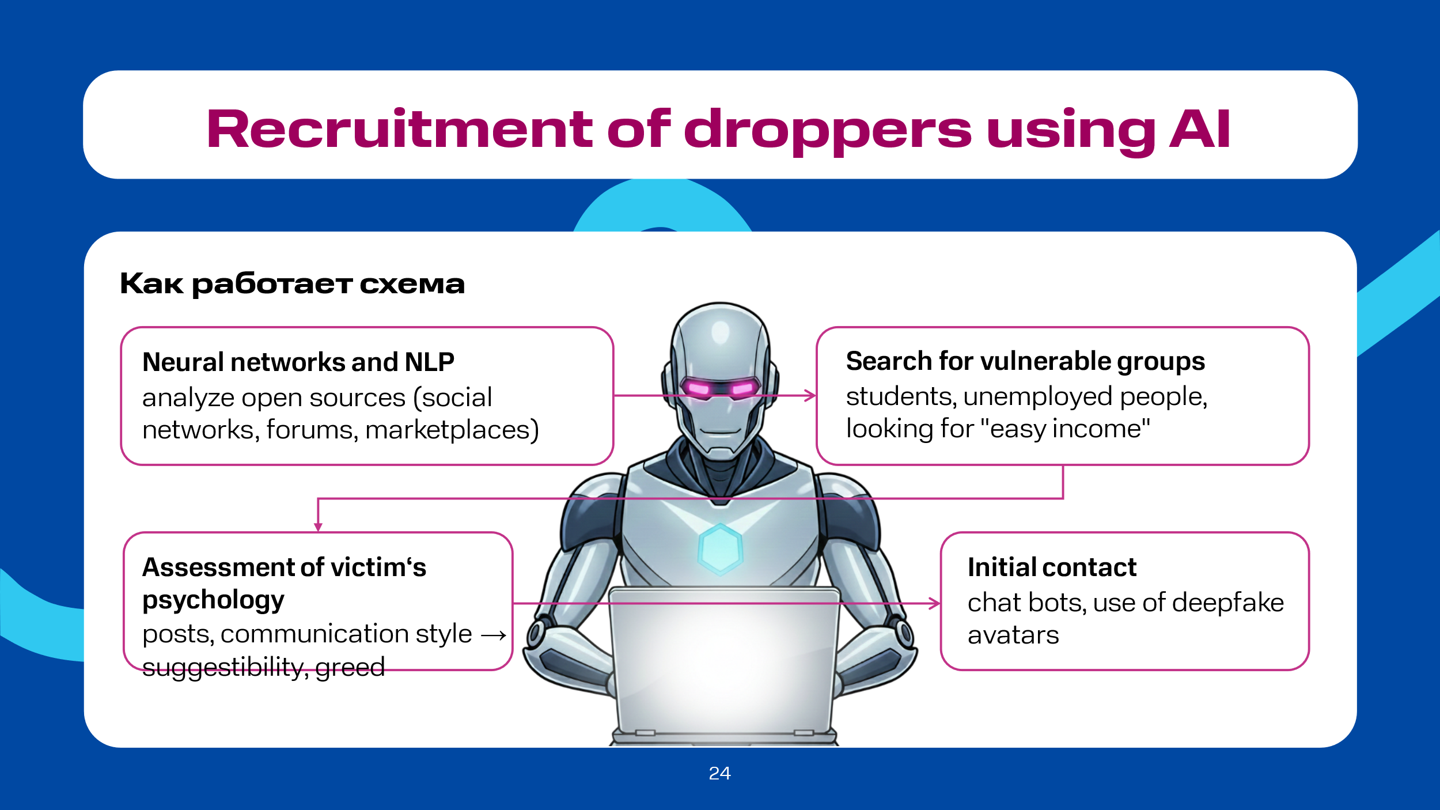 | Special attention should be paid to the recruitment of droppers considering the development of AI algorithms such as neural networks and NLP (Natural Language Processing). It is these that allow attackers to find suitable people for this role faster, as the search becomes smarter and more targeted. The aforementioned AI algorithms scan open sources (social networks, forums, marketplaces) to find vulnerable groups: people with financial difficulties, students, unemployed looking for quick money, or those expressing dissatisfaction with work, and others. AI algorithms can also assess the psychological profile of a potential employee: likes, posts, communication style are analyzed to determine the level of suggestibility, propensity for risk, despair, or greed. This allows for building maximally personalized approaches to finding the right people.  As a rule, the first contact with a potential dropper is not established by people, but by advanced AI chatbots capable of conducting long, natural conversations in different languages. Sometimes deepfake avatars (video recordings or real-time communication) are used to create false trust, for example, a representative of an HR agency or a successful stock speculator. If the dialogue is conducted by a person themselves, AI prompts them on what to answer to a particular question from the applicant, for example, about the legality of the potential job.  Let's analyze some examples of dropper recruitment.

Slide 25  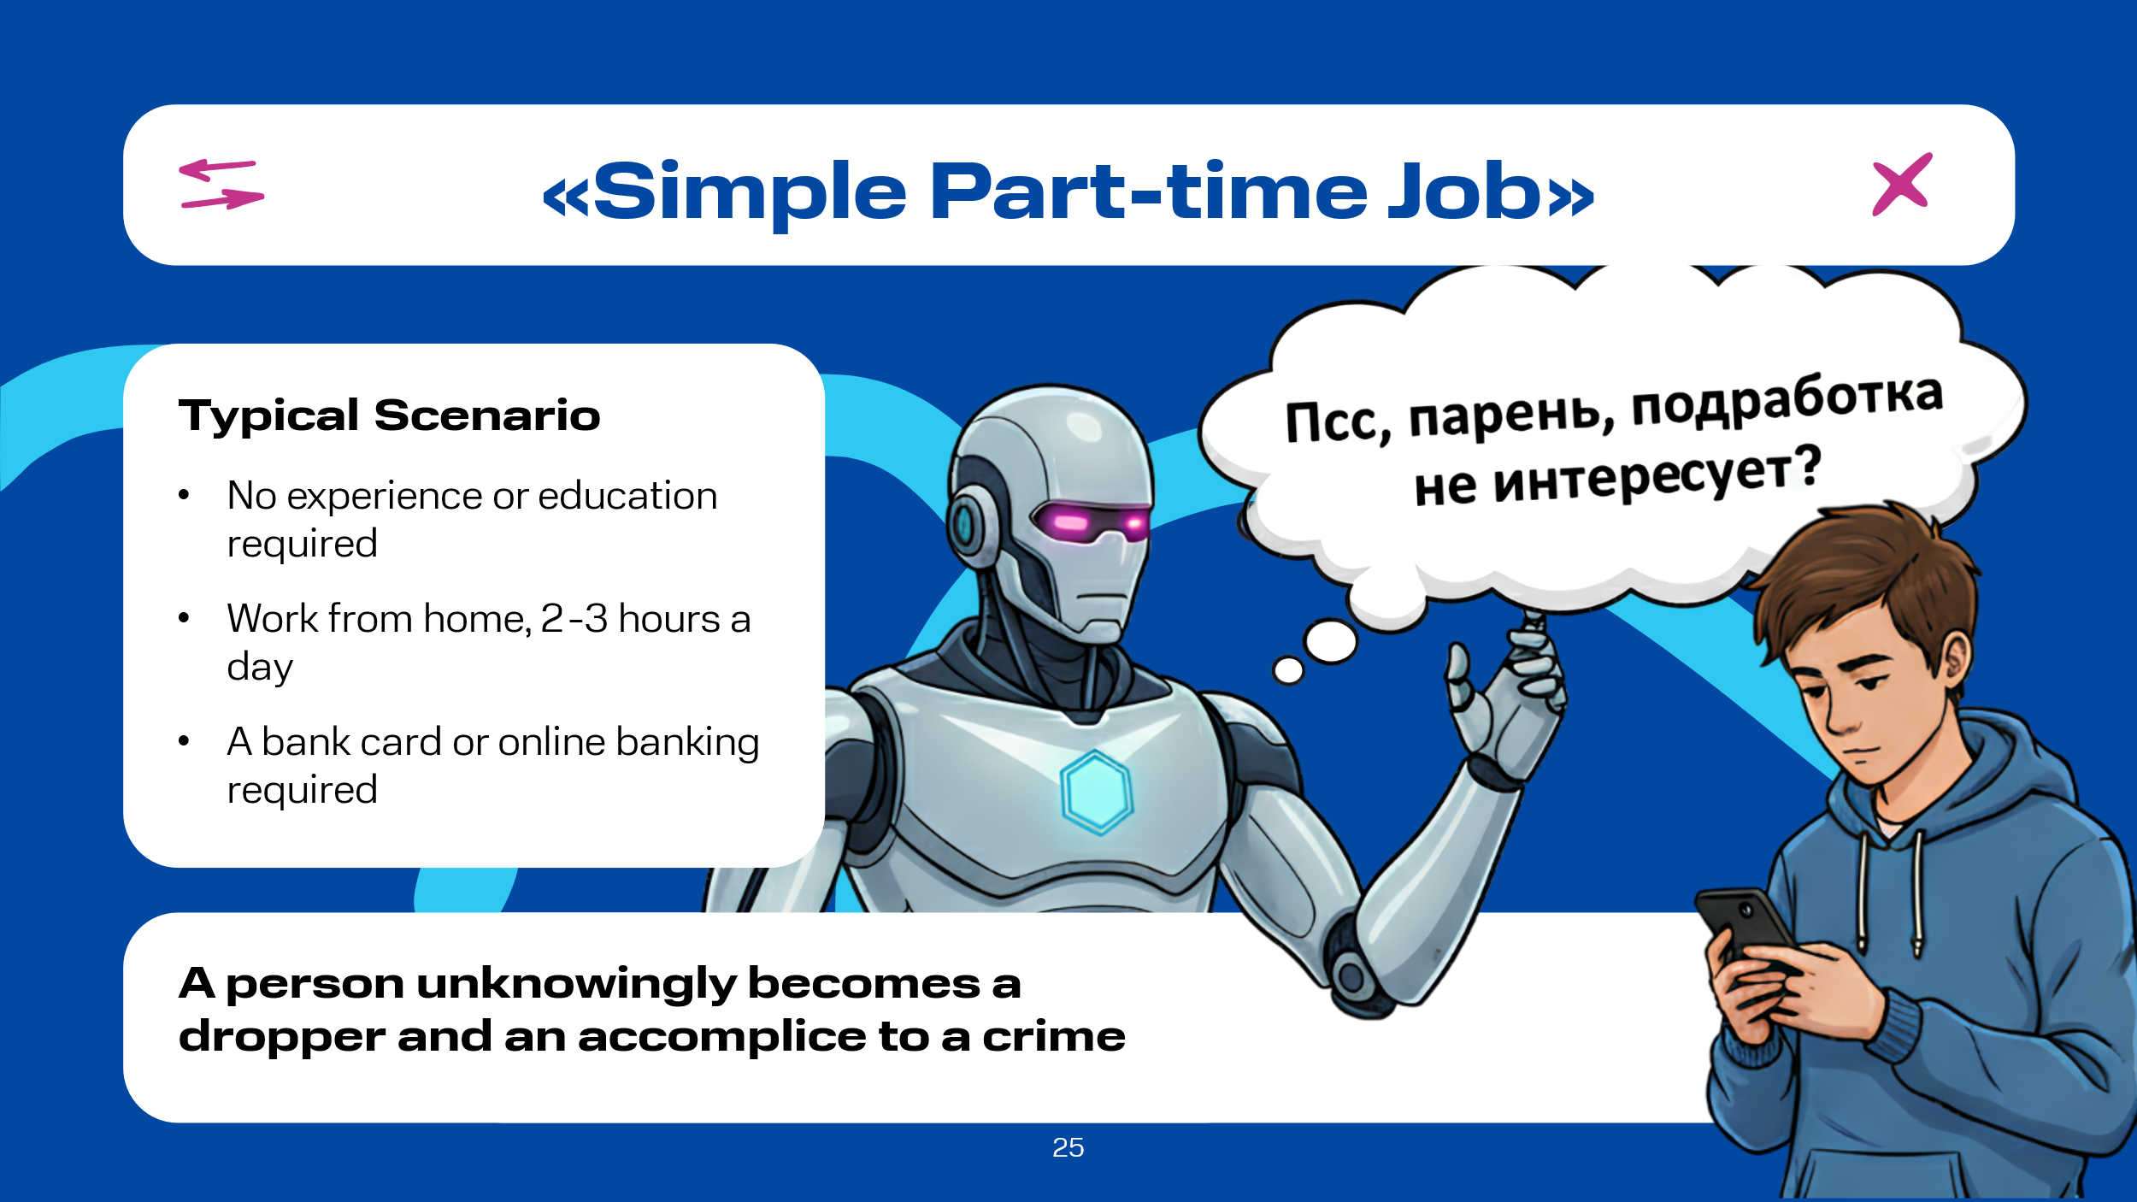 | "Simple Part-Time Job". A high school student decided to earn his first money; on the Internet he saw a tempting job advertisement: education not required; work experience not required; work from home a few hours a day. And finally, the main condition -- having a bank card or access to online banking. It is not hard to guess what this kind of part-time job is about. Using well-practiced legends, fraudsters convince unsuspecting people, most often young people, to make transfers or provide access to their accounts. Thus, victims, not realizing the true nature of what is happening, become accomplices in criminal operations.

Slide 26  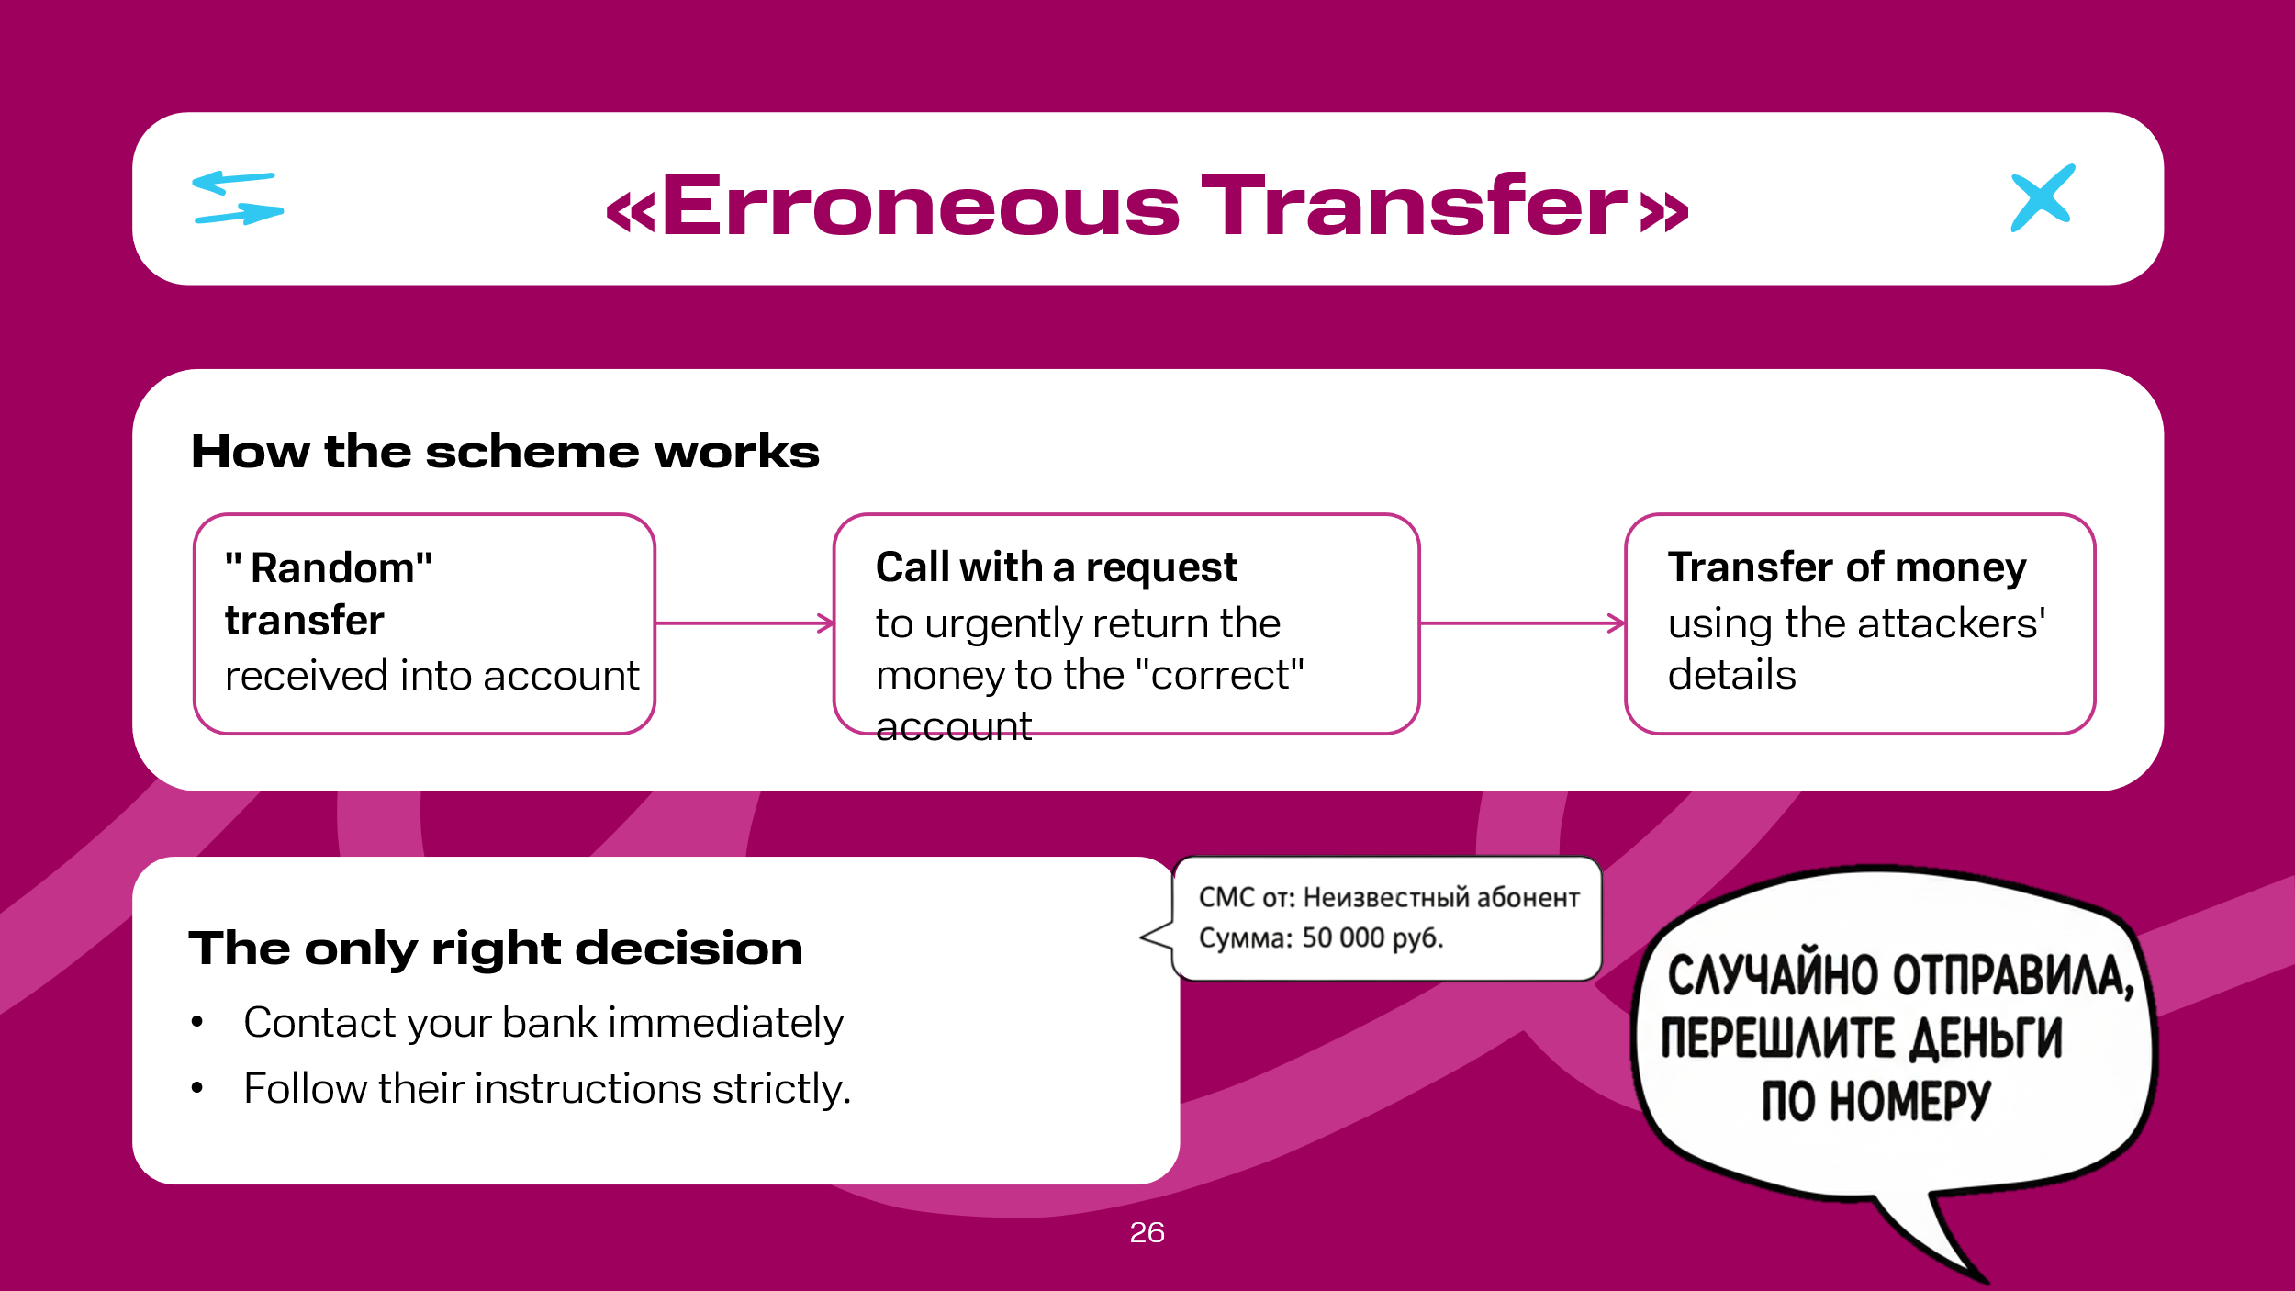 | "Erroneous Transfer". This scheme is still relevant today. This trick is aimed at people's inattention and conscientiousness. You are misled: after a "random" transfer of funds to your account, you receive a call asking for help and to return the money to the "correct" account. It is important to remember: returning the payment to the details specified by the attacker means becoming an accomplice to the crime. The only correct decision is to immediately contact the bank and follow its instructions.

Slide 27  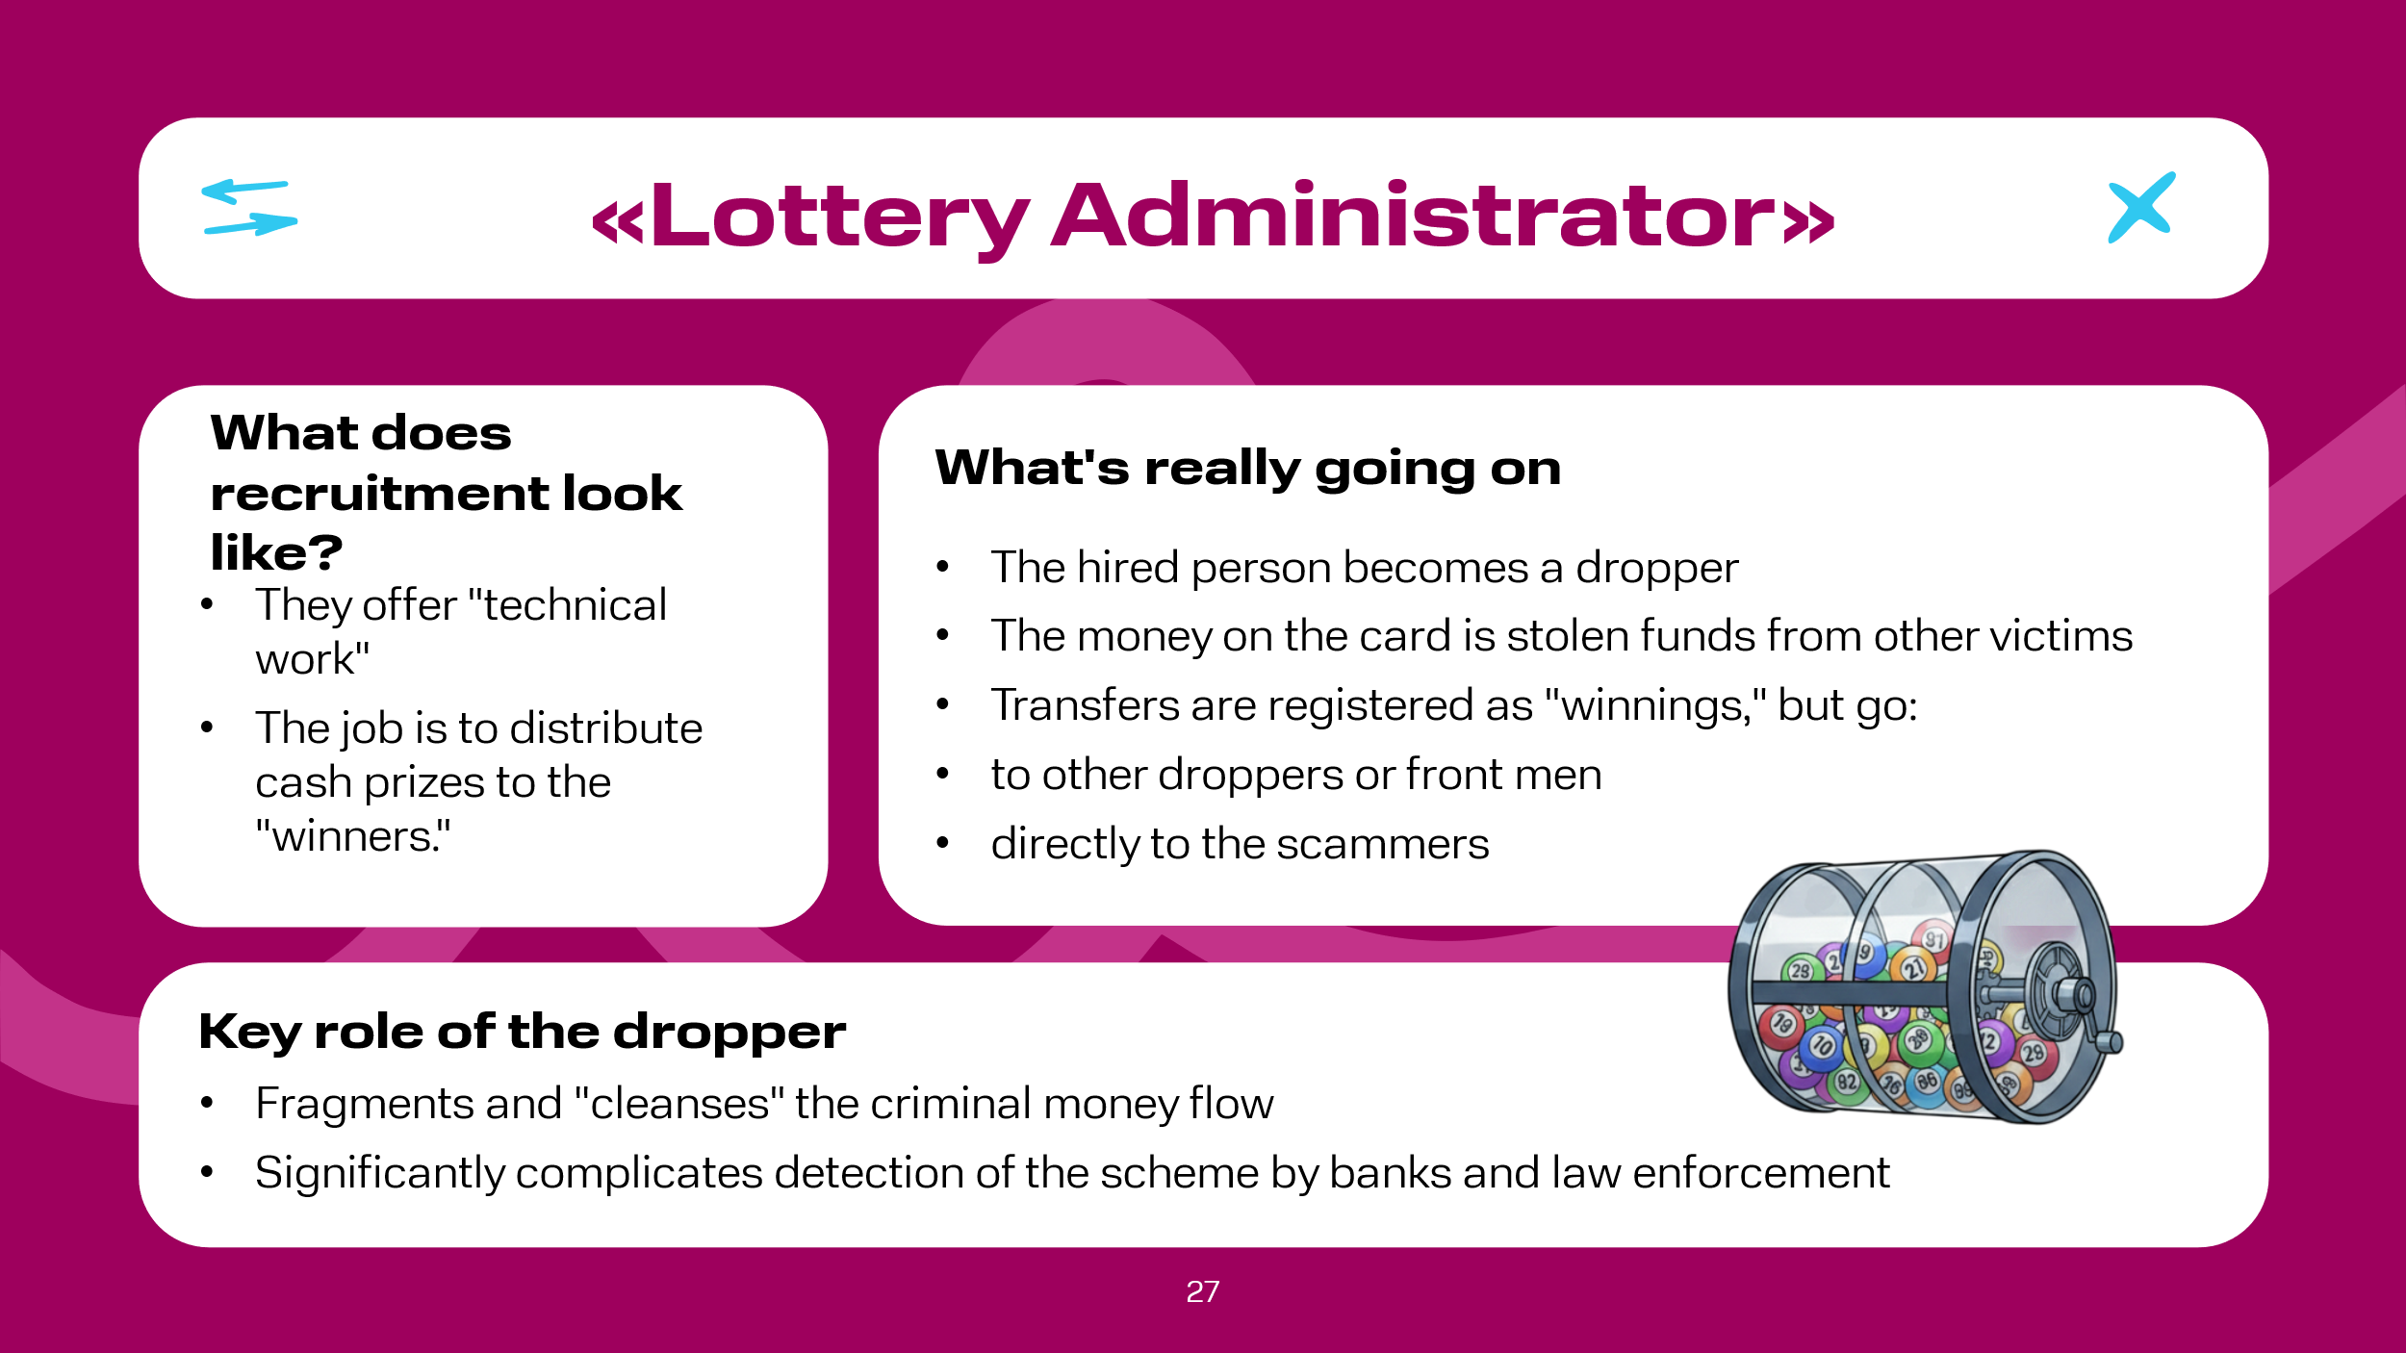 | "Lottery Administrator". The essence of the scheme is very simple: a recruiter, posing as an employer, hires a person for technical work: distributing cash prizes among lottery "winners." In fact, the hired person (dropper) becomes the final link that legitimizes money stolen from other victims, transferring it to criminals under the guise of "winnings." In reality, the money received into the dropper's card are funds collected from dozens of deceived people (for example, through fake online stores, investment schemes, hacks), and the "winners'" cards are accounts of other droppers, front persons, or directly the fraudsters. Thus, the dropper fragments and "cleanses" the criminal flow, making it harder for banks and law enforcement to track.

Slide 28  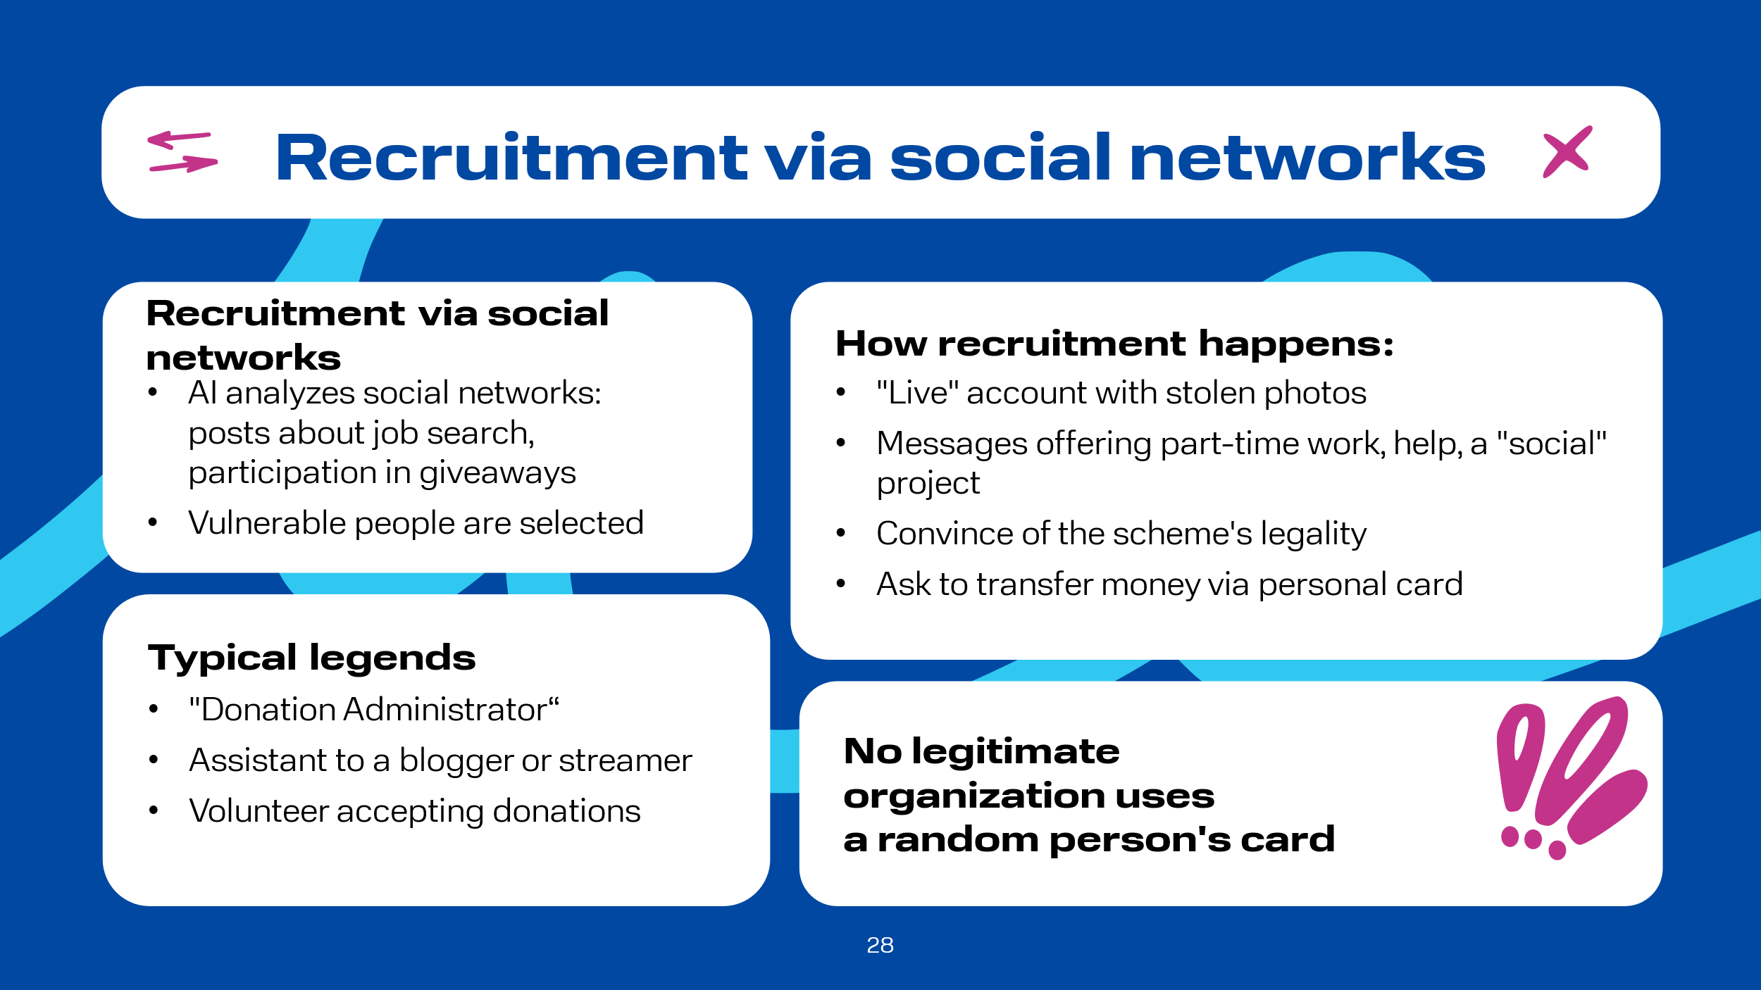 | "Social Networks". As previously reported, AI is actively used for targeted search of suitable people with a relevant psychological profile. An example is searching for a person who complains about lack of money in posts or discussions, looks for work, is in groups like "Part-time Job," "Quick Money," etc., or actively participates in giveaways. When a person is found, they receive a message from an account with a photo of an attractive girl or man (the photos are, of course, stolen), and the account looks alive: it has added friends, uploaded photos, reposts. Messages may contain job offers or, for example, offers of help:  -- "Hi! Saw your comment that you're looking for a part-time job. We are just looking for responsible people for remote payment support in social projects. We don't register officially, but we pay immediately. If interested, I'll tell you more details. Write here..."  -- "Hello! I'm reaching out to you as an active and, judging by your profile, sensible person. We are raising funds for a children's hospice. We need a volunteer for 2-3 hours a day to quickly receive small donations from people via SBP (Fast Payment System) and accumulate them in one account. There is a small reward. It could save lives. Can you help?"  Further, if the person responds to this message, the recruiters involve them further, emphasizing the legality of the work, detailing the legend. The recruiter's message using the "Payment Administrator" legend for a streamer or blogger might look like this: "I'm the producer of a popular streamer. Viewers constantly donate to him, but if everything goes to his card, the bank will block the account due to the huge number of incoming transfers from different people. So we distribute the flow across assistants' cards. You will receive donations, keep 10%, and transfer the rest to our main account. We will provide you with a schedule and screenshots from the stream for verification."  Such examples could go on endlessly. They are diverse and often tempting. However, no legitimate organization will transfer money of unknown origin to the card of a random person from social networks for further manipulation. Such offers are 100% fraud.

Slide 29  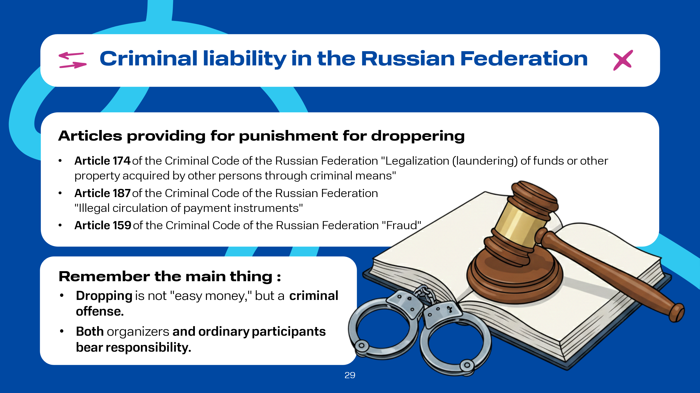 | Remember that for participation in schemes to legalize criminally obtained funds, several articles of the criminal code may be applied simultaneously in the Russian Federation:  Article 174 of the Criminal Code of the Russian Federation "Legalization (laundering) of funds or other property acquired by other persons by criminal means";  Article 159 of the Criminal Code of the Russian Federation "Fraud";  Article 187 of the Criminal Code of the Russian Federation "Illegal Circulation of Means of Payment".  All this suggests that dropper activity is still not "easy money," but a criminally punishable activity, punishable by real prison terms. Moreover, the aforementioned legislative framework allows for bringing both organizers and ordinary executors, who through their actions (or inaction) contributed to the commission of crimes, to justice.  It is important to remember that nothing free and easily accessible exists without a downside, so any job offers supposedly offering easy and quick money should be ignored. Moreover, from the examples given above, we see that a conversation on a social network can start with a casual chat, smoothly transitioning into the need to provide personal data, including bank card details, or even to transfer data necessary for accessing the banking application to third parties.

Slide 30  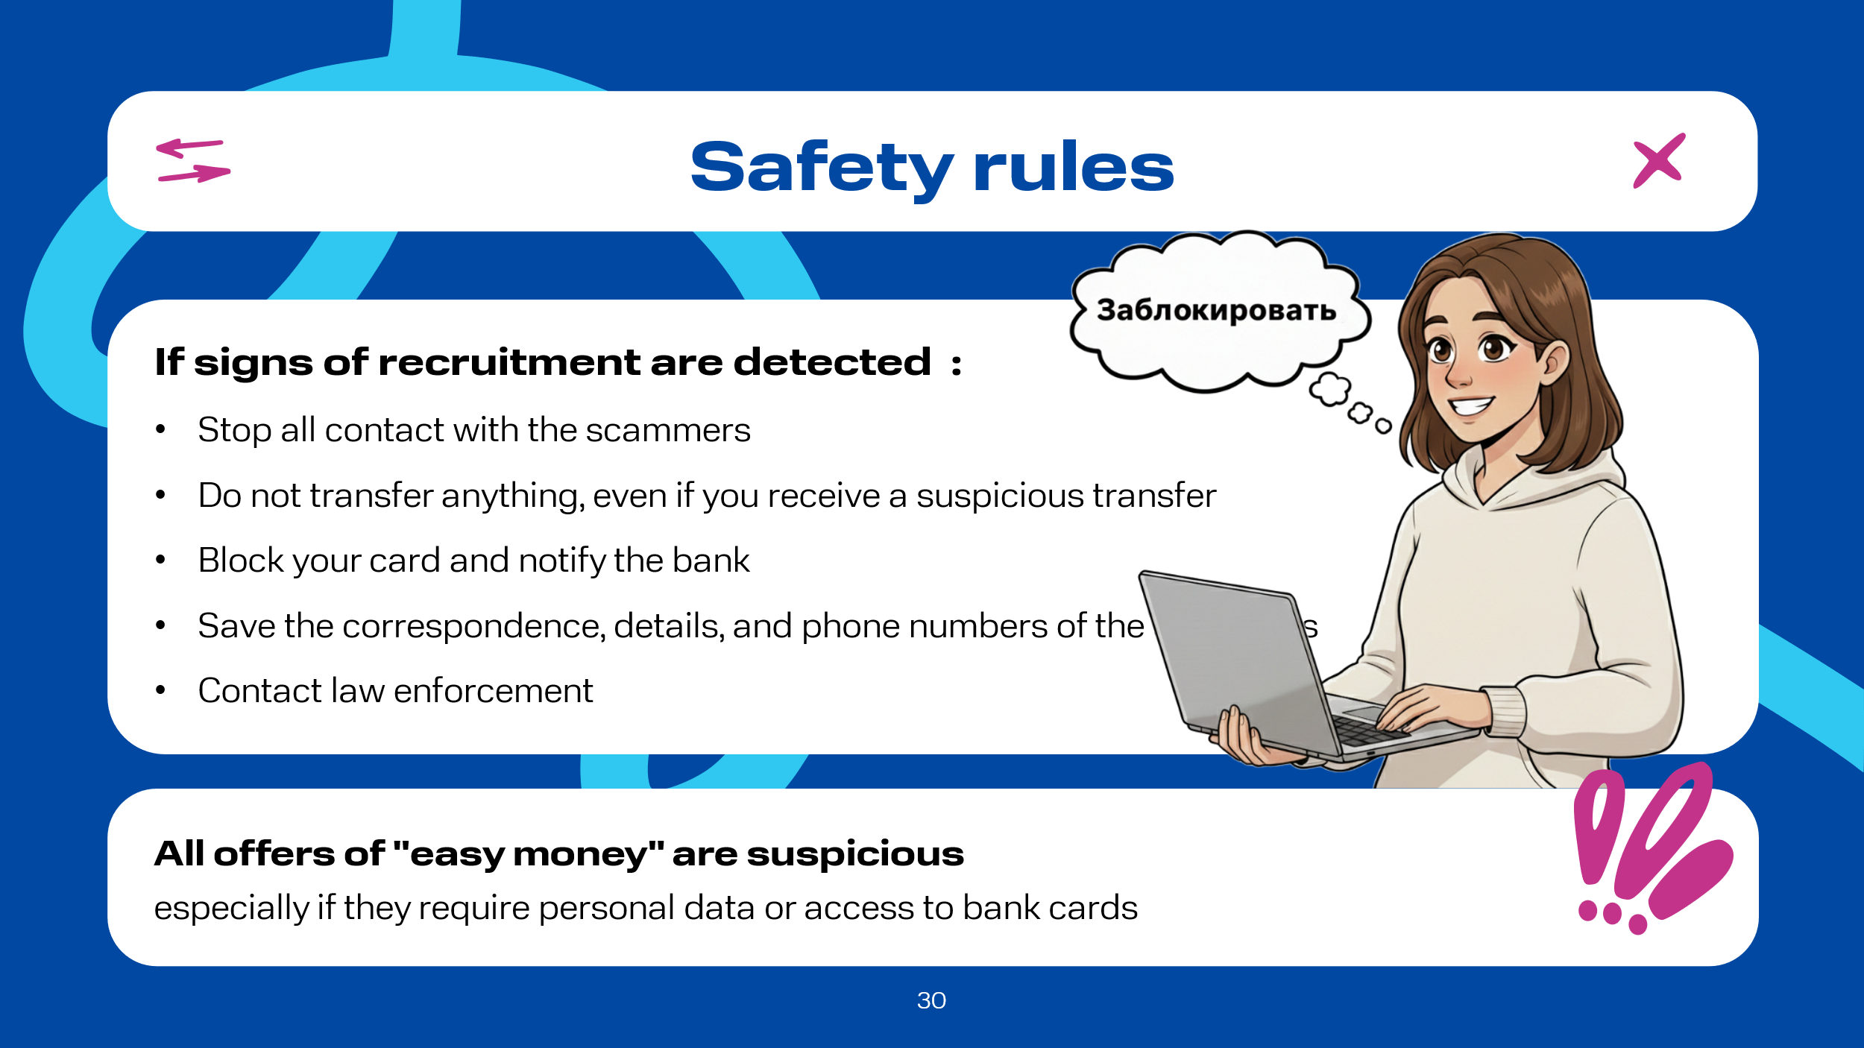 | If it does happen that you detect signs of recruitment, then:  - immediately cease all contact;  - do not transfer anything. If money has already been transferred to you, do not withdraw or transfer it further under any circumstances;  - block the card. If you have already provided details or received suspicious transfers, call the bank and block the card, explaining that suspicious funds have been received into it;  - save the correspondence. Take screenshots of the correspondence, phone numbers, and details. They may be needed by the police;  - contact law enforcement authorities.

Slide 31  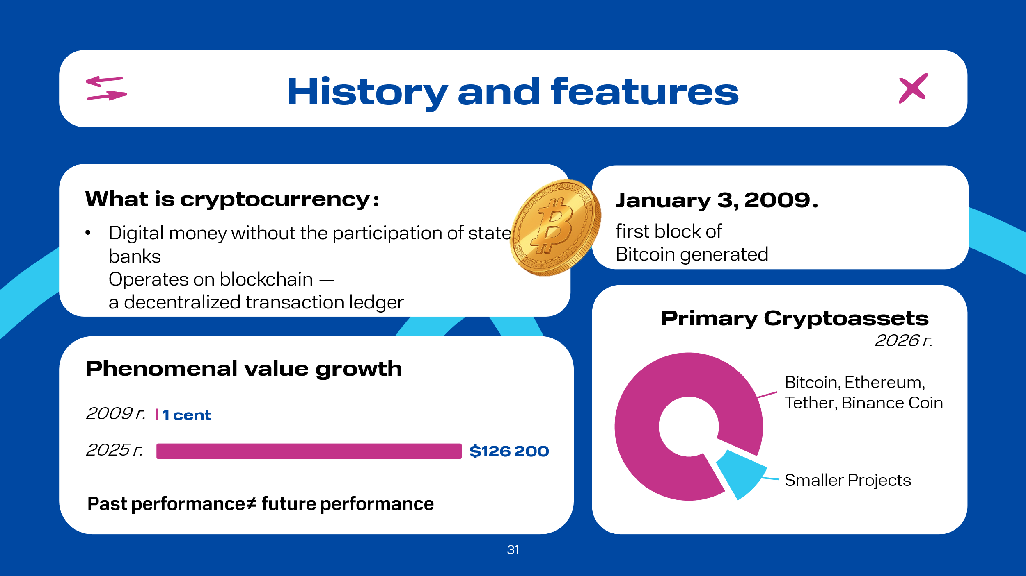 | The history of cryptocurrency begins on January 3, 2009, when the first block of the Bitcoin network was generated, which in January 2026 celebrated its 17th anniversary. Cryptocurrency was once an experiment that, years later, became part of the global financial sector.  Cryptocurrency is a form of digital money. Its issuance and circulation do not depend on government institutions or banks. Cryptocurrency operates on the so-called blockchain base. Since cryptocurrency is decentralized, meaning there is no single control center, information about all operations with these types of currencies is distributed across many computers worldwide. In simple terms, blockchain can be imagined as a table with records of all transactions ever made between all participants, stored on every computer connected to the network. Consequently, to commit fraud, for example, to cancel yesterday's transfer to a friend, one would have to connect to every computer and make changes to that table, or rather completely rewrite it, which is practically impossible since there are a huge number of independent computers in the network.  Creating (issuing) a cryptocurrency today is technically quite simple to organize, so at the beginning of 2026 there are several thousand crypto assets. However, the main crypto assets are still Bitcoin, Ethereum, Tether, Binance Coin, and others, as they occupy 85-90% of the entire market. The remaining 10-15% are projects with very small capitalization, low liquidity, or completely inactive. Many are created for speculation, jokes (memecoins), or specific narrow tasks.  The profitability of Bitcoin due to its price increase has been phenomenal since its inception, as at the beginning of its journey it cost less than 1 US cent, and its historical peak was in October 2025 -- at the level of 126.2 thousand US dollars per bitcoin.  In any investment, including crypto assets, it is important to understand that past profitability does not guarantee future profitability. For example, if we look at its monthly profitability in 2025, we see that for 6 months its value was negative, while it is important to note its volatility: from -2.3% in March to -17.67% in November. As a result, by the end of 2025, the price of bitcoin had fallen by almost 8% relative to the beginning of January, to $87,160.08 at the close of trading on December 29 of the same year. If we look at its historical volatility, it was about 10-30% in the short term; after sharp rises, corrections often occurred and vice versa.  At the same time, in 2026, Bitcoin is one of the most popular assets in the world, seriously considered by financial institutions and even states: from El Salvador and Bhutan to the USA, where a state Bitcoin reserve was formed.

Slide 32  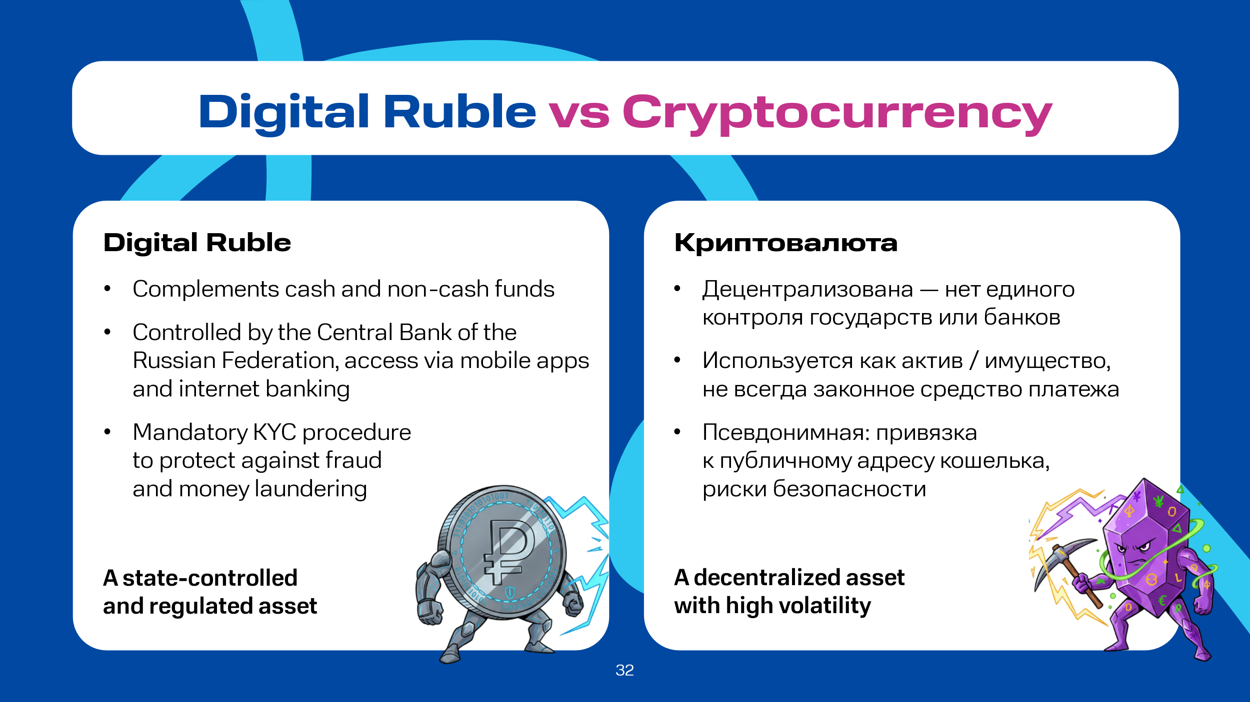 | It is worth noting that besides crypto assets, there are also digital currencies. In various information sources, digital currencies also include crypto assets. We will consider this term using the example of the digital form of the Russian national currency. According to the Central Bank of the Russian Federation, the digital ruble is a digital form of the ruble. Currently, in Russia, there are cash (banknotes and coins in wallets) and non-cash (money in bank accounts) forms of the national currency, and a digital form will appear in addition to them. Digital rubles will be stored in digital ruble accounts (digital wallets) of citizens and organizations. Digital ruble accounts, in turn, will be opened on the Bank of Russia platform, where transactions with digital rubles will be carried out. Access to digital ruble accounts will be possible through familiar remote channels: mobile banking apps and internet banking. Based on this information, the first important difference between the digital ruble and cryptocurrency is immediately noticeable. Cryptocurrency, as previously reported, is decentralized, meaning its circulation and issuance are not controlled by states or banks, which cannot be said about digital currencies, which are centralized, i.e., controlled by states and financial institutions. In addition, cryptocurrency in many countries is not a legal means of payment at the legislative level, but is considered only as an asset, property, or commodity.  Of course, it is important to note such an important aspect as security from the point of view of anonymity, because cryptocurrency can be called pseudonymous -- it is tied to a public wallet address, which certainly attracts attackers. While the digital ruble is regulated by the mandatory KYC (Know Your Customer) procedure, aimed at preventing fraud, money laundering, and financing of illegal activities.

Slide 33  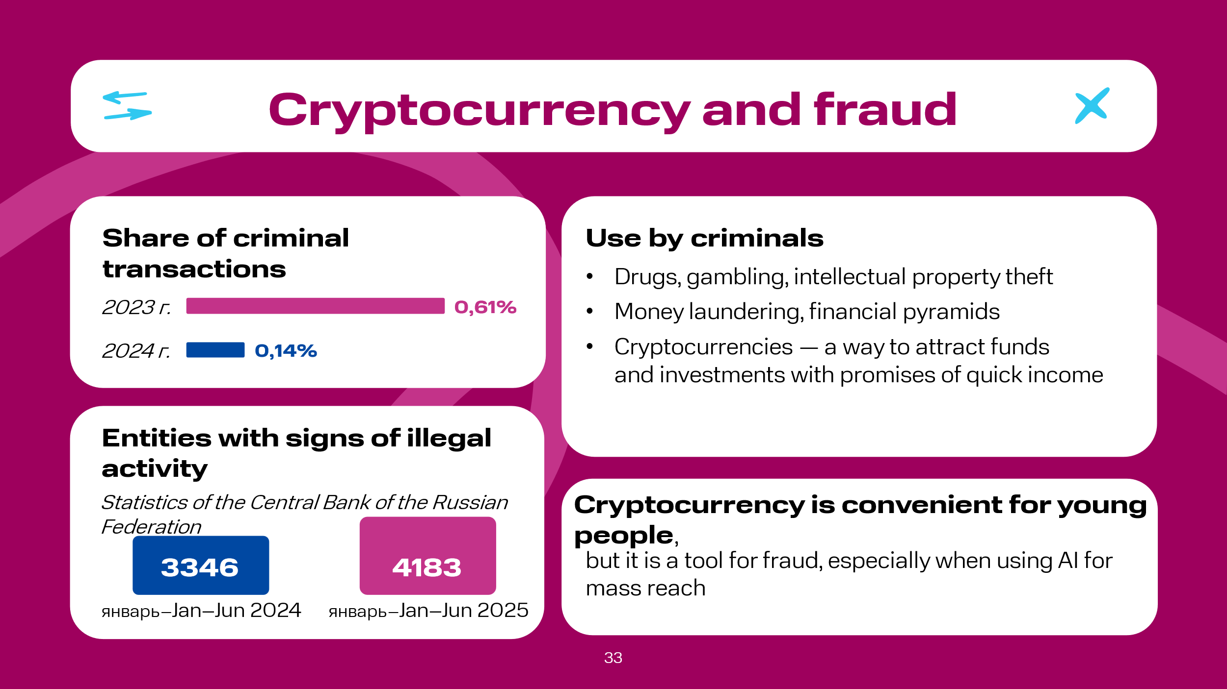 | According to some data, in 2024, transfers to crypto wallets associated with criminal activity amounted to 0.14% of all blockchain transactions, a year earlier this share was 0.61%. At the same time, according to the same source, it is reported that many criminal groups, including transnational organized crime groups, are increasingly using cryptocurrency to commit traditional crimes such as drug trafficking, gambling, intellectual property theft, and money laundering.  Special attention should be paid to financial pyramids in general and those using cryptocurrency in particular. According to the Central Bank of the Russian Federation, in January-June 2025, the Bank of Russia identified 4183 entities (companies, projects, individual entrepreneurs, etc.) with signs of illegal activity, including signs of financial pyramids. This is almost 20% more than in the same period last year, but 24% less compared to the second half of 2024. The share of fraudulent projects using cryptocurrencies both as a way to attract user funds and as an asset, investment in which guarantees quick income, continues to increase. The Central Bank of the Russian Federation also reports that amid declining confidence in investing in foreign securities, fraudsters have become more active in attracting interested audiences, mainly from social networks, to play on the difference in cryptocurrency exchange rates. It is obvious that here too, attackers actively use AI to reach a wider range of potential victims, helping to find suitable people for this role on the Internet (online games, social networks, messenger channels, thematic forums, etc.).  The financial reality of young people differs radically from the experience of their parents. Queues at banks and exchange offices have been replaced by a few icons on a smartphone. For many now, a crypto wallet, this or that social network/messenger, marketplaces -- all this has become a natural environment where investments become routine, and operations with digital assets are no more complicated than installing a game.

Slide 34  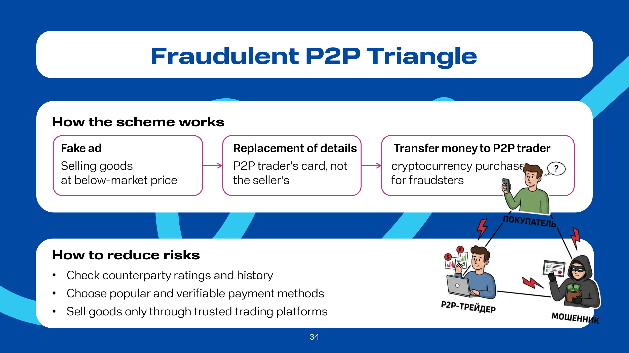 | Let's consider some schemes using crypto assets and AI.  «Fraudulent p2p Triangle». On an online platform for selling used goods, on a social network or messenger, a fraudster posts an advertisement for selling something, for example, a smartphone, at a price usually below market value. The victim agrees to pay for the goods, and here the most important moment occurs: instead of their own details, the fraudster provides the details of a peer-to-peer (p2p) crypto asset trader. At the same time, the fraudster opens an order to buy cryptocurrency from the trader on the exchange, and the buyer, transferring money to the trader, is sure that they are transferring money to the seller for the phone. As a result, the buyer is left without money and the phone, the fraudster receives a cryptocurrency transfer from the trader into their account, and the trader, in turn, unsuspectingly, faces the threat of criminal prosecution if the buyer files a corresponding complaint with the police, since it was to his card that the funds from the victim were received. Of course, for greater reach, attackers actively use AI, as today's technologies allow AI to build an algorithmized dialogue with a potential victim, taking into account the latter's responses. In addition, AI is capable of conducting dialogues with an unlimited number of people simultaneously.  To minimize risks, it is worth using only well-known p2p platforms and monitoring counterparty ratings. It is also advisable to choose deals with popular payment methods where the transaction can be easily confirmed. Sellers of goods, on the other hand, are better off using relevant, trusted, and well-known platforms.

Slide 35  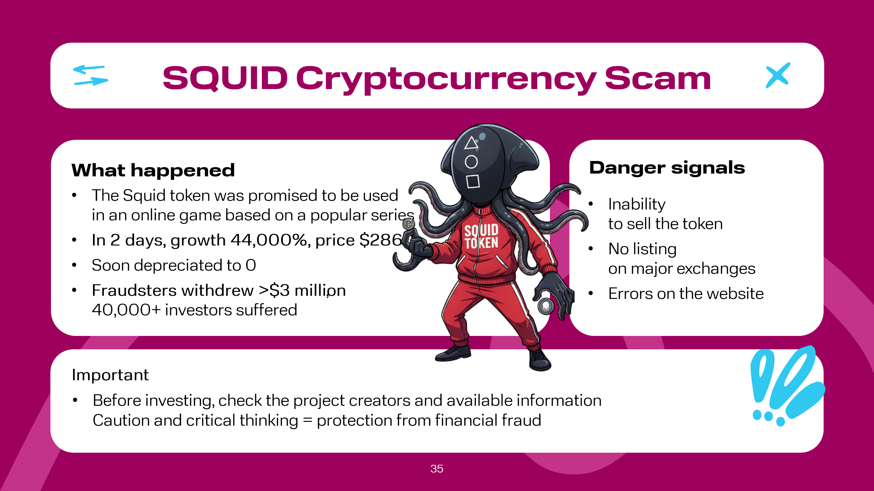 | SQUID Cryptocurrency Scam. The Squid token was created at the end of October. The developers promised it could be used in an online game based on a very popular series. In just two days, the cryptocurrency anomalously grew by as much as 44,000%. Major world media wrote about it. By November 1st, Squid was already worth $2860 per unit, and during the day it sharply depreciated to zero. The developers' website and social media were blocked. In total, the fraudsters withdrew over $3 million; more than 40,000 people invested in the currency. Many things should have alerted crypto investors: the impossibility of selling this token, the absence of listing of the token on major and well-known crypto exchanges, and finally, grammatical and spelling errors on the project's website.  It is important to remember that there can be many such projects, so before deciding whether to participate in them, it is necessary to obtain as much information as possible, including about their creators.

Slide 36  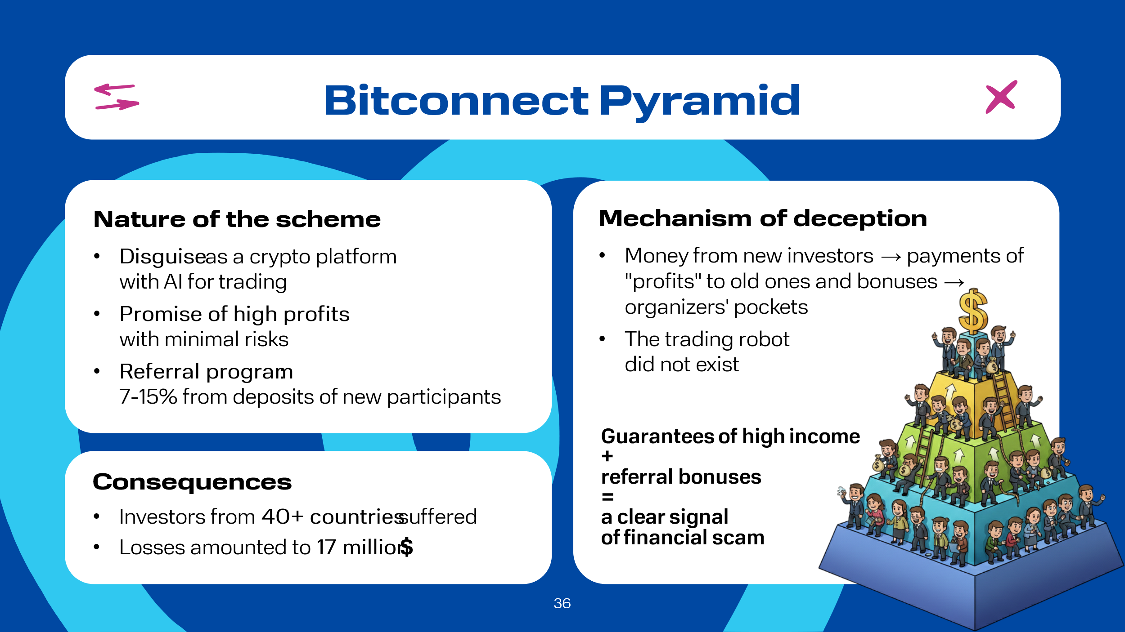 | Bitconnect Financial Pyramid Bitconnect is arguably one of the most infamous and large-scale cryptocurrency scam projects in history, operating from 2016 to 2018. It was a classic financial pyramid with Ponzi scheme elements, cleverly disguised as an innovative crypto platform. Investors were promised astronomical profits with minimal risks, as the cornerstone was supposedly a trading robot based on artificial intelligence. However, the heart of the pyramid was the referral program: by inviting new participants, an investor received 7-15% of their deposits, in addition to the promised 1% per day. Money from new investors went to pay "profits" to old ones, referral bonuses, and into the organizers' pockets. No trading robot ever existed. Victims of this financial pyramid were citizens from more than 40 countries, who suffered losses totaling over $17 million

Slide 37  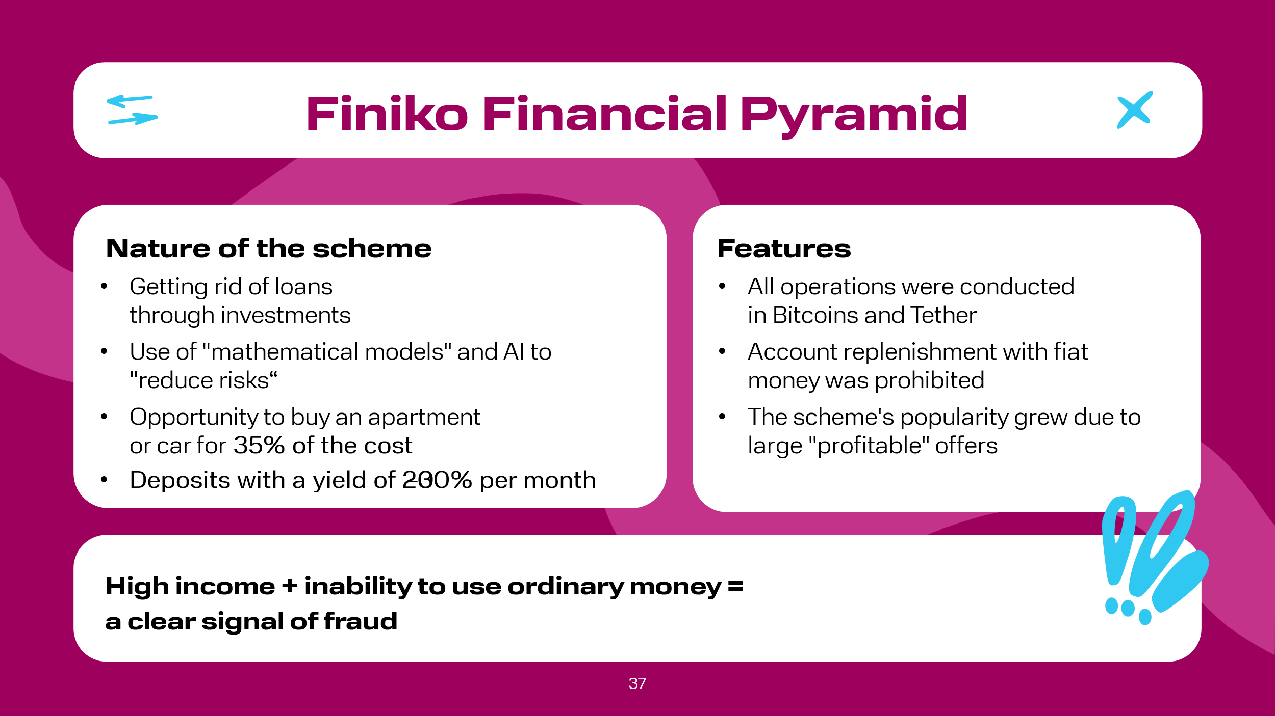 | Finiko Financial Pyramid. The Finiko financial pyramid appeared in the Russian Federation in Kazan back in 2019 and promised to rid citizens of loans. As the creators assured, their key competence was the ability to make money in various stock markets, and in order to reduce absolutely all risks, they developed appropriate mathematical models, i.e., AI was supposed to be used. A distinctive feature of this financial pyramid was the presence of various programs; for example, there were programs with which one could buy an apartment or a car for 35% of their cost, or one could simply open a deposit at 20-30% per month. Probably, this influenced the high popularity of the scheme among citizens. It is worth noting that the account in this program could not be topped up with fiat money, since all operations were carried out in Bitcoins and Tether cryptocurrency. This was an important point in the judicial process, since the organization did not have the right to receive funds in the form we are used to from the population, as this requires an appropriate license from the Central Bank of the Russian Federation, and cryptocurrency is not money

Slide 38  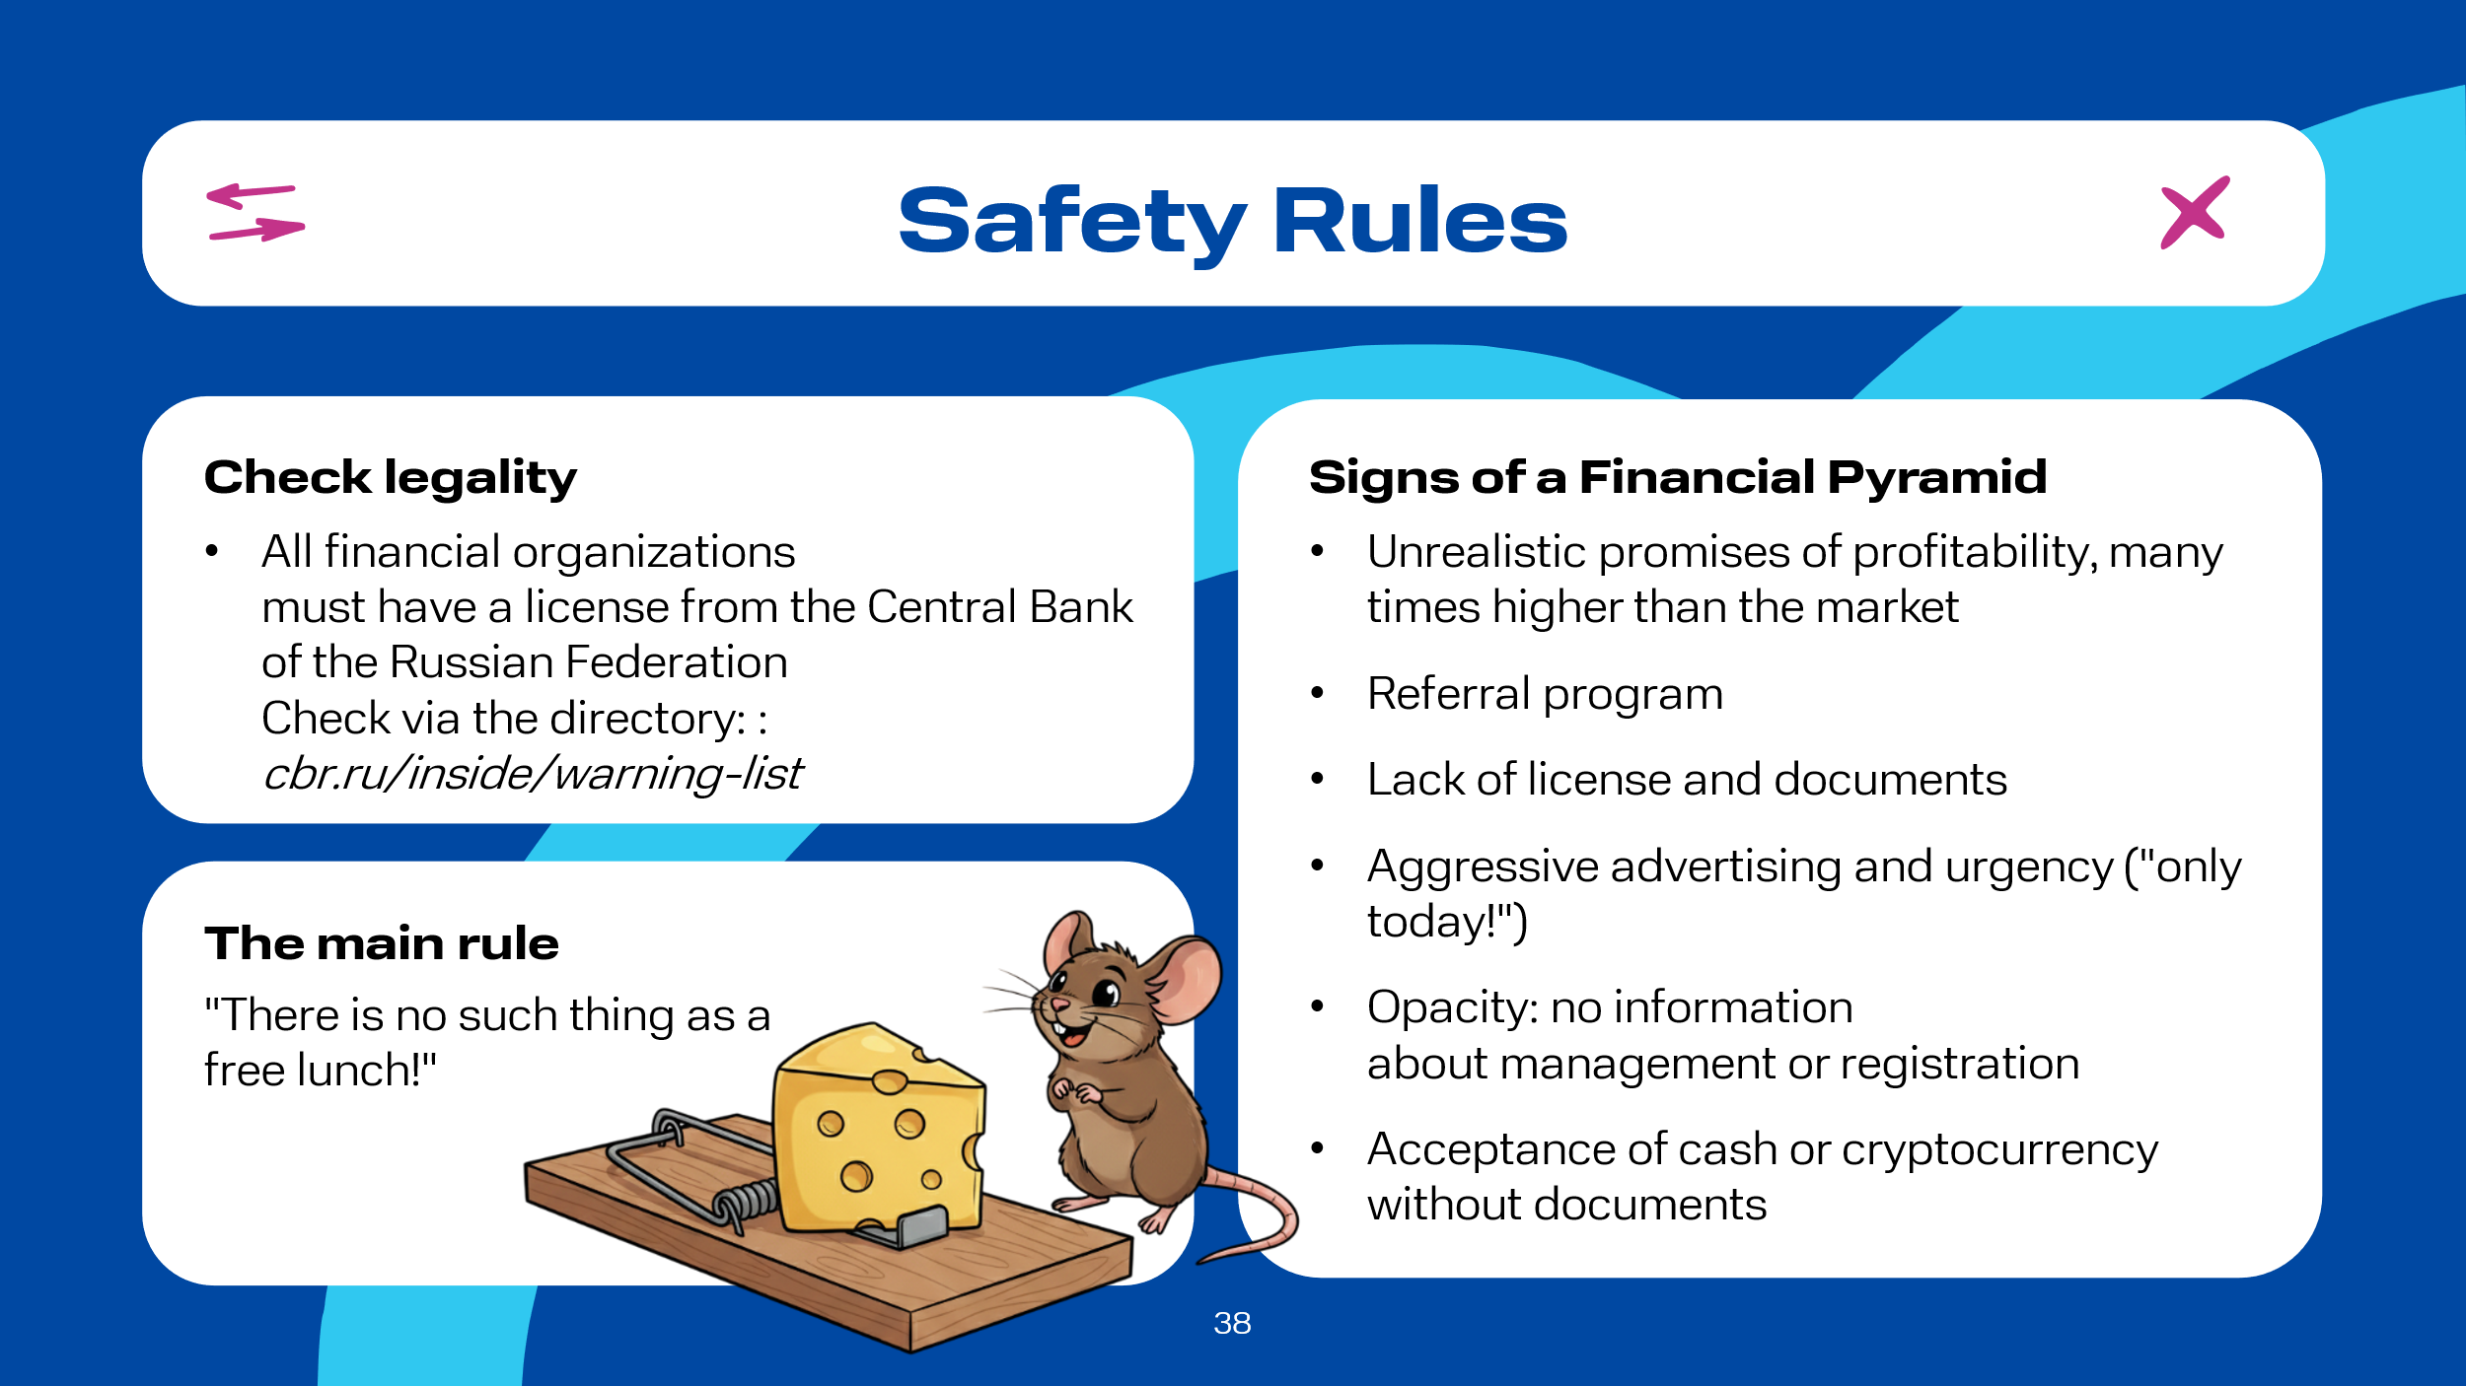 | In the Russian Federation, to warn citizens and reduce the risks of involvement in illegal activities, the Bank of Russia's website daily updates a list of companies with identified signs of illegal activity in the financial market: signs of a "financial pyramid," illegal lender, illegal professional participant in the securities market (including illegal forex dealers), and other illegal participants in the financial market. A market participant must have a license from the Bank of Russia or be included in its register to provide most financial services in the territory of the Russian Federation. This can be checked in the directory of financial organizations. If this condition is not met, then the organization is most likely operating illegally, and consumers may be deceived. Website for verification – https://cbr.ru/inside/warning-list/.  In addition, one should pay attention to the following signs of financial pyramids:  unrealistic promises: high profitability, far outstripping any legal analogues, especially backed by guarantees -- this is the universal and main bait of any pyramid;  attracting new participants or referral program: paying new depositors with money from old ones – a classic sign;  lack of license: no Central Bank of the Russian Federation license for financial activity (insurance, investment);  aggressive advertising: pressure, urgency ("only today!");  opacity: no information about management, registration, lack of official documents;  cash acceptance: refusal of official registration, accepting money in cash or cryptocurrency without documents.  The main thing to always remember: there is no such thing as a free lunch!

Slide 39  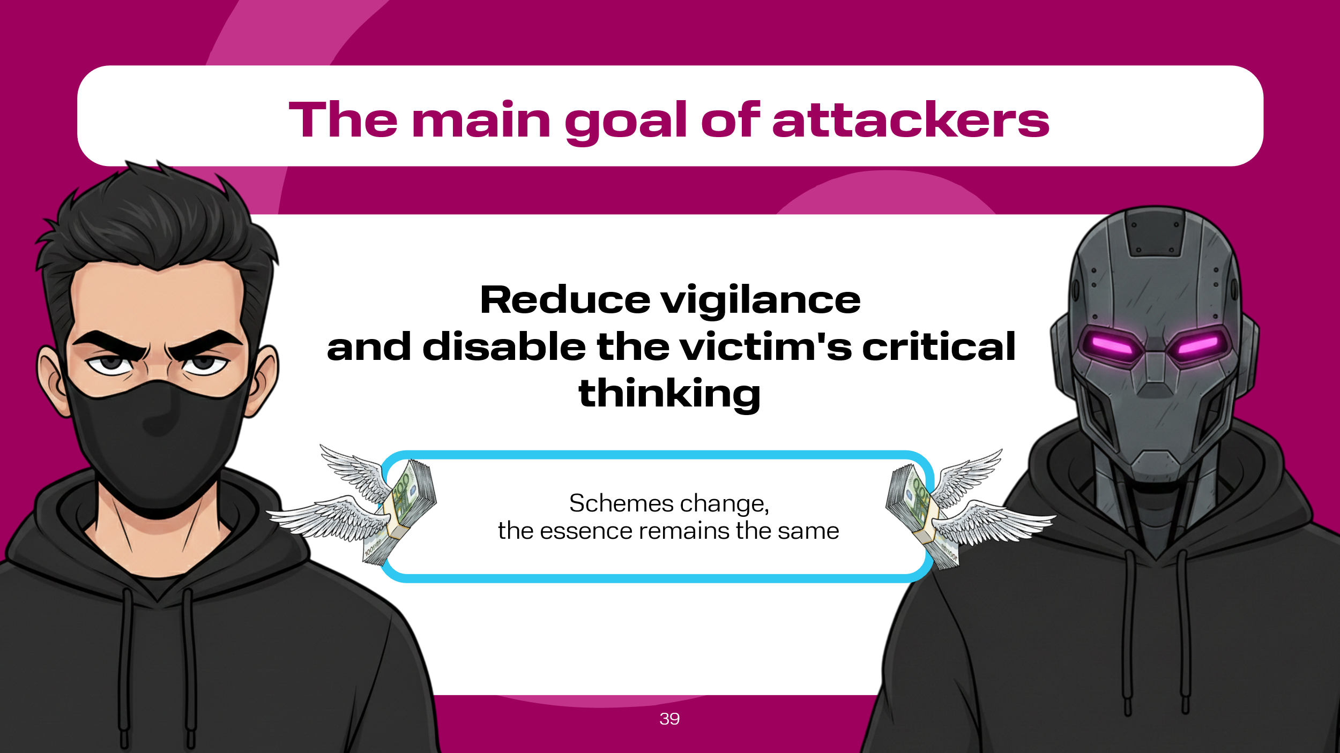 | As we all know, attackers are always looking for information hooks and have adapted very well to this procedure, so it will be important to recall once again the current fraud schemes. It is important to note that the schemes change, but the essence remains the same -- the priority is to reduce the victim's vigilance and disable critical thinking.

Slide 40  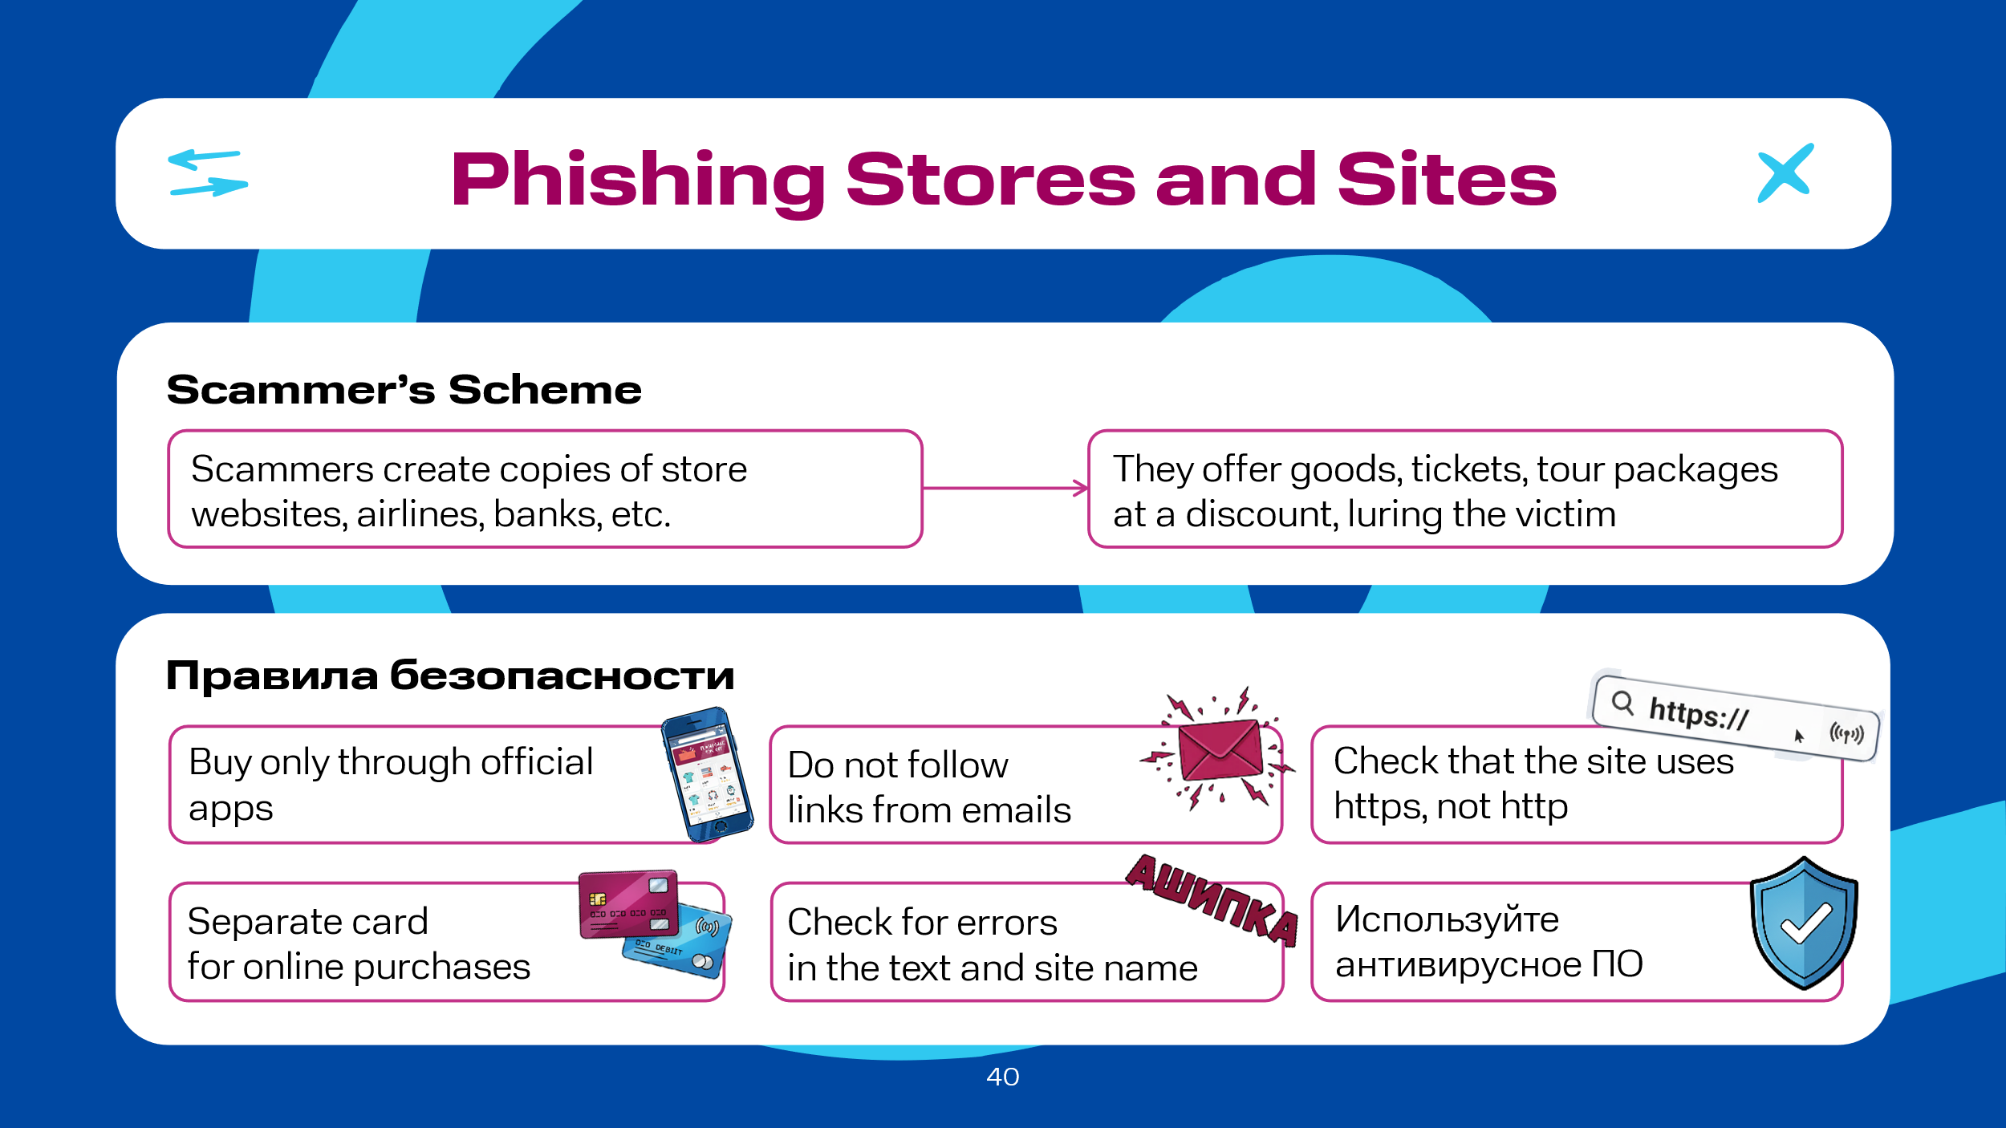 | Let's consider the most popular schemes.  Phishing Online Stores and More. This scheme is relevant all year round, as people always need to buy something: from tour packages, air and railway tickets due to another vacation or long holidays, to banal purchases like food. Those users who make such purchases through previously installed applications from the official stores of a particular smartphone manufacturer are protected, but often, if a citizen decides to find tour packages for their next trip, preferably with a discount, through well-known search engines, then there is a risk of making a purchase on a fake (phishing) site. In this case, there is a risk not only of losing some of your money, but also of compromising your personal data, since such sites require filling in data such as full name, phone number, email address, possibly passport details if, for example, we want to buy a train or plane ticket, and of course, your bank card details. It is worth noting that fraudsters most often fake the sites of airlines, banking and microfinance organizations, and the authorization and payment pages of online stores.  Safety Rules  It is necessary to:  - make purchases through applications installed from the phone manufacturer's official stores;  - when following links provided by a search engine, make sure the site name starts with "https" and not "http";  - ensure there are no grammatical errors on the site; if there are, it's a phishing site;  - check the correctness of the site name in the address bar; phishing sites always contain errors;  - do not go to such sites via links, including those from email;  - do not follow tempting links from advertisements posted on the Internet;  - use antivirus software; additional protection is never superfluous;  - use a separate card for online purchases, topping it up with the necessary amount before making a purchase.

Slide 41  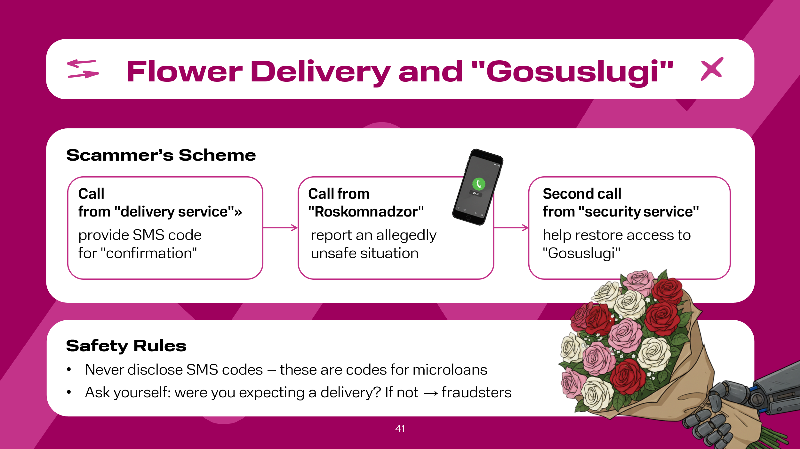 | Flower Delivery for Stealing "Gosuslugi" (Government Services Account). Fraudsters are constantly finding new information hooks to steal money, but they also refine existing schemes. This scheme has not been ignored either. Now fraudsters have developed a new two-stage deception scheme[^21]. First, the victim receives a call from a flower delivery service and is asked to provide an SMS code allegedly to verify the order with the courier. After that, the call is interrupted by a message from Roskomnadzor about insecurity.  Then the attackers call again, this time as "service employees," offering to help regain access to "Gosuslugi" and cancel a microloan application. At this time, four-digit codes from microfinance organizations arrive on the phone, which the fraudsters try to extract to log into "Gosuslugi," the hacking of which can lead to the loss of comprehensive information about the Russian citizen  Safety Rules  The most important rule applicable to all types of fraud attempts: no one will ever ask for an SMS code; it should be treated like a password.  Ask yourself the obvious question: were you expecting a flower delivery? If not, it's most likely fraudsters

Slide 42  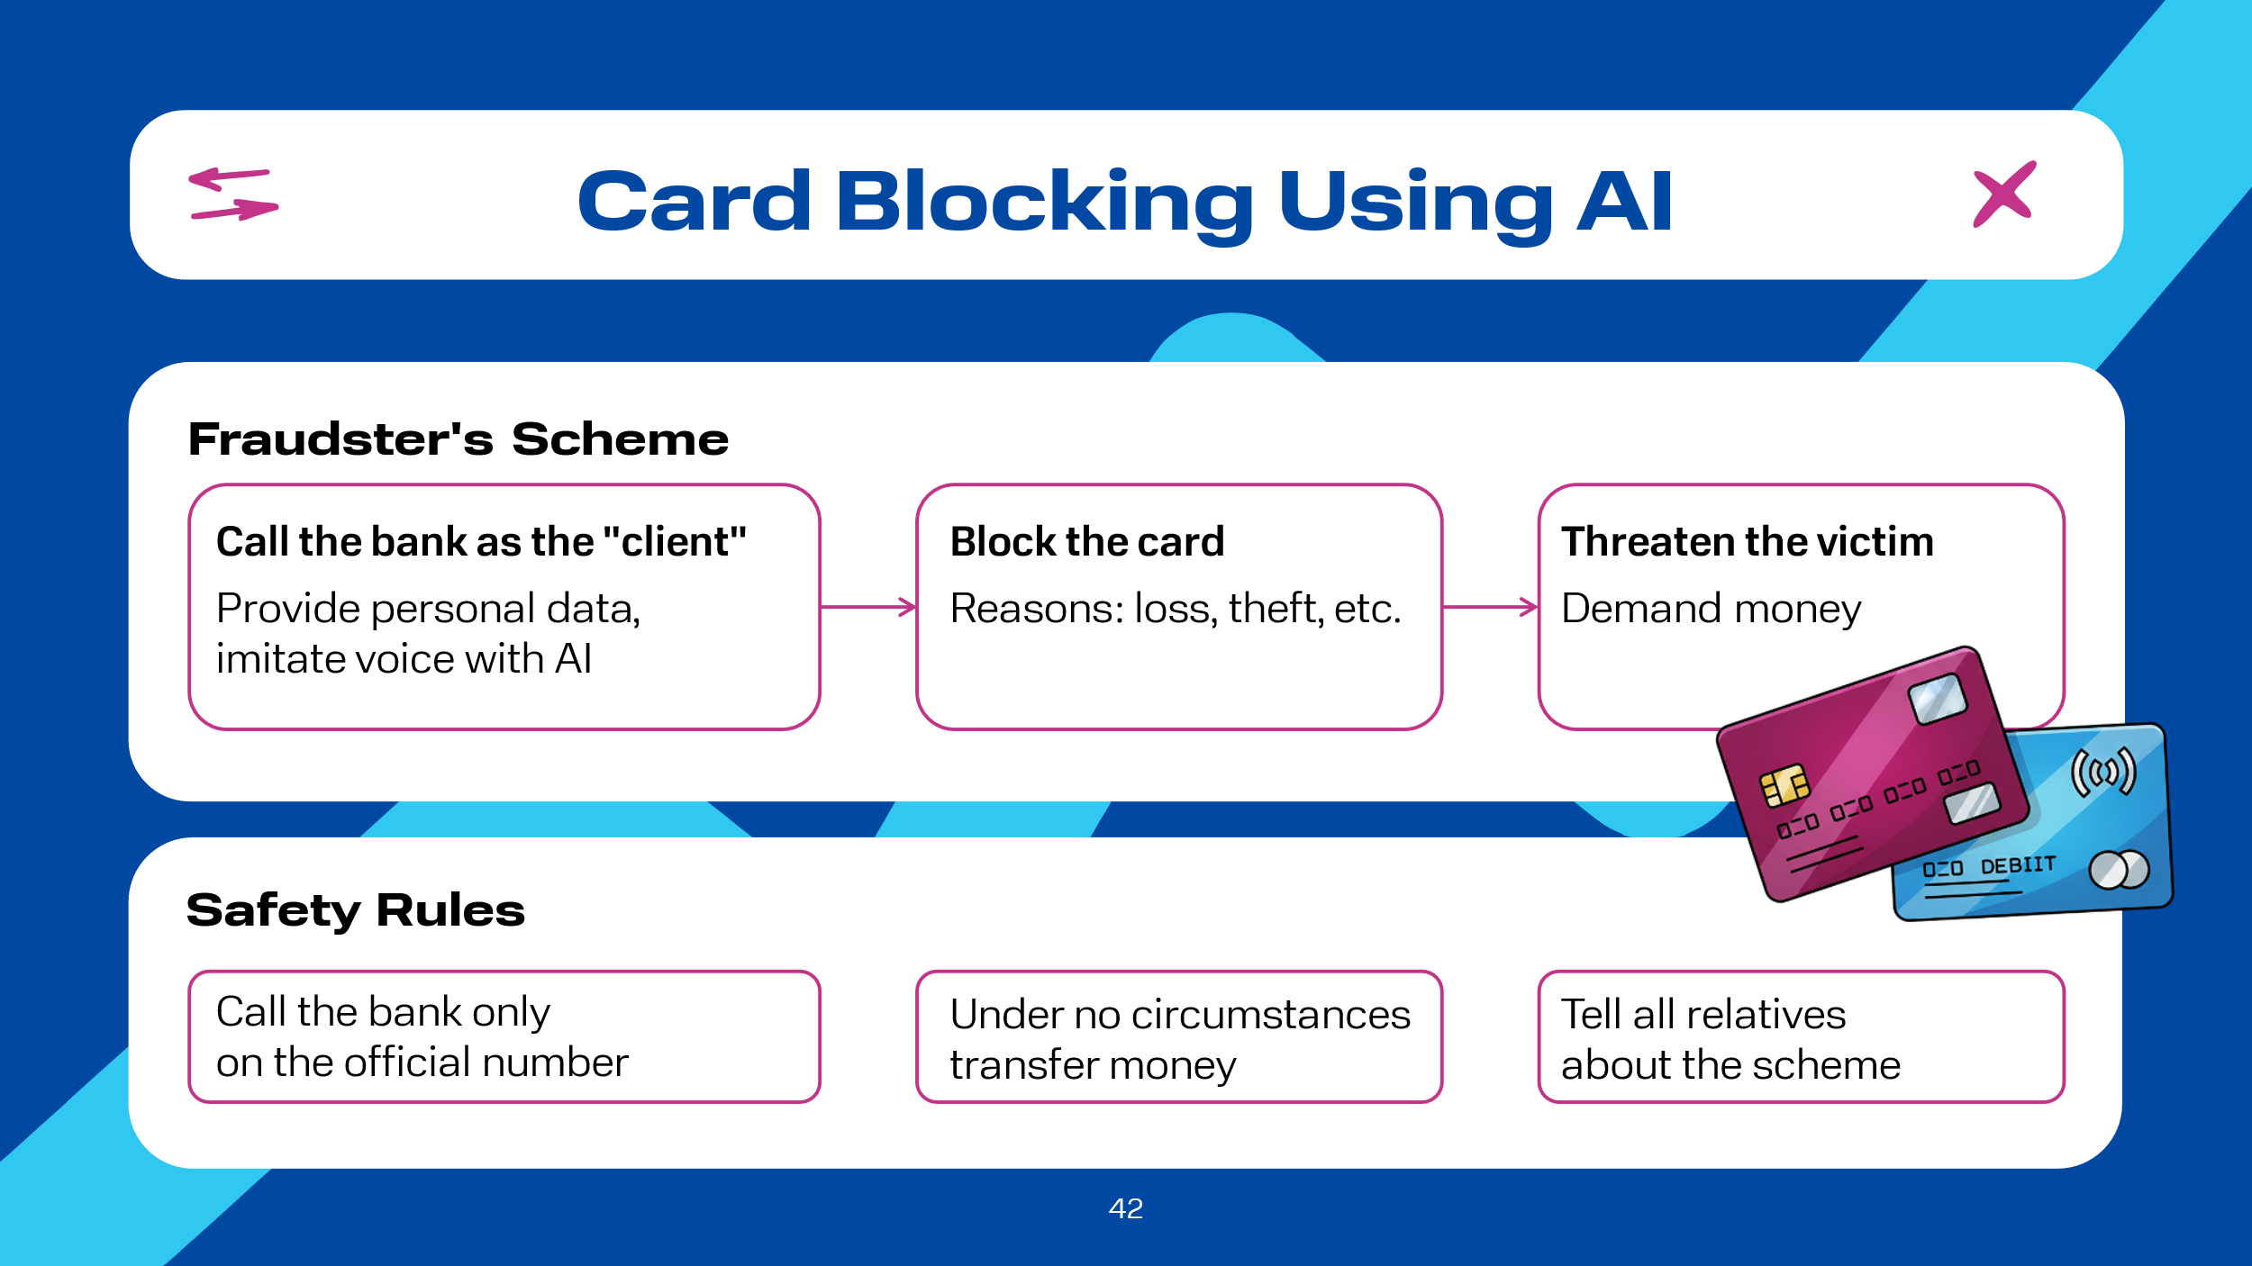 | Bank Card Blocking Using AI. Fraudsters have learned to block bank cards remotely, because to do this, it's enough to call the bank's call center and provide your full name and date of birth. And to make the deception even more convincing, fraudsters imitate the client's voice using AI neural networks. The reason for blocking can be anything, for example, loss or theft of the card.  After blocking the card, fraudsters contact the victim and, threatening violence or blocking the cards of relatives and acquaintances, extort money. They already demonstrate the "result" -- your indeed blocked cards.  Safety Rules  It is necessary to:  - always treat the situation critically, call back to verify information about the card blocking to the bank's call center (using the phone number on the back of the card);  - under no circumstances transfer money to anyone's account, but go to a bank branch;  - inform relatives, especially the elderly, about this scheme

Slide 43  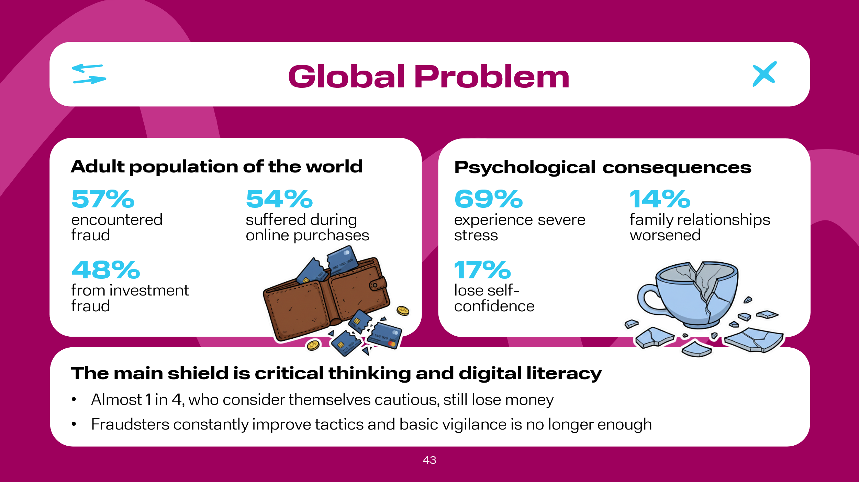 | In conclusion, recent data from a global study shows a worrying picture: fraud has become a mass phenomenon, and its consequences go far beyond financial losses. In 2025, 57% of the world's adult population encountered fraud. Among those who lost funds, 54% fell victim to online shopping fraud, and 48% suffered from investment fraud. Special attention should be paid to the psychological damage: 69% experience severe stress, 17% lose self-confidence, and 14% report deteriorating family relationships.  Most people declare: "This definitely won't happen to me." At the same time, almost one in four of this confident group still loses money, indicating a serious gap between risk perception and real threats. Fraudsters are improving their tactics, and basic vigilance is sometimes no longer enough. High self-assessment of one's own caution can create a false sense of security, making a person vulnerable. All this suggests that it is necessary to constantly increase the level of digital literacy and critical thinking

Slide 44  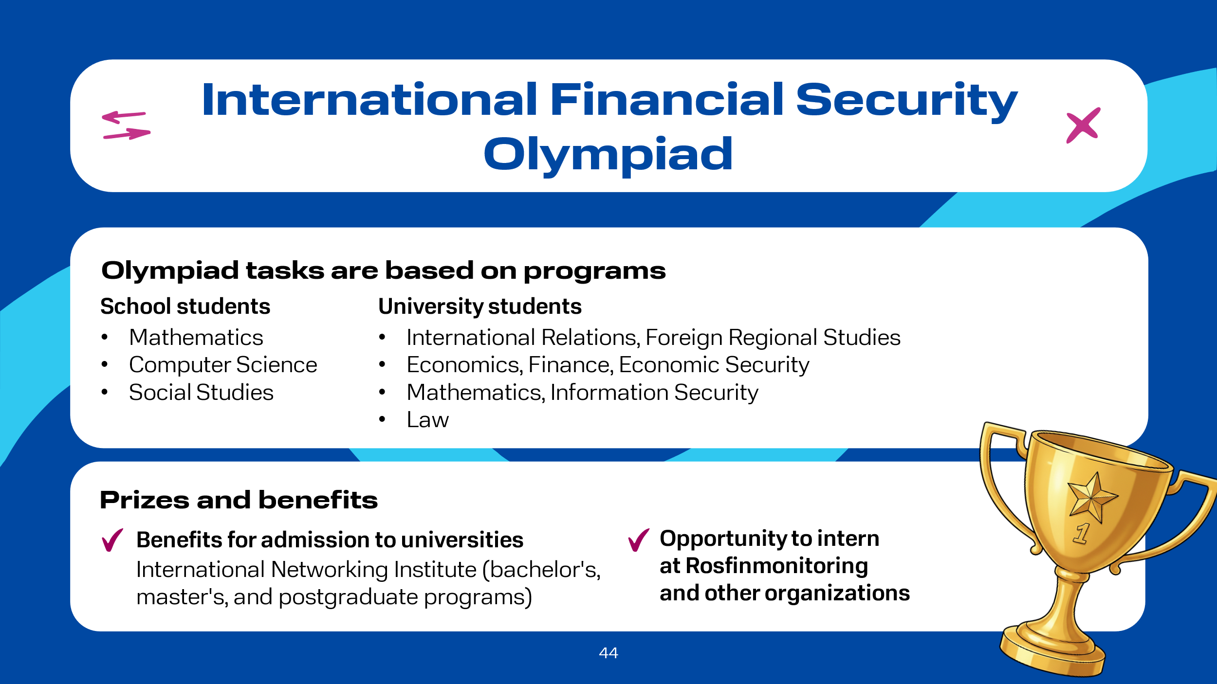 | The International Financial Security Olympiad is an annual Level I Olympiad, held on the instructions of the President of the Russian Federation, V.V. Putin. The Olympiad aims to increase information, financial, and legal literacy among the younger generation, find talented youth, and stimulate educational, cognitive, and research activities in the field of financial security.  Given the profile of the Olympiad ("Financial Security"), the Olympiad tasks are based on the following programs:  for school students – based on general education subject programs: mathematics, computer science, social studies;  for university students – based on the main educational programs of higher education in the following fields of study:  law; mathematics, information security, etc.; economics, finance and credit, economic security; international relations, foreign regional studies.  Winners and prize-winners of the Olympiad receive advantages when applying to universities of the International Network Institute in the field of AML/CFT for bachelor's, master's, and postgraduate programs in accordance with the benefits of Level I Olympiads, as well as the opportunity to intern at Rosfinmonitoring and other organizations.

Slide 45  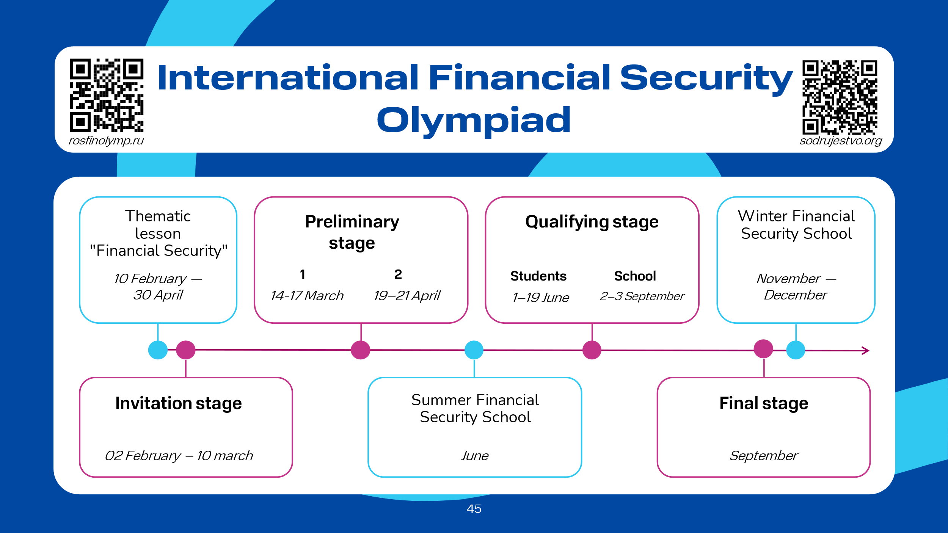 | The Olympiad takes place in several stages: thematic lesson "Financial Security"; invitation stage; preliminary stage; qualifying stage; final stage.

Slide 46  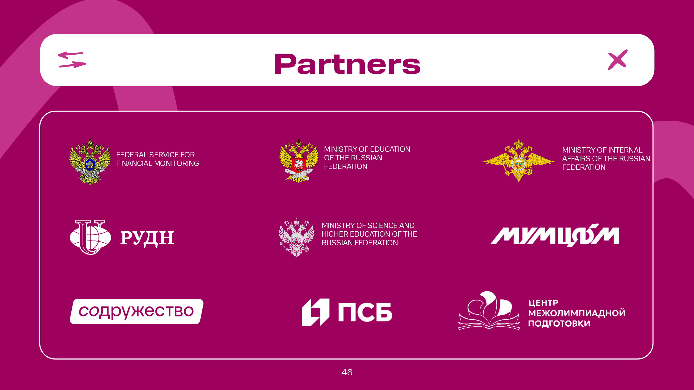 | Partners of the lesson and the Olympiad

